|  |  |  |  |  |  |  |  |  |  |  |  |  |  |  |  |  |  |  |  |  |  |  |  |  |  |  |  |  |  |  |  |  |  |  |  |  |  |  |  |  |  |  |  |  |  |  |  |  |  |  |  |  |  |  |
| --- | --- | --- | --- | --- | --- | --- | --- | --- | --- | --- | --- | --- | --- | --- | --- | --- | --- | --- | --- | --- | --- | --- | --- | --- | --- | --- | --- | --- | --- | --- | --- | --- | --- | --- | --- | --- | --- | --- | --- | --- | --- | --- | --- | --- | --- | --- | --- | --- | --- | --- | --- | --- | --- | --- |
| Requirements and Design Specification Document  <DocSage>  **Project Code:** CS-463  **Advisor:** Mam Fouqia Zafeer  **Project Team:**   |  |  |  | | --- | --- | --- | | 01. | Muhammad Umar Farooq | 202370006 | | 02. | Jameel Ahmad | 212370053 | | 03. | Nouman Shahid | 232370045 | | 04. | Usama | 212370004 |   **Submission Date:** 10-Feb-2024    Certificate by Supervisor  This Project has been carried out under my direct supervision. It has been checked by me and has been found to be satisfactory regarding content, format tools and thus fulfils the requirements for the awards of BS degree.  Name of Supervisor Signature of Supervisor    Date:      **Document Information**   | Category | Information | | --- | --- | | Customer | GIFT | | Project | DocSage | | Document | Requirement Specifications | | Document Version | 1.0 | | Identifier |  | | Status | Final | | Author(s) | M. Umar Farooq, Nouman Shahid, Jameel Ahmad, Usama | | Approver(s) | Mam Fouqia Zafeer | | Issue Date |  | | Document Location | GIFT Library | | Distribution | 1. Advisor 2. PM 3. Project Office |   **Definition of Terms, Acronyms and Abbreviations**  This section should provide the definitions of all terms, acronyms, and abbreviations required to interpret the terms used in the document properly.   | Term | Description | | --- | --- | | ASP | Active Server Pages | | DD | Design Specification | |  |  | |  |  | |  |  | |  |  | |  |  | |  |  | |

Table of Contents

1.Introduction 6

1.1 Purpose 6

1.2 Overview 6

1.3 Scope 7

1.3.1 Stakeholders 7

1.3.2 Out of Scope 8

2. Overall Description 8

3. Specific Requirements 9

3.1 Functional Requirements 9

3.1.1 Stakeholder Admin 9

3.1.2 Stakeholder Doctor 9

3.1.3 Stakeholder Patient 11

3.2 Non-Functional Requirements 12

3.3 Usability 13

3.4 Design Constraints 13

4. System Design 14

4.1 System Architecture 14

4.2 Class Diagram 15

4.3 ER Diagram 16

4.4 Data Flow Diagrams 17

4.4.1 DFD Level 0 17

4.4.2 DFD Level 01 18

4.4.3 DFD Level 02 19

5. Use Case Analysis 20

5.1 Use Case Diagram 20

5.1.1 Admin 20

5.1.2 Doctor 21

5.1.3 Patient 22

5.2 Use Case Description 23

5.2.1 Stakeholder Admin 23

5.2.2 Stakeholder Doctor 28

5.2.3 Stakeholder Patient 38

6. UI Design 47

6.1 Mockups 47

6.2. Sequence Diagram 58

6.2 Sequence Diagrams 58

6.2.1 Admin Perspective 58

6.2.2 Doctor Perspective 65

6.2.3 Patient Perspective 77

7. Project Plan 86

7. Testing Plan 86

7.1 Purpose of Testing 86

7.1.1 Project Overview 86

7.2 Scope of Testing 86

7.2.1 In Scope 86

8. Test Plan Strategy 87

9.1 Unit Testing 87

9.1.1. Participants 87

9.1.2. Methodology: 87

9.2 Integration Testing 87

9.2.1 Participants 87

9.2.2 Methodology 87

9.3 System Testing 88

9.3.1 Participants: 88

9.3.2 Methodology: 88

10. Test Environment 88

Development Environment 88

Testing Tools: 88

11. Schedule 88

12. Control Activities 89

13. Resources 89

13.1 Human 89

13.2 Hardware 89

13.3 Software 89

14. Test Case Design and Description 89

14.1 Admin Module 89

Test case 9: View Pending Verification 94

14.2 Doctor Module 96

14.3 Patient Module 108

15. Major Deliverables 120

16. Risks and Assumptions 121

Risks: 121

Assumptions: 121

17. Exit Criteria 121

18. Team Leader Remarks 121

# **1.Introduction**

## **1.1 Purpose**

The purpose of DocSage is to provide a comprehensive and accessible platform that connects patients with dermatological care through AI-powered skin analysis and streamlined access to dermatologists. DocSage aims to address the challenges of preliminary skin condition assessment and specialist access by:

* **Offering AI-powered Preliminary Diagnosis:** Enabling users to upload images of skin conditions for initial analysis and potential disease classification, thus providing a first step in understanding their symptoms.
* **Facilitating Timely Access to Specialists:** Connecting patients with relevant dermatologists based on their location and the AI-predicted skin condition, enabling quicker access to expert consultations.
* **Streamlining the Consultation Process:** Providing a platform for online video consultations, appointment scheduling, and providing prescription, improving the convenience and efficiency of dermatological care.
* **Empowering Doctors with Enhanced Tools:** Equipping doctors with AI-assisted diagnostic capabilities and a platform to efficiently manage online consultations, patient records, and prescriptions.

DocSage seeks to improve the overall experience of dermatological care by leveraging technology to enhance diagnosis, access, and communication between patients and doctors.

## **1.2 Overview**

DocSage is a web platform designed to facilitate access to dermatological care by connecting patients with dermatologists through AI-powered preliminary diagnosis and streamlined consultation processes. The system allows patients to upload images of skin conditions for initial analysis, providing potential disease classifications. It then connects patients with relevant dermatologists based on their location and the AI-predicted condition, facilitating quicker access to expert consultations via video. DocSage also provides a platform for appointment scheduling and prescription management. The system also gives doctors access to AI analysis tools and a platform to manage online consultations, patient records, and prescriptions. The platform aims to provide a centralized hub for dermatological information, enhancing the continuity of care.

**Functionality:**

1. **Admin- Perspective:**
   * System login.
   * Free access to AI symptom checker.
   * User management (view/update patient and doctor data).
   * Revenue tracking.
   * View Articles related to skin diseases
2. **Doctor- Perspective:**
   * Secure user signup/signin.
   * AI-powered symptom checker access (subscription-based).
   * Online consultation management.
   * View Articles related to skin diseases
3. **Patient-Perspective:**
   * Secure user signup/signin.
   * AI-powered symptom checker (subscription-based).
   * Report generation and download as pdf.
   * Geolocation-based dermatologist directory.
   * Video consultation booking.
   * View Articles related to skin diseases
   * Prescription access.

**Basic Design Approach:**

DocSage utilizes a multi-tiered architecture comprised of the following components:

* Frontend: A user-friendly interface built with Next.js, styled using ShadCN UI and Tailwind CSS, ensuring a responsive and modern experience for both patients and doctors.
* Backend: Implemented using Next.js, handling user authentication, database interactions, serverless functions, and business logic.
* Database: Utilizes Supabase PostgreSQL, a relational database, to store structured data such as user information, appointment details, subscription data, and report information. Zod is used for schema validation.
* Authentication: User authentication and access control are managed using Clerk, ensuring secure and seamless login flows.
* AI Model: A symptom checker model is integrated via a Fast-API-based API for medical condition analysis.
* Cloud Storage: Cloudinary is used for storing and managing disease images and other medical records.
* Currency Conversion: The Exchange Rate API is used to provide real-time USD to PKR currency conversion.
* Payment Integration: Stripe is integrated to handle secure payment processing for subscriptions and services.

## **1.3 Scope**

Our system has the following stakeholders, and each stakeholder has the following boundaries.

### **1.3.1 Stakeholders**

1. **Admin**

* Login to the system.
* Use symptom checker freely.
* See all patients and doctors and can update them.
* See the total revenue.
* See the total revenue generated using subscriptions from patients and doctor’s month-wise.

1. **Doctors**

* Sign up and sign in.
* Subscribe to the symptom checker service.
* Check symptoms of the affected skin by uploading the affected skin area picture
* Treat patients online via the platform and receive the appointment fee (total - 100 Rs).
* Provide patients with prescriptions after video consultation.
* See the skin diseases articles

1. **Patients**

* Sign up and sign in.
* Check symptoms of their skin by uploading the affected area picture, which goes to our model API.
* Need to take a subscription to the symptom checker ML model before using it.
* See detailed reports and download them in PDF format.
* View a list of dermatologists treating specific diseases based on location and predicted disease.
* Take video consultations by selecting a time slot and paying the fee.
* Take direct online appointments by exploring doctor profiles, filtered by disease or symptoms.
* See the skin diseases articles

### **1.3.2 Out of Scope**

1. Insurance Claim Processing: Integration with insurance providers is not included.
2. Multi-Language Support: The initial version will be in English only.
3. Mobile Application: The initial scope focuses on a web application.

**Definitions, Acronyms, and Abbreviations**

|  |  |  |
| --- | --- | --- |
| ***Sr no.*** | ***Acronym*** | ***Definition*** |
| *1.* | *API* | *Application Programming Interface* |
| *2.* | *PMDC* | Pakistan Medical and Dental Council |

# **2. Overall Description**

**Product Perspective:**

DocSage is a web-based platform designed to provide accessible and convenient dermatological care through online consultations and AI-driven skin analysis. It enhances communication between patients and doctors, offering tools for diagnosis, treatment, and ongoing monitoring of skin conditions.

**Key Functions:**

* **AI-Powered Symptom Checker:** Patients can upload images of affected skin areas for AI analysis, receiving potential disease classifications.
* **Find Doctors:** A searchable directory allows patients to find dermatologists based on location, specialty, and treated conditions.
* **Online Appointments:** Patients can schedule and conduct video consultations with doctors, including payment processing and appointment management.
* **Prescriptions:** Doctors can issue prescriptions electronically, stored securely within the platform.
* **User Management:** Secure signup/signin for patients, doctors, and administrators.

**Key Features & Considerations:**

* **AI Model Subscription:** The AI symptom checker requires a subscription for both patients and doctors.
* **Data Security:** Compliance with data privacy regulations is crucial.
* **Scalability:** The system should handle a growing number of users and data.
* **Technology Stack:** Utilizes technologies such as Prisma, Supabase, and potentially others for the AI model.
* **Payment Integration:** Uses Stripe for subscription and appointment fee processing.

# **3. Specific Requirements**

## **3.1 Functional Requirements**

### **3.1.1 Stakeholder Admin**

**FR-A-001: User Login:**

The system will allow the admin to log in to the system

**FR-A-002: User Management:**

The system will allow the admin to create, update, and deactivate user accounts (patients and doctors).

**FR-A-003: Symptom Checker Access:**

The system will allow the admin to have free access to the AI symptom checker.

**FR-A-004: Reporting and Analytics:**

The system will allow the admin to view reports on platform usage, revenue, etc.

**FR-A-005: Revenue Tracking:**

The system will allow the admin to track total revenue and subscription revenue (patients and doctors) monthly.

**FR-A-006: Article Access:**

The system will allow the admin to view health-related articles in the system.

**FR-A-007: Doctor Verification:**

The system will allow the admin to review, approve, or reject doctor verification requests.

**FR-A-008: Profile Management:**

The system will allow the admin to update their own profile information.

**FR-A-009: Logout:**

The system will allow the admin to securely log out and terminate their session.

**FR-A-010: Registration Tracking:**

The system will allow the admin to track and monitor new user registrations with statistics

### **3.1.2 Stakeholder Doctor**

**FR-D-001: User Account Creation:**

The system will allow doctors to create accounts with credentials.

**FR-D-002: Symptom Checker Access:**

The system will allow doctors to use the AI symptom checker after getting a subscription.

**FR-D-003: Appointment Management:**

The system will allow doctors to confirm or cancel appointments.

**FR-D-004: Patient Information Access:**

The system will allow doctors to access patients' symptom checker reports and medical history (if provided).

**FR-D-005: Video Consultation:**

The system will allow doctors to conduct secure video consultations with patients.

**FR-D-006: Prescription Issuance:**

The system will allow doctors to issue electronic prescriptions.

**FR-D-007: Payment Handling:**

The system will allow doctors to receive appointment payments (total amount - 100 Rs goes to the doctor).

**FR-D-008: Profile Update:**

The system will allow doctors to update their profile information.

**FR-D-009: View Articles:**

The system will allow doctors to view articles related to skin diseases.

**FR-D-010: Availability Management:**

The system will allow doctors to set their working hours, vacation days, and consultation duration.

**FR-D-011: Account Verification Process:**

The system will require doctors to submit credentials for admin verification before gaining full access.

**FR-D-012: Patient Communication:**

The system will allow doctors to message patients before appointments.

**FR-D-013: Secure Logout**

The system will allow doctors to securely terminate their sessions.

**FR-D-014: Specialization Management:**

The system will allow doctors to update symptoms and diseases they handle.

**FR-D-015: Consultation Fee Setting:**

The system will allow doctors to set their consultation fees.

**FR-D-016: Subscription Management:**

The system will allow doctors to view and purchase AI service subscription plans.

### **3.1.3 Stakeholder Patient**

**FR-P-001: User Account Creation:**

The system will allow patients to create accounts with credentials.

**FR-P-002: AI Symptom Checker Subscription:**

The system will allow patients to subscribe to the AI symptom checker by taking monthly or yearly plans.

**FR-P-003: Image-Based Symptom Check:**

The system will allow patients to upload images to the AI model, receiving a disease classification (0-23).

**FR-P-004: Report Generation & Access:**

The system will allow patients to access AI model results, which are saved as reports, and view/download them.

**FR-P-005: Doctor Discovery:**

The system will allow patients to find dermatologists treating specific diseases based on location.

**FR-P-006: Appointment Booking**:

The system will allow patients to book video consultations with doctors.

**FR-P-007: Appointment Management:**

The system will allow patients to view their appointments.

**FR-P-008: Video Consultation:**

The system will allow patients to have secure video consultations with doctors.

**FR-P-009: Prescription Access:**

The system will allow patients to view prescriptions issued by doctors.

**FR-P-010: Location-Based Doctor Prioritization:**

The system will allow patients to see prioritized doctors based on proximity to their location.

**FR-P-011: Symptom-Based Doctor Filtering:**

The system will allow patients to filter doctors by symptoms and skin diseases they treat.

**FR-P-012: Profile Update:**

The system will allow patients to update their profiles as needed.

**FR-P-013: View Articles:**

The system will allow patients to view articles related to skin diseases.

**FR-P-014: Secure Logout:**

The system will allow patients to securely terminate their sessions.

**FR-P-015: Payment Processing:**

The system will allow patients to process payments for appointments and subscriptions.

**FR-P-016: Message Doctor:**

The system will allow patients to send messages to doctors with whom they have appointments.

**FR-P-017: Download Medical Reports**:

The system will allow patients to download their medical reports in various formats.

**FR-P-018: Alternative Authentication**:

The system will allow patients to use Google authentication as an alternative to email-based registration.

**FR-P-019: Security Configuration:**

The system will allow patients to configure security settings for their accounts.

**FR-P-020: Share AI Diagnosis:**

The system will allow patients to share their AI diagnosis results with selected doctors.

## **3.2 Non-Functional Requirements**

**NFR-001: Performance:**

The system should load quickly and respond promptly to user requests.

**NFR-002: Maintainability:**

The portal should be easy to maintain and update with minimal downtime.

**NFR-003: Usability:**

The portal should provide a personalized and engaging user experience. The patient interface shall be intuitive and easy to use. The doctor interface shall be intuitive and efficient for managing appointments and patient records.

**NFR-004: Security:**

Securely store and protect all data (personal information, medical history, payment details).

**NFR-005: Scalability:**

The system shall be able to handle a growing number of users and consultations.

**NFR-006: Accessibility:**

The system shall be accessible to patients with disabilities, adhering to accessibility guidelines.

**NFR-007: AI Accuracy:**

The AI symptom checker shall provide accurate and reliable disease classifications, with measures in place to mitigate potential errors.

## **3.3 Usability**

**US-001: Intuitive Navigation**

The system should have clear navigation menus that are easy to understand and use.

Users should be able to find what they need quickly.

**US-002: Feedback Mechanism**

Provide feedback mechanisms for users to rate their experience with doctors or report issues.

Use this feedback to improve the platform over time.

**US-003: Clear Instructions**

Offer clear instructions on how to use each feature (e.g., AI symptom checker).

**US-004: Error Handling**

Implement robust error handling that provides helpful messages when something goes wrong.

## **3.4 Design Constraints**

**DC-001: Color Scheme & Branding**

Use a calming color scheme suitable for healthcare services (e.g., blues and whites).

Ensure consistency in branding across all pages.

**DC-002: Layout Consistency**

Maintain consistent layouts throughout the site for familiarity.

**DC-003: Typography & Readability**

Select fonts that are easy to read across different devices.

**DC-004: Visual Hierarchy**

Organize content using visual hierarchy principles (size, colour) so important elements stand out.

**DC005 : UI components**

UI components such as buttons, input fields, dropdowns etc should be designed properly

# **4. System Design**

## **4.1 System Architecture**

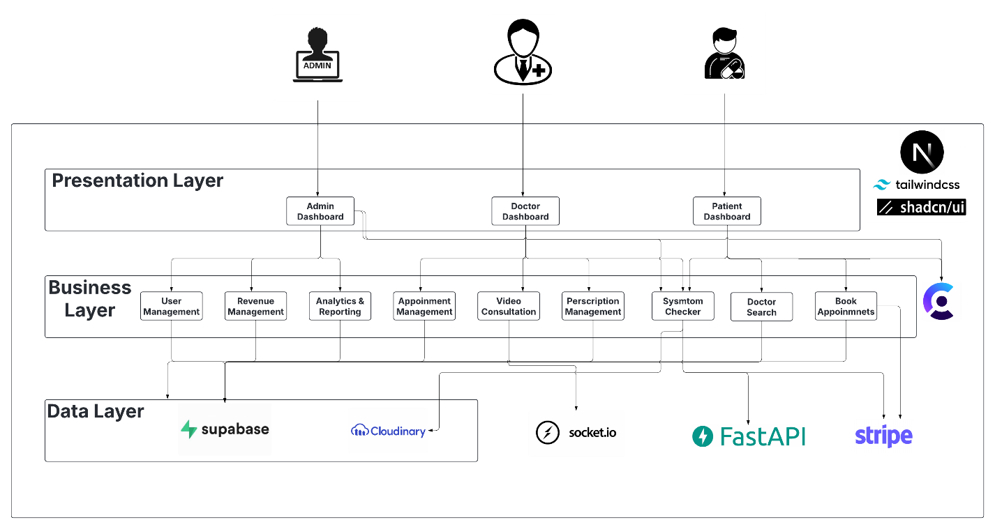

## **4.2 Class Diagram**

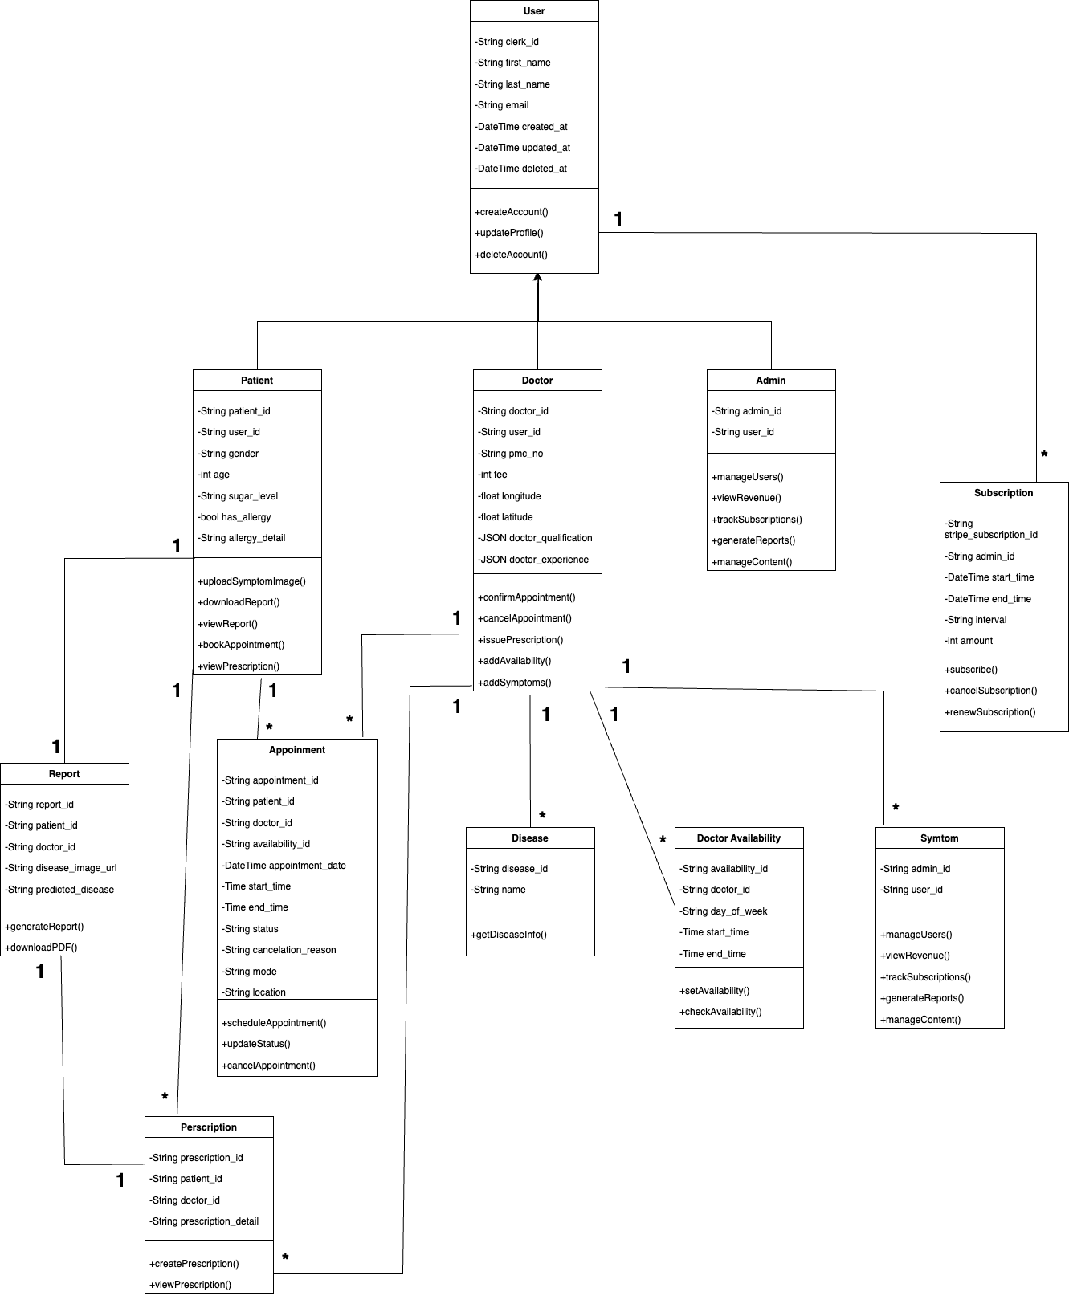

## **4.3 ER Diagram**

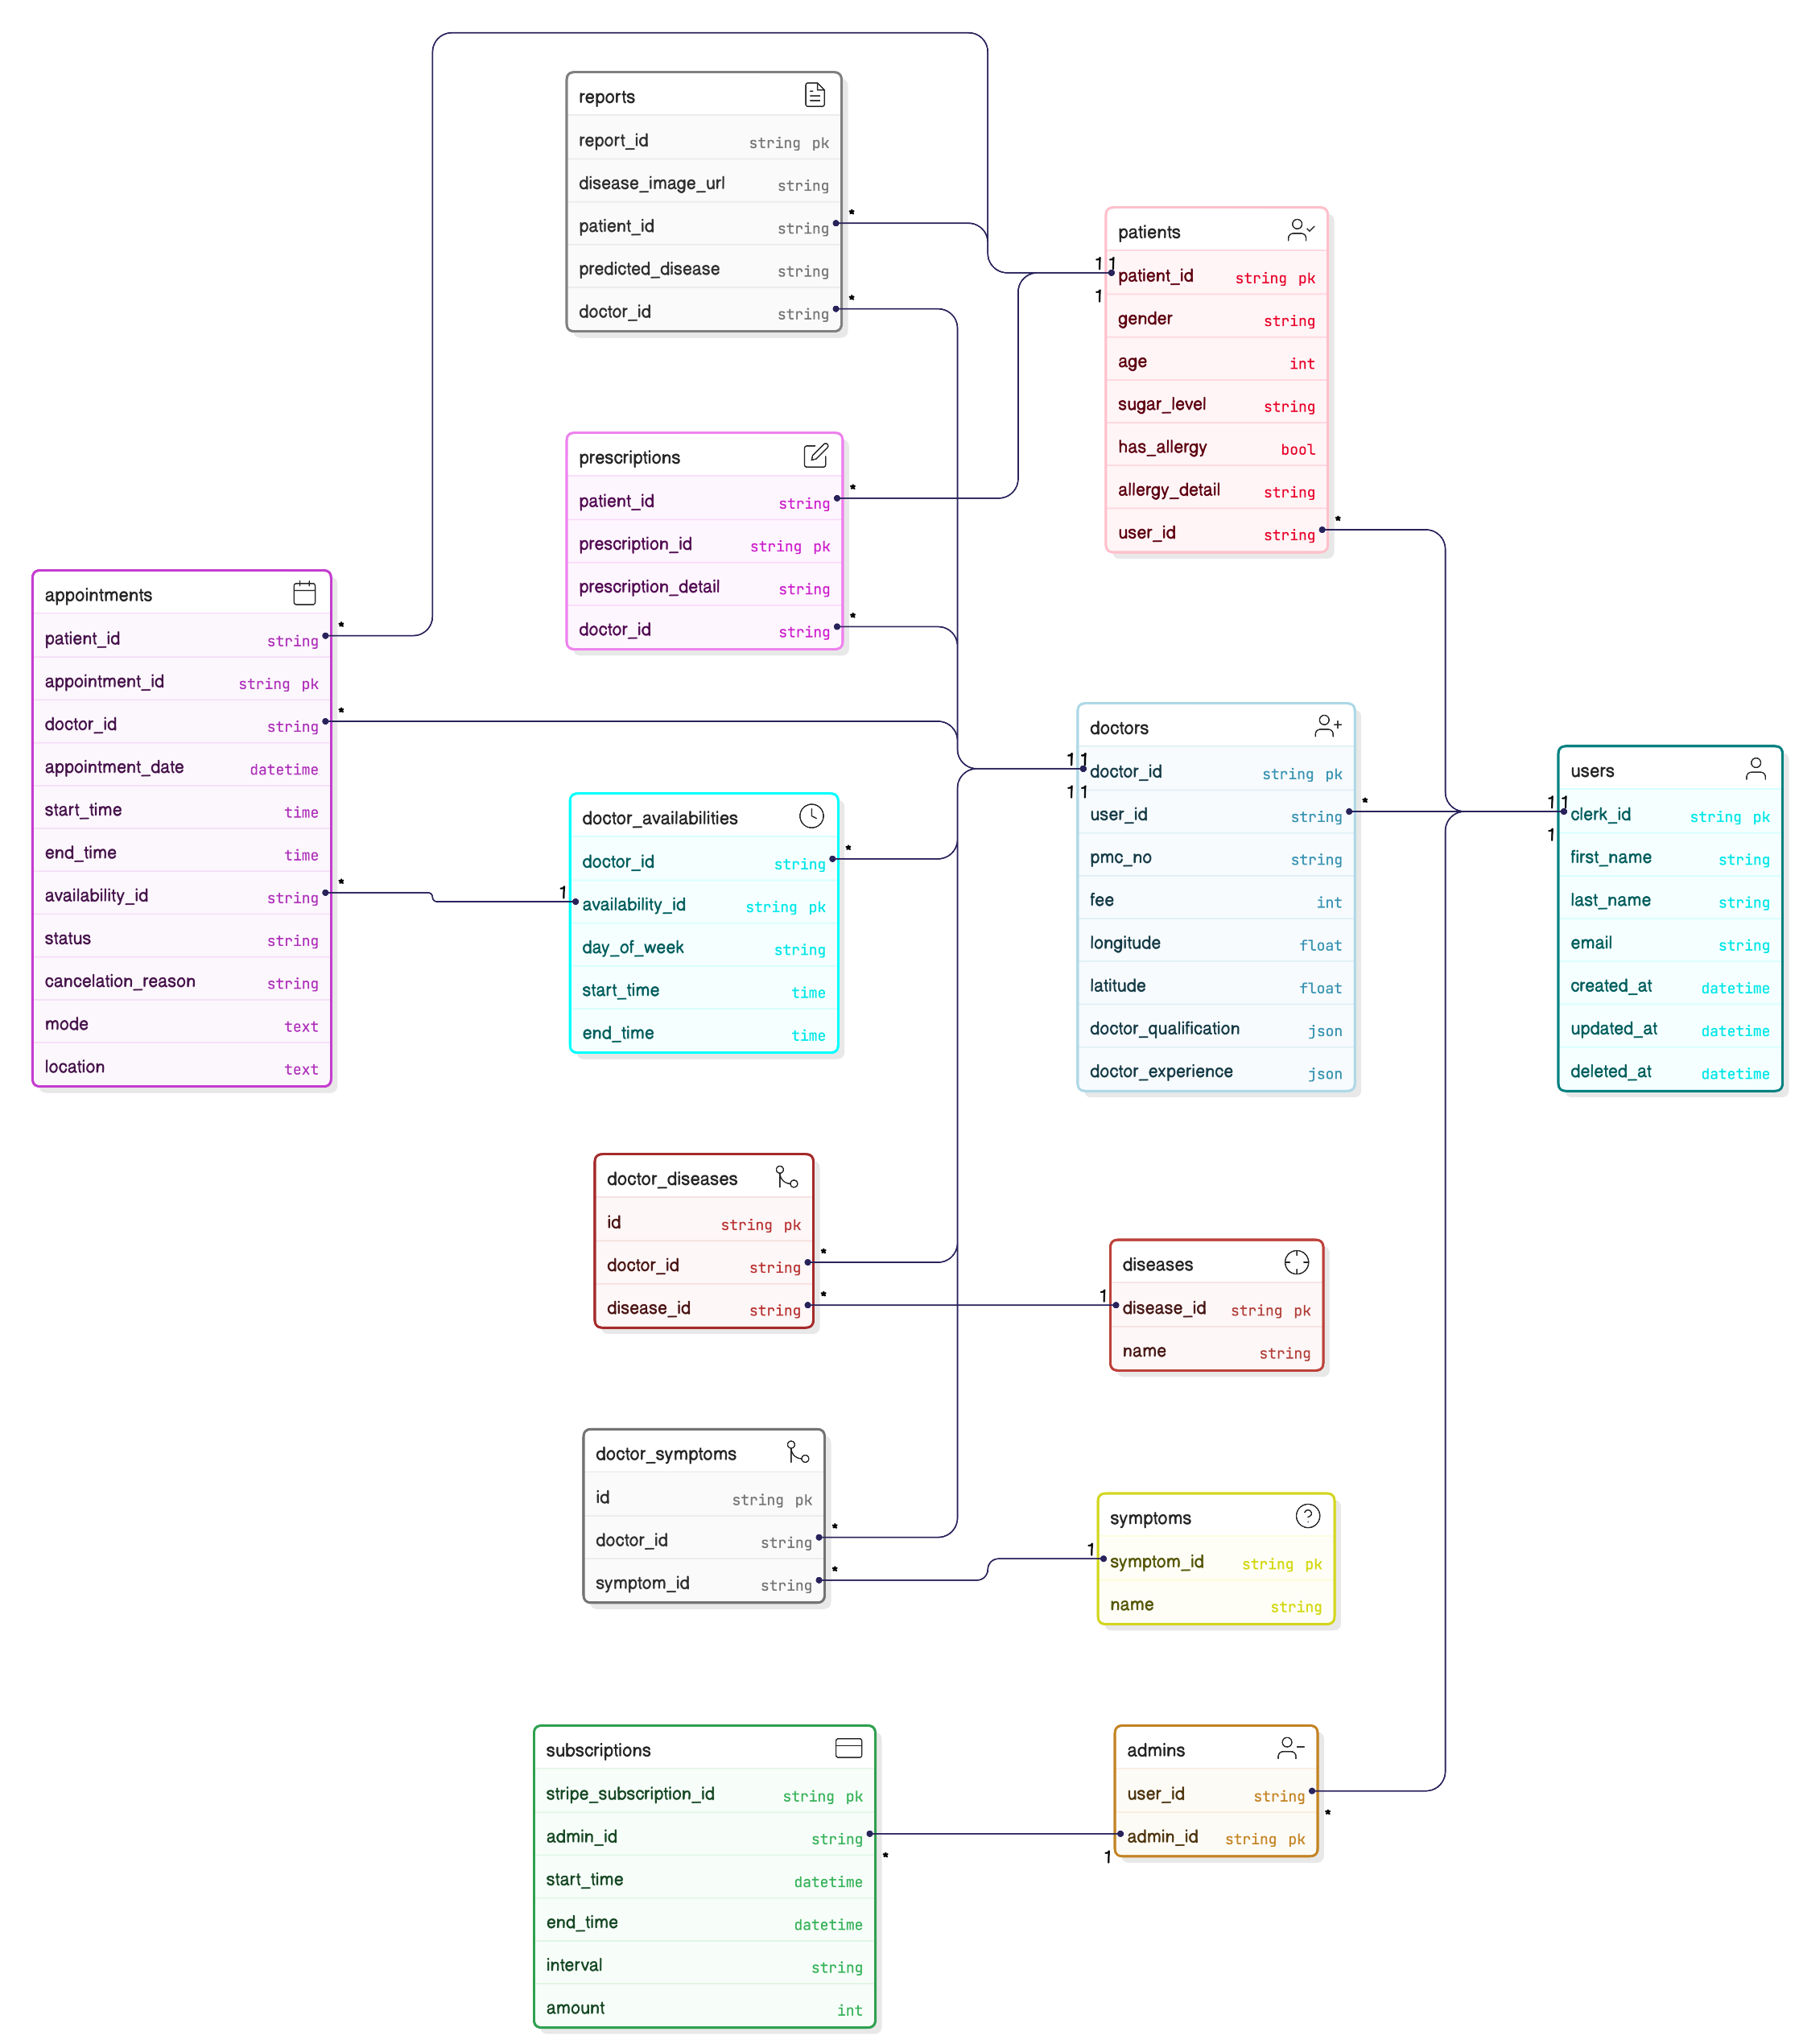

## **4.4 Data Flow Diagrams**

### **4.4.1 DFD Level 0**

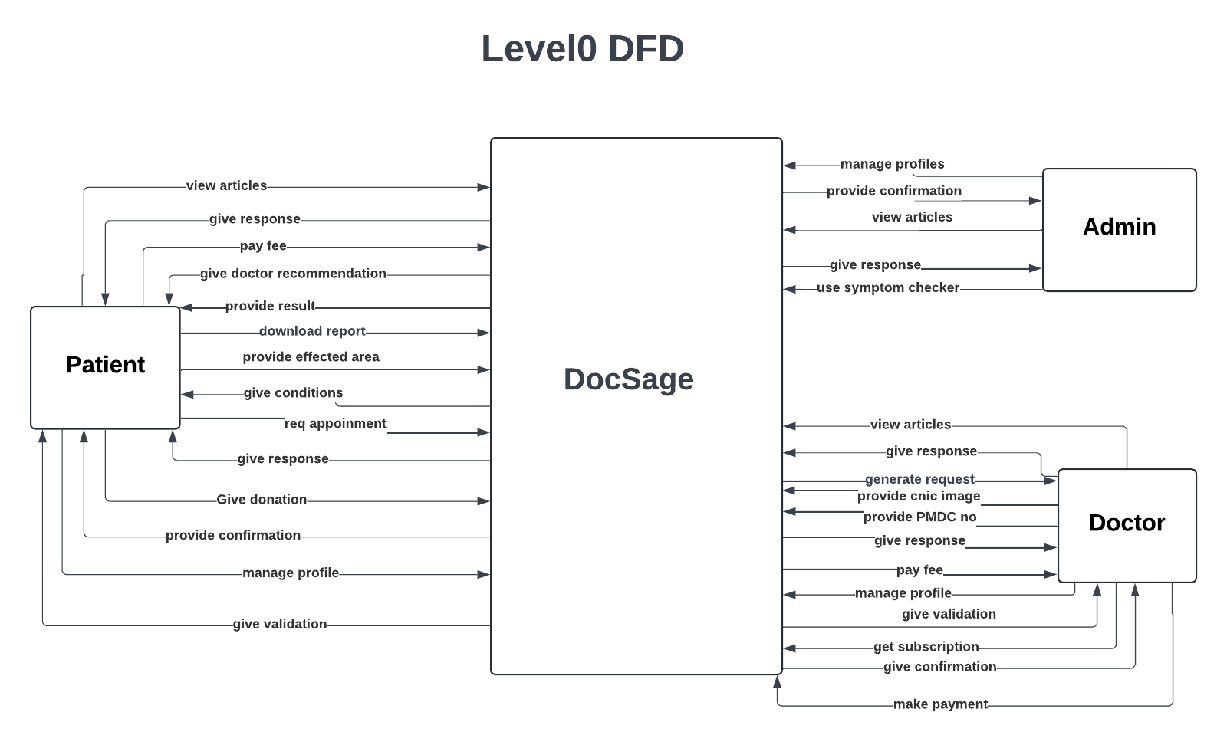

### **4.4.2 DFD Level 01**

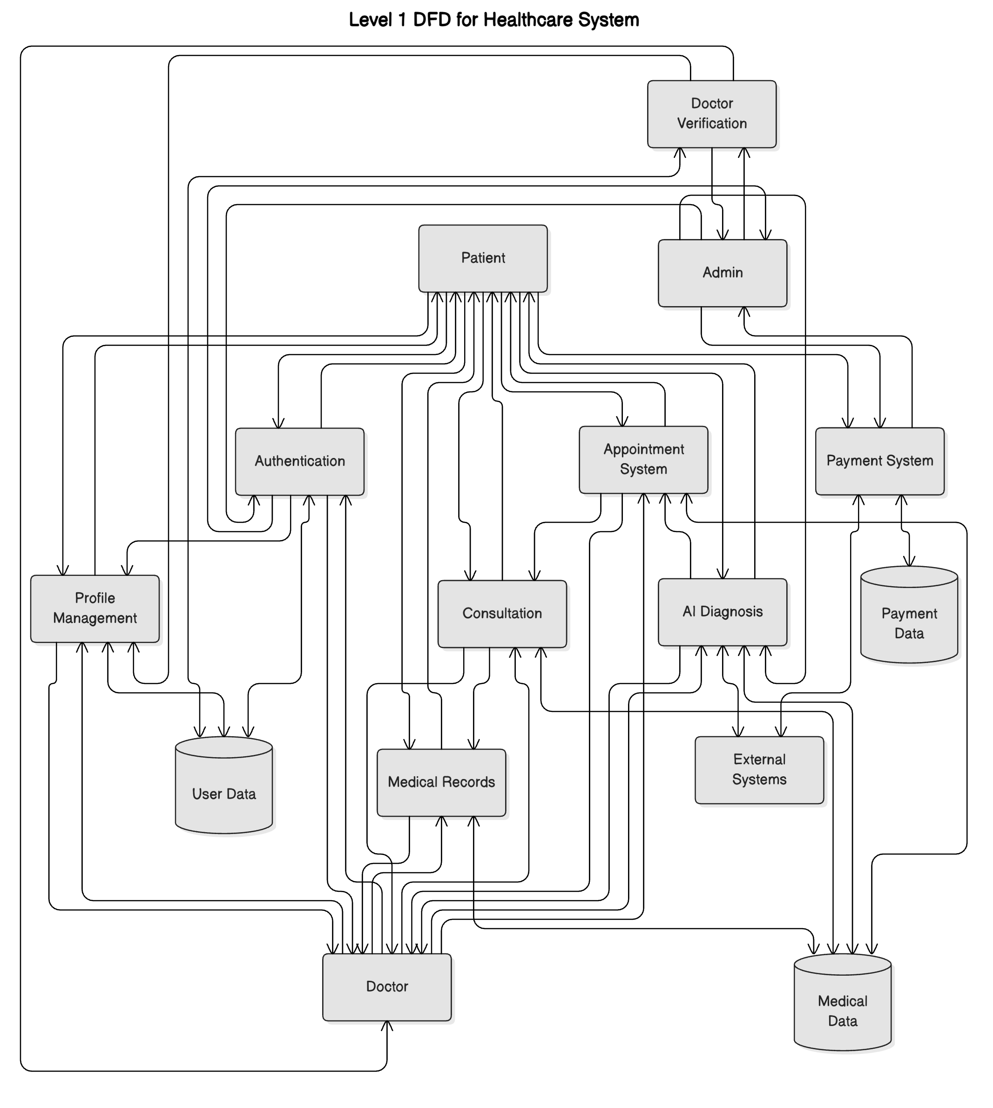

### **4.4.3 DFD Level 02**

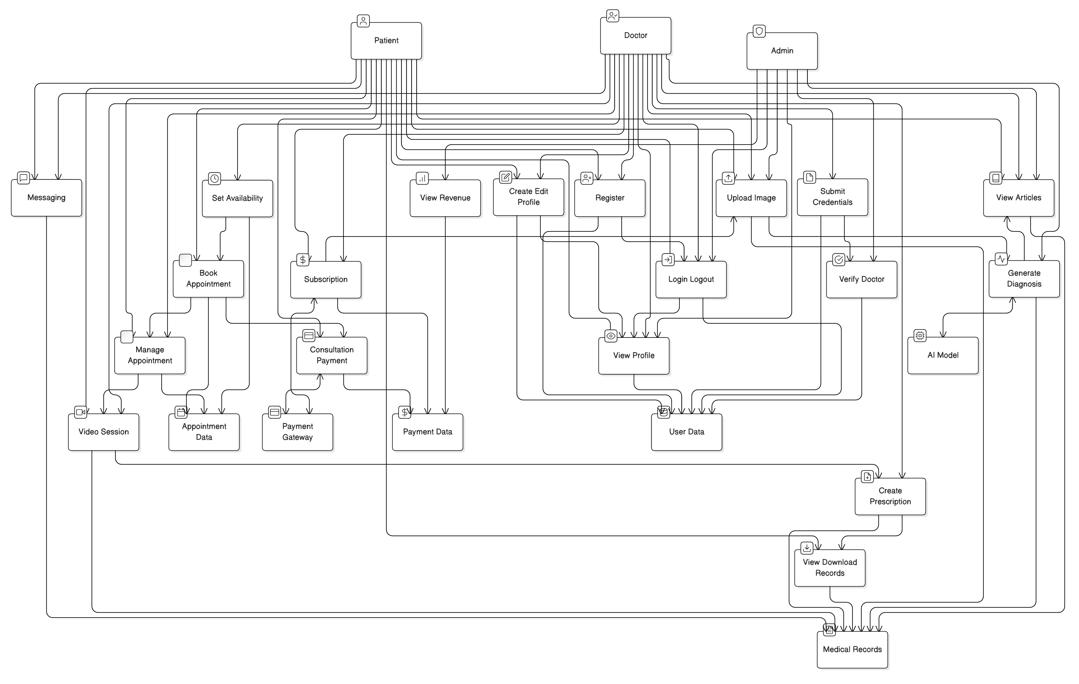

# **5. Use Case Analysis**

## **5.1 Use Case Diagram**

### **5.1.1 Admin**

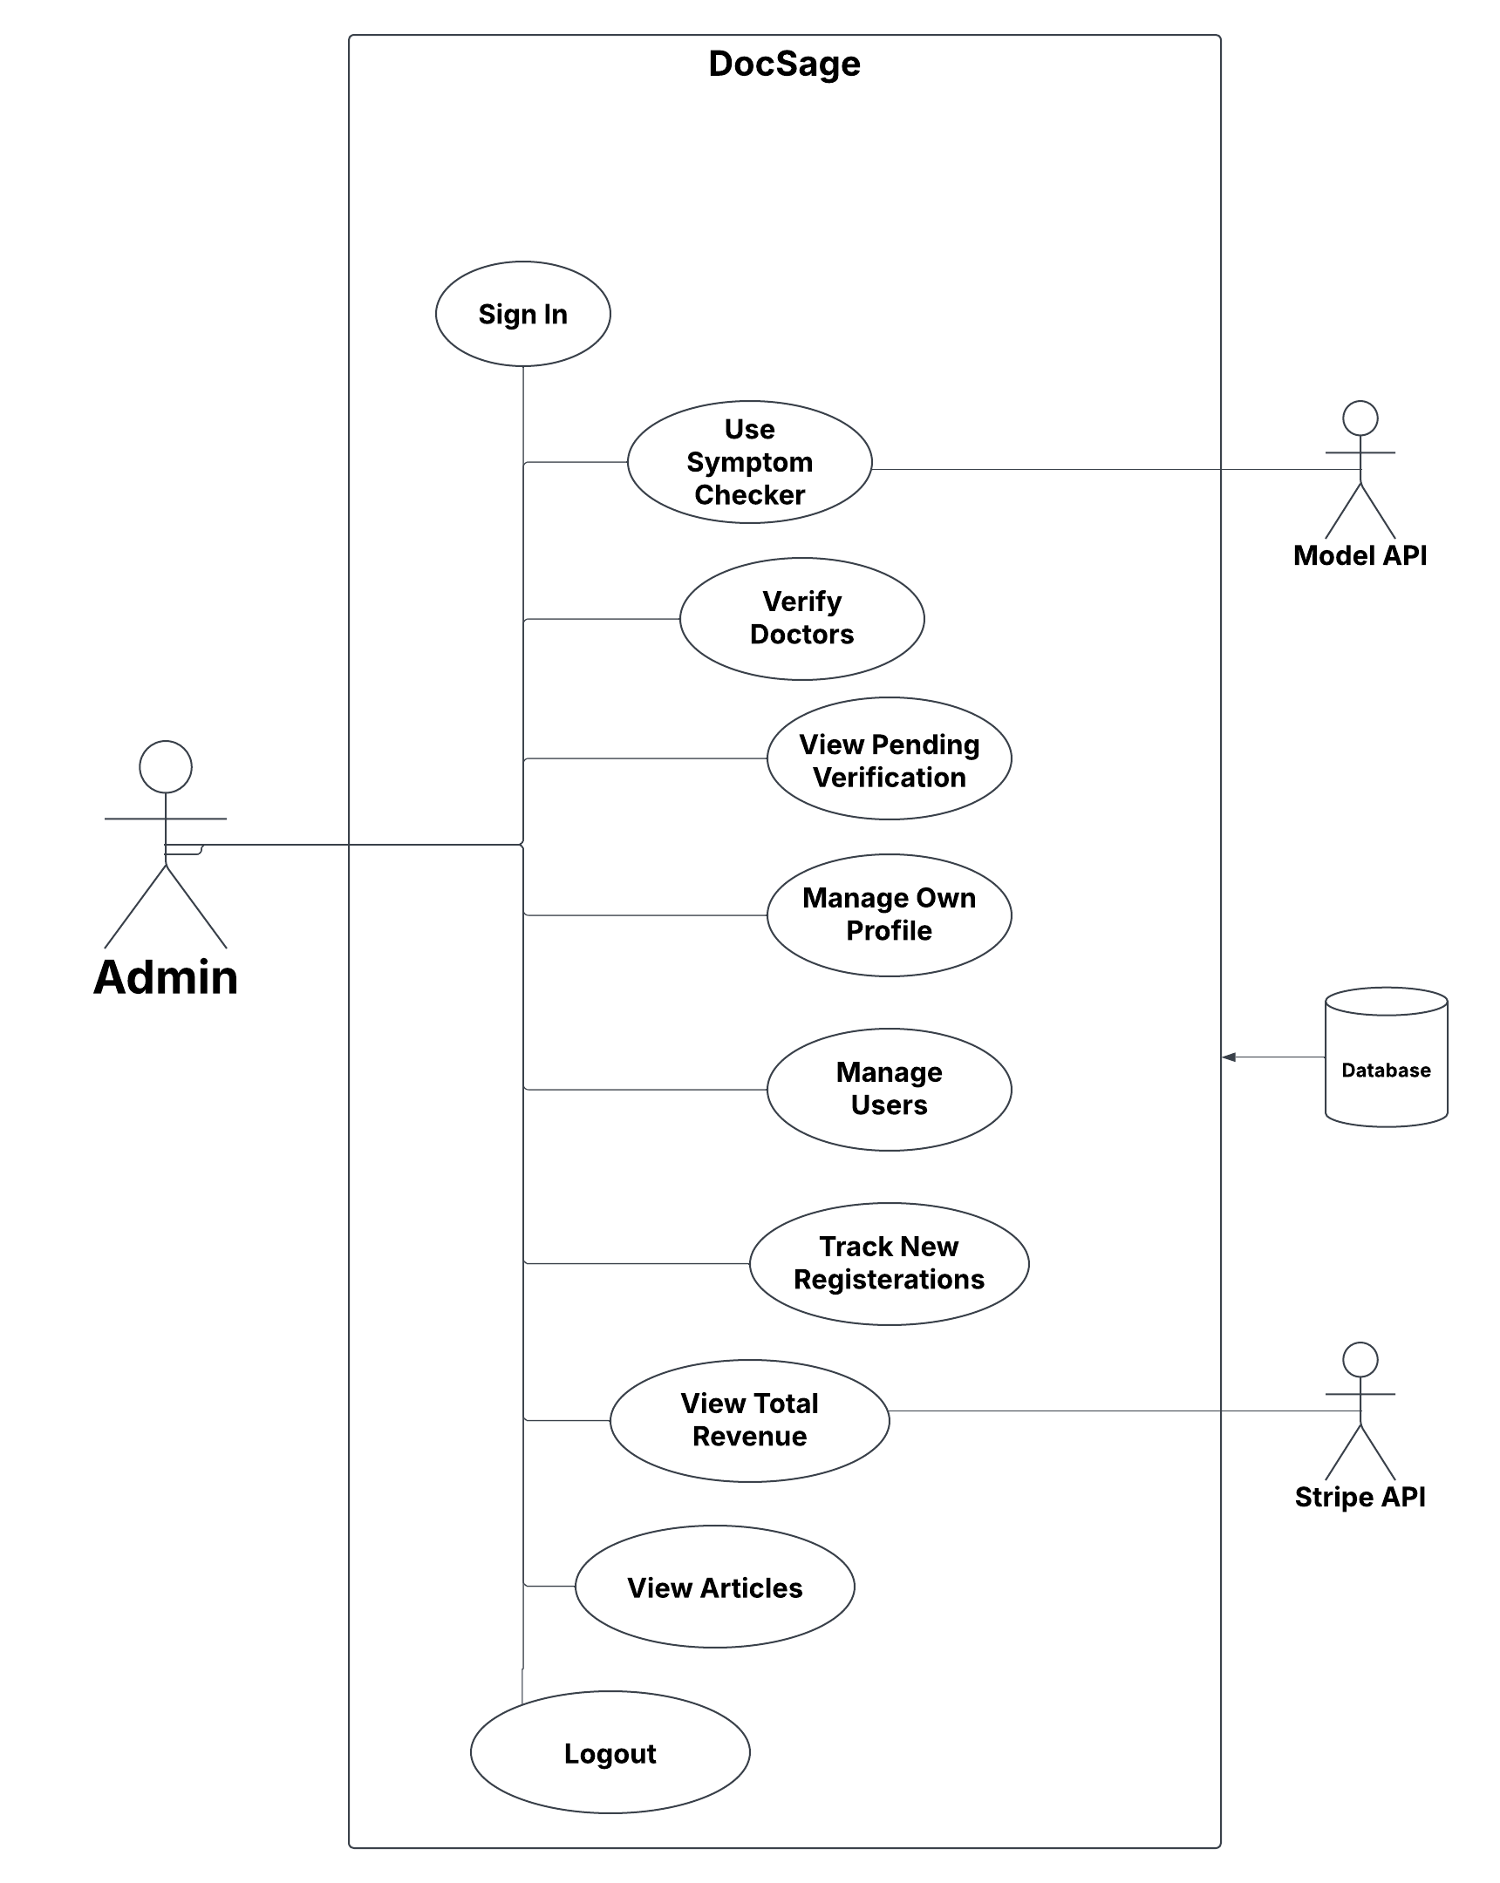

### **5.1.2 Doctor**

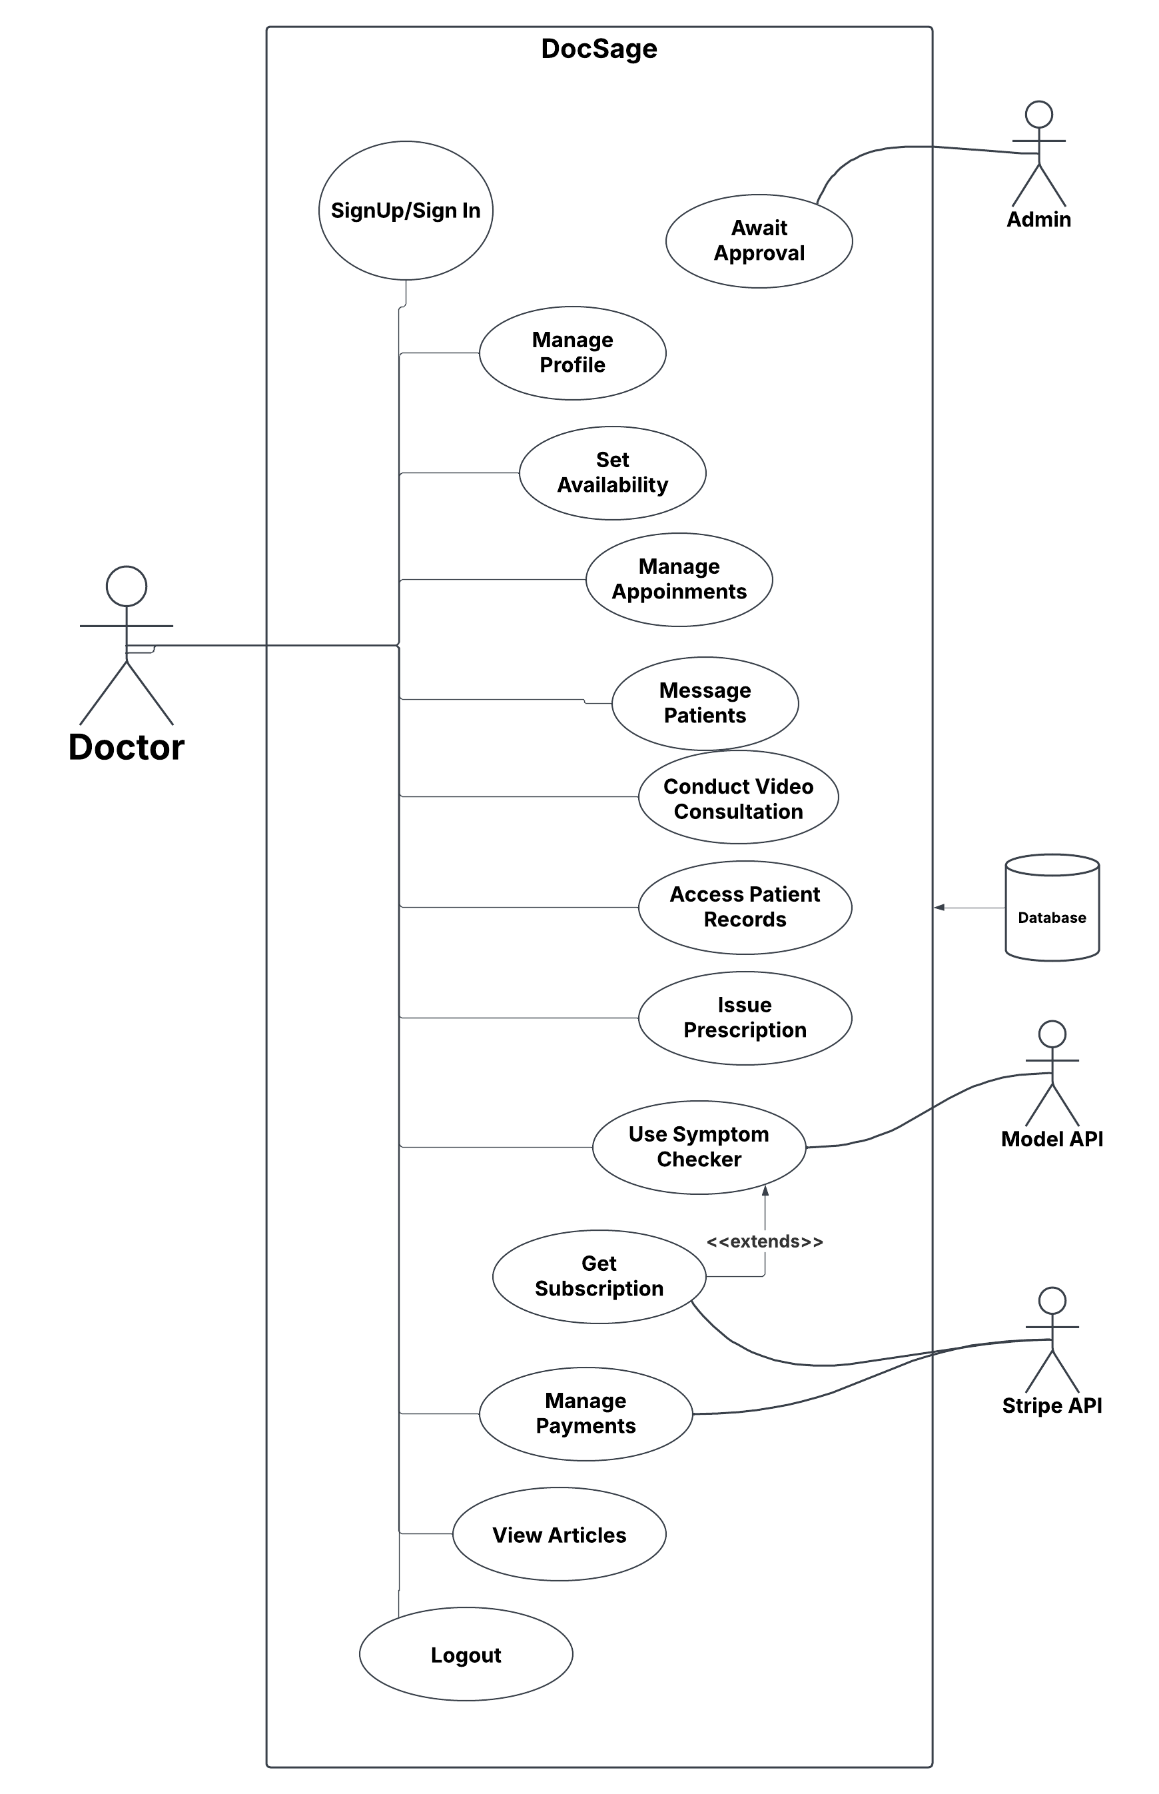

### **5.1.3 Patient**

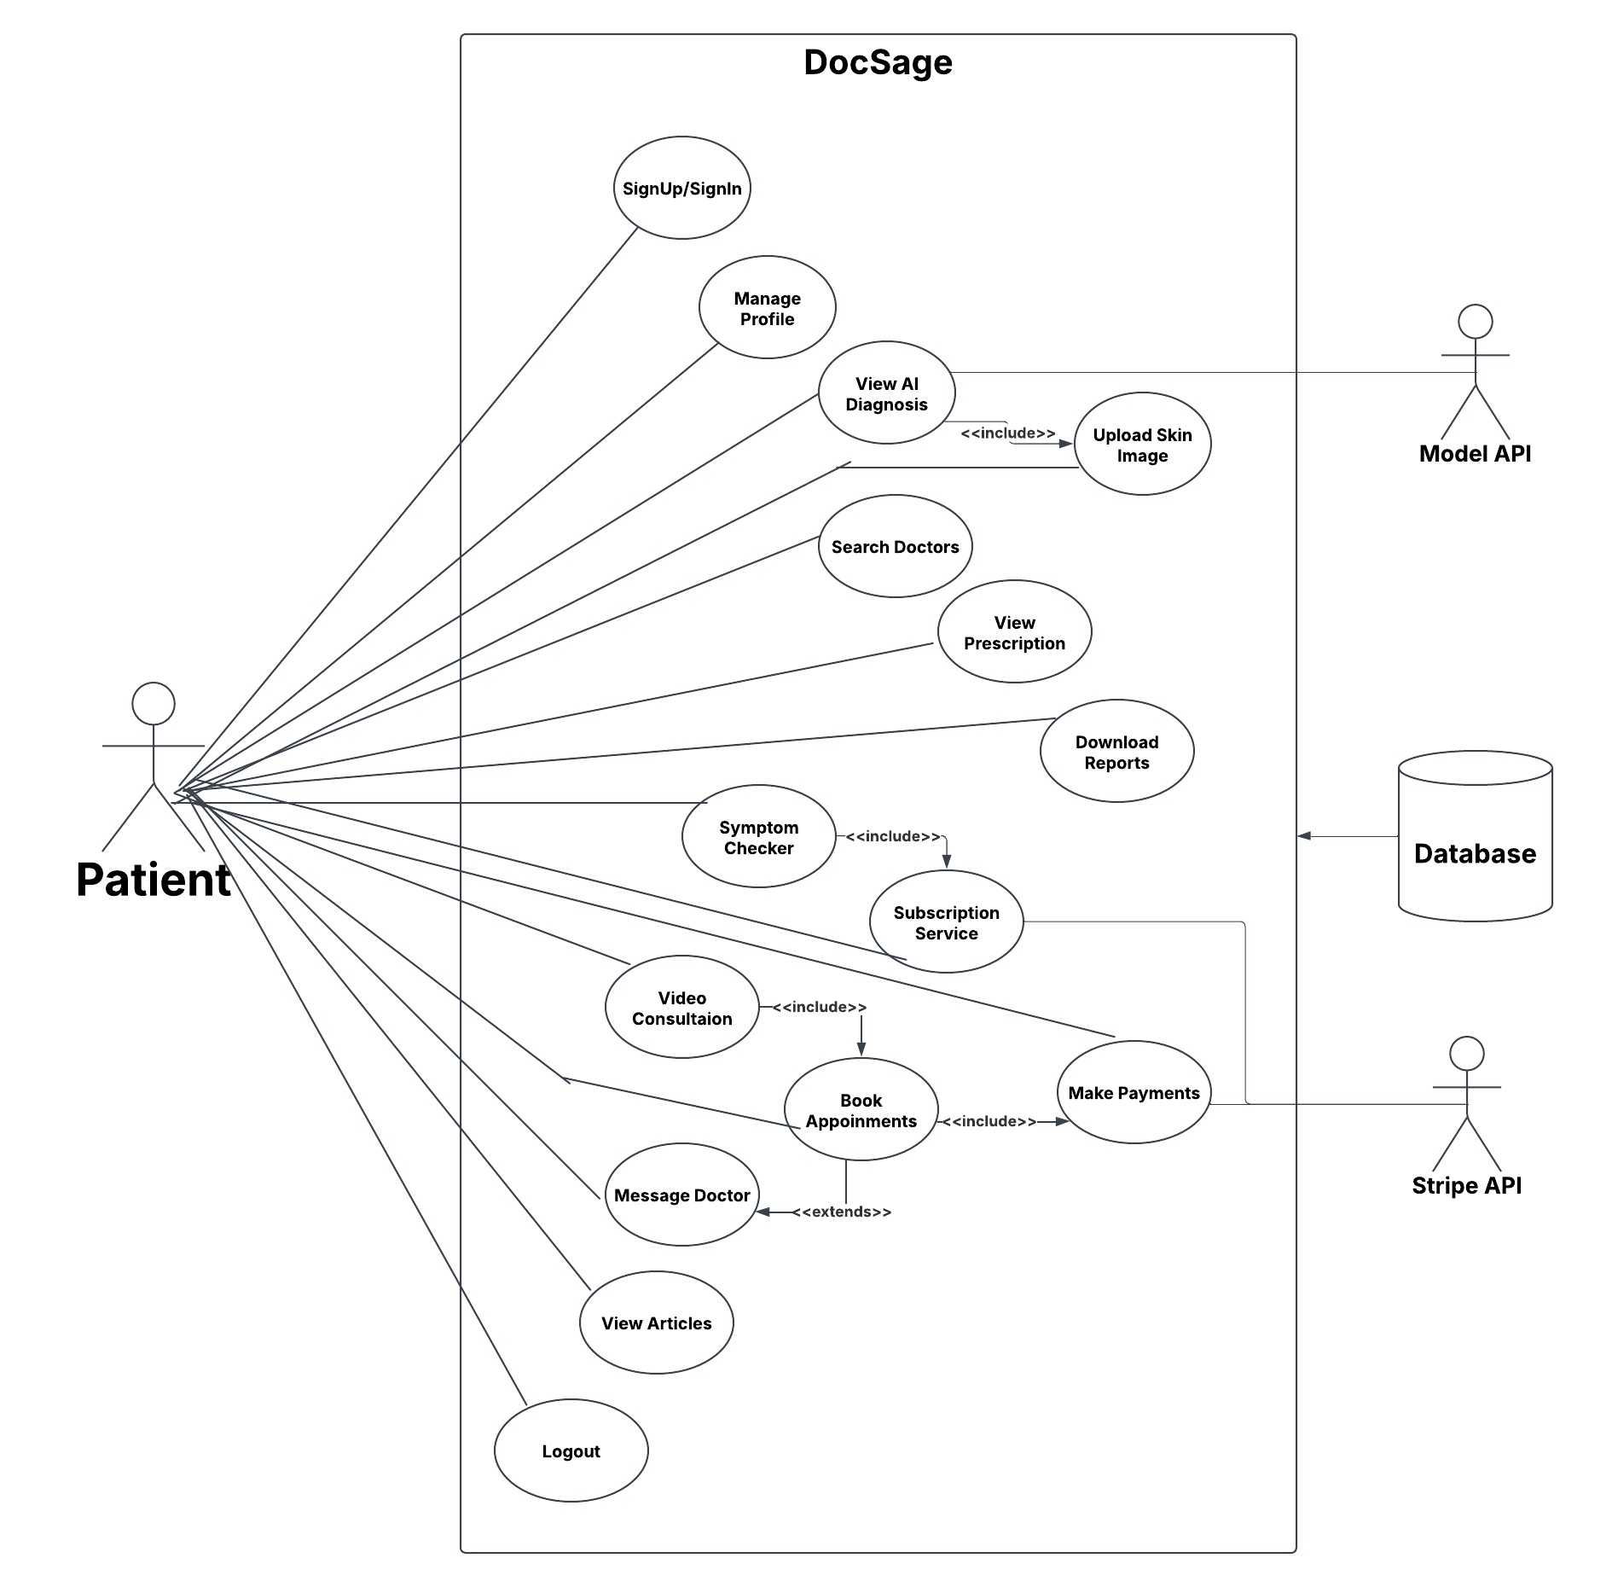

## **5.2 Use Case Description**

### **5.2.1 Stakeholder Admin**

|  |  |  |  |  |
| --- | --- | --- | --- | --- |
| **<Use case:** *Sign In* **>** | | | | |
| **Actors:**  Admin | | | | |
| **Feature:** *Sign In* | | | | |
| **Use case Id:** | | *1* | | |
| **Pre-condition:** | | Admin has valid credentials | | |
| **Scenarios** | | | | |
| **Step#** | **Action** | | | **Software Reaction** |
| **1.** | Admin accesses system login page | | | System displays login form |
| **2.** | Enters admin credentials | | | System validates credentials |
| **3.** |  | | | System grants admin access and redirects to dashboard |
| **Post Conditions:** | | | | |
| **Step#** | **Description** | | | |
| **1** | Admin is logged into system with administrative privileges | | | |
| **Use Case Cross referenced** | | | *Authentication* | |
| **User Interface reference** | | | Sign In Page | |

|  |  |  |  |  |
| --- | --- | --- | --- | --- |
| **<Use case:** Use Symptom Checker**>** | | | | |
| **Actors:**  Admin, Model API | | | | |
| **Feature:** Symptom Checker Access | | | | |
| **Use case Id:** | | *2* | | |
| **Pre-condition:** | | Admin is logged in and AI service is operational | | |
| **Scenarios** | | | | |
| **Step#** | **Action** | | | **Software Reaction** |
| **1.** | Admin accesses symptom checker | | | System displays symptom checker interface |
| **2.** | Admin inputs (image) symptoms | | | System processes through Model API |
| **3.** |  | | | System displays results and recommendations |
| **Post Conditions:** | | | | |
| **Step#** | **Description** | | | |
| **1** | Symptom check completed and results displayed with some recommendation | | | |
| **Use Case Cross referenced** | | |  | |
| **User Interface reference** | | | Symptom Checker Page | |

|  |  |  |  |  |
| --- | --- | --- | --- | --- |
| **<Use case:** Verify Doctors**>** | | | | |
| **Actors:**  Admin | | | | |
| **Feature:** Doctor Verification | | | | |
| **Use case Id:** | | *3* | | |
| **Pre-condition:** | | Doctor verification requests exist | | |
| **Scenarios** | | | | |
| **Step#** | **Action** | | | **Software Reaction** |
| **1.** | Admin accesses verification queue | | | System shows pending verifications |
| **2.** | Admin reviews: medical credentials, license validity, professional background | | | System displays verification details |
| **3.** | Admin can: approve/reject applications or request additional information | | | System updates verification status |
| **Post Conditions:** | | | | |
| **Step#** | **Description** | | | |
| **1** | Doctor verifications are processed | | | |
| **Use Case Cross referenced** | | |  | |
| **User Interface reference** | | | *Dashboard Page* | |

|  |  |  |  |  |
| --- | --- | --- | --- | --- |
| **<Use case:** View Pending Verification**>** | | | | |
| **Actors:**  Admin | | | | |
| **Feature:** Doctor Verification | | | | |
| **Use case Id:** | | *4* | | |
| **Pre-condition:** | | Doctor verification requests exist | | |
| **Scenarios** | | | | |
| **Step#** | **Action** | | | **Software Reaction** |
| **1.** | Admin accesses verification queue | | | System shows pending verifications |
| **Post Conditions:** | | | | |
| **Step#** | **Description** | | | |
| **1** |  | | | |
| **Use Case Cross referenced** | | |  | |
| **User Interface reference** | | | *Dashboard Page* | |

|  |  |  |  |  |
| --- | --- | --- | --- | --- |
| **<Use case:** Manage Own Profile**>** | | | | |
| **Actors:**  Admin | | | | |
| **Feature:** Profile Management | | | | |
| **Use case Id:** | | *5* | | |
| **Pre-condition:** | | Admin is logged in | | |
| **Scenarios** | | | | |
| **Step#** | **Action** | | | **Software Reaction** |
| **1.** | Admin accesses profile settings | | | System displays admin profile |
| **2.** | Admin updates profile information | | | System validates changes |
| **3.** |  | | | System saves updated profile |
| **Post Conditions:** | | | | |
| **Step#** | **Description** | | | |
| **1** | Admin profile is updated | | | |
| **Use Case Cross referenced** | | |  | |
| **User Interface reference** | | | Profile Page | |

|  |  |  |  |  |
| --- | --- | --- | --- | --- |
| **<Use case:** Manage Users **>** | | | | |
| **Actors:**  Admin | | | | |
| **Feature:** Manage Users | | | | |
| **Use case Id:** | | *6* | | |
| **Pre-condition:** | | Admin is logged in | | |
| **Scenarios** | | | | |
| **Step#** | **Action** | | | **Software Reaction** |
| **1.** | Admin accesses user management dashboard | | | System displays user categories: (Patients, Doctors) |
| **2.** | Admin can: (View user details, suspend accounts, Reset passwords) | | | System fulfils admin actions |
| **3.** | Admin can track new user registrations | | | System displays registration statistics |
| **Post Conditions:** | | | | |
| **Step#** | **Description** | | | |
| **1** | User management actions are completed and logged | | | |
| **Use Case Cross referenced** | | | Track New Registrations | |
| **User Interface reference** | | | Dashboard Page | |

|  |  |  |  |  |
| --- | --- | --- | --- | --- |
| **<Use case:** Track New Registration **>** | | | | |
| **Actors: Admin** | | | | |
| **Feature: Manage Users** | | | | |
| **Use case Id:** | | *7* | | |
| **Pre-condition:** | | Admin is logged in | | |
| **Scenarios** | | | | |
| **Step#** | **Action** | | | **Software Reaction** |
| **1.** | Admin accesses user management dashboard | | | System displays registration statistics |
| **Post Conditions:** | | | | |
| **Step#** | **Description** | | | |
| **1** | User management actions are completed and logged | | | |
| **Use Case Cross referenced** | | | Track New Registrations | |
| **User Interface reference** | | | Dashboard Page | |
|  | | |  | |
| **<Use case:** View Total Revenue**>** | | | | |
| **Actors:**  Admin | | | | |
| **Feature:** Revenue Management | | | | |
| **Use case Id:** | | *7* | | |
| **Pre-condition:** | | Financial transactions exist | | |
| **Scenarios** | | | | |
| **Step#** | **Action** | | | **Software Reaction** |
| **1.** | Admin visit dashboard | | | System shows revenue chart |
| **2.** | Admin views revenue metrics | | | System displays: revenue streams, subscription revenue |
| **Post Conditions:** | | | | |
| **Step#** | **Description** | | | |
| **1** | Revenue data is accessed | | | |
| **Use Case Cross referenced** | | |  | |
| **User Interface reference** | | | *Dashboard Page* | |

|  |  |  |  |  |
| --- | --- | --- | --- | --- |
| **<Use case:** Logout**>** | | | | |
| **Actors:**  Admin | | | | |
| **Feature:** System Logout | | | | |
| **Use case Id:** | | *9* | | |
| **Pre-condition:** | | Admin is logged in | | |
| **Scenarios** | | | | |
| **Step#** | **Action** | | | **Software Reaction** |
| **1.** | Admin clicks logout | | | System ends admin session |
| **3.** |  | | | System redirects to login page |
| **Post Conditions:** | | | | |
| **Step#** | **Description** | | | |
| **1** | Admin is logged out and session is terminated | | | |
| **Use Case Cross referenced** | | |  | |
| **User Interface reference** | | | All Pages | |

|  |  |  |  |  |
| --- | --- | --- | --- | --- |
| **<Use case:** View Articles**>** | | | | |
| **Actors:**  Admin | | | | |
| **Feature:** Health Information Access | | | | |
| **Use case Id:** | | *8* | | |
| **Pre-condition:** | | Articles are available in system | | |
| **Scenarios** | | | | |
| **Step#** | **Action** | | | **Software Reaction** |
| **1.** |  | | | System displays article list |
| **2.** | Admin selects article | | | System shows full content |
| **Post Conditions:** | | | | |
| **Step#** | **Description** | | | |
| **1** |  | | | |
| **Use Case Cross referenced** | | | View AI Diagnosis | |
| **User Interface reference** | | | *Articles Page* | |

### 5.2.2 Stakeholder Doctor

|  |  |  |  |  |
| --- | --- | --- | --- | --- |
| **<Use case:** Sign Up/Sign In **>** | | | | |
| **Actors:**  Doctor | | | | |
| **Feature:** Sign Up/Sign In | | | | |
| **Use case Id:** | | *1* | | |
| **Pre-condition:** | | Doctor has valid medical credentials and license | | |
| **Scenarios** | | | | |
| **Step#** | **Action** | | | **Software Reaction** |
| **1.** | Doctor enter valid medical credentials and license | | | System validates credentials |
| **2.** | For Sign Up:   * Enters personal and professional details * Uploads medical license and credentials * Creates account password * Submits for verification | | | System saves information and triggers admin verification process |
| **3.** | For Sign In:   * Enters registered email and password | | | System validates credentials and grants access based on verification status |
| **Post Conditions:** | | | | |
| **Step#** | **Description** | | | |
| **1** | Doctor successfully accesses the system with appropriate access level (full or restricted based on verification status) | | | |
| **Use Case Cross referenced** | | | *Authentication* | |
| **User Interface reference** | | | *Sign Up/Sign In Page* | |

|  |  |  |  |  |
| --- | --- | --- | --- | --- |
| **<Use case:** Await Approval**>** | | | | |
| **Actors:**  Doctor, Admin | | | | |
| **Feature:** Account Verification | | | | |
| **Use case Id:** | | *2* | | |
| **Pre-condition:** | | Doctor has completed sign-up and initial authentication | | |
| **Scenarios** | | | | |
| **Step#** | **Action** | | | **Software Reaction** |
| **1.** | System places doctor account in pending status | | | System displays restricted dashboard with pending approval message |
| **2.** | Admin reviews doctor's credentials: (PMDC number License documentation Degree certificates) | | | System flags account for admin review |
| **3.** | Admin approves or rejects account | | | System updates account status and sends notification to doctor |
| **Post Conditions:** Doctor profile is updated | | | | |
| **Step#** | **Description** | | | |
| **1** | Doctor account is either fully activated or remains restricted/rejected | | | |
| **Use Case Cross referenced** | | | Sign Up/Sign In | |
| **User Interface reference** | | | Dashboard (restricted view) | |

|  |  |  |  |  |
| --- | --- | --- | --- | --- |
| **<Use case:** Manage Profile **>** | | | | |
| **Actors:**  Doctor | | | | |
| **Feature:** Manage Profile | | | | |
| **Use case Id:** | | *3* | | |
| **Pre-condition:** | | Doctor is logged into the system | | |
| **Scenarios** | | | | |
| **Step#** | **Action** | | | **Software Reaction** |
| **1.** | Doctor accesses profile section | | | System displays current profile information |
| **2.** | Doctor can update:   * Professional qualifications * Specializations * Work experience * Profile picture * Contact information | | | System validates and saves changes |
| **3.** | Doctor updates symptoms and diseases handled | | | System updates the doctor's specialization data |
| **Post Conditions:** | | | | |
| **Step#** | **Description** | | | |
| **1** | Doctor profile is updated | | | |
| **Use Case Cross referenced** | | |  | |
| **User Interface reference** | | | *Dashboard Page* | |

|  |  |  |  |  |
| --- | --- | --- | --- | --- |
| **<Use case:** Set Availability **>** | | | | |
| **Actors:**  Doctor | | | | |
| **Feature:** Set Availability | | | | |
| **Use case Id:** | | *4* | | |
| **Pre-condition:** | | Doctor is verified and logged in | | |
| **Scenarios** | | | | |
| **Step#** | **Action** | | | **Software Reaction** |
| **1.** | Doctor accesses schedule management | | | System displays calendar view |
| **2.** | Doctor can:   * Set working hours * Mark vacation days * Define consultation duration | | | System updates availability time sots |
| **3.** | Doctor can set multiple schedules for different days | | | System stores all schedule variations |
| **Post Conditions:** | | | | |
| **Step#** | **Description** | | | |
| **1** | Doctor's availability schedule is set and visible to patients seeking appointments | | | |
| **Use Case Cross referenced** | | | Manage Appointments | |
| **User Interface reference** | | | *Dashboard Page* | |

|  |  |  |  |  |
| --- | --- | --- | --- | --- |
| **<Use case:** Manage Appointments **>** | | | | |
| **Actors:**  Doctor | | | | |
| **Feature:** Manage Appointments | | | | |
| **Use case Id:** | | *5* | | |
| **Pre-condition:** | | Doctor has existing appointments or scheduled appointments | | |
| **Scenarios** | | | | |
| **Step#** | **Action** | | | **Software Reaction** |
| **1.** |  | | | System shows appointment details |
| **2.** | Doctor can:   * Confirm appointments * Cancel appointments (with required reason) * View confirmed appointments | | | System updates appointment status |
| **3.** | For cancellations, doctor provides reason | | | System records cancellation reason and notifies patient |  |
| **Post Conditions:** | | | | |
| **Step#** | **Description** | | | |
| **1** | Appointments are updated as requested and patients are notified of status changes | | | |
| **Use Case Cross referenced** | | | Set Availability | |
| **User Interface reference** | | | *Dashboard Page* | |

|  |  |  |  |  |
| --- | --- | --- | --- | --- |
| **<Use case:** Message Patients**>** | | | | |
| **Actors:**  Doctor, Patient | | | | |
| **Feature:** Patient Communication | | | | |
| **Use case Id:** | | *6* | | |
| **Pre-condition:** | | Doctor has confirmed appointments with patients | | |
| **Scenarios** | | | | |
| **Step#** | **Action** | | | **Software Reaction** |
| **1.** | Doctor accesses messaging interface | | | System displays list of patients with active appointments |
| **2.** | Doctor selects patient to message | | | System opens messaging thread with selected patient |
| **3.** | Doctor composes and sends message | | | System delivers message to patient and stores in conversation history |
| **4.** | Doctor receives and responds to patient messages | | | System updates conversation in real-time |
| **Post Conditions:** | | | | |
| **Step#** | **Description** | | | |
| **1** | Doctor and patient can communicate until the appointment day | | | |
| **Use Case Cross referenced** | | | Manage Appointments | |
| **User Interface reference** | | | *Chat Page* | |

|  |  |  |  |  |
| --- | --- | --- | --- | --- |
| **<Use case:** Conduct Video Consultations **>** | | | | |
| **Actors:**  Doctor, Patient | | | | |
| **Feature:** Conduct Video Consultations | | | | |
| **Use case Id:** | | *7* | | |
| **Pre-condition:** | | Scheduled video appointment exists and appointment time has arrived | | |
| **Scenarios** | | | | |
| **Step#** | **Action** | | | **Software Reaction** |
| **1.** | Doctor enters virtual consultation room at scheduled time | | | System initiates video call connection |
| **2.** | Doctor and patient establish connection | | | System enables audio/video transmission |
| **3.** | Doctor conducts consultation | | | System maintains connection and records consultation duration |
| **4.** | Doctor ends consultation | | | System updates appointment status to "completed" and get payment automatically (deduct 100 rs for platform services). |
| **Post Conditions:** | | | | |
| **Step#** | **Description** | | | |
| **1** | Consultation is completed and documented in the system | | | |
| **Use Case Cross referenced** | | | Manage Appointments | |
| **User Interface reference** | | | *Chat Page* | |

|  |  |  |  |  |
| --- | --- | --- | --- | --- |
| **<Use case:** Access Patient Records **>** | | | | |
| **Actors:**  Doctor | | | | |
| **Feature:** Access Patient Records | | | | |
| **Use case Id:** | | *8* | | |
| **Pre-condition:** | | Doctor has patients with active appointments or past consultations | | |
| **Scenarios** | | | | |
| **Step#** | **Action** | | | **Software Reaction** |
| **1.** | Doctor searches for specific patient | | | System displays patient list |
| **2.** | Doctor selects patient | | | System shows the record |
| **Post Conditions:** | | | | |
| **Step#** | **Description** | | | |
| **1** | Doctor can view comprehensive patient records to inform treatment decisions | | | |
| **Use Case Cross referenced** | | |  | |
| **User Interface reference** | | | *Dashboard Page* | |

|  |  |  |  |  |
| --- | --- | --- | --- | --- |
| **<Use case:** Issue Prescriptions **>** | | | | |
| **Actors:**  Doctor | | | | |
| **Feature:** Issue Prescriptions | | | | |
| **Use case Id:** | | *9* | | |
| **Pre-condition:** | | Doctor has completed consultation with patient | | |
| **Scenarios** | | | | |
| **Step#** | **Action** | | | **Software Reaction** |
| **1.** | Doctor accesses prescription module | | | System displays prescription template linked to patient and consultation |
| **2.** | Doctor enters:   * Medications * Dosage instructions * Duration * Special instructions | | | System validates prescription |
| **3.** | Doctor digitally signs prescription | | | System saves prescription to database and makes it available to patient |
| **Post Conditions:** Prescription is issued to patient | | | | |
| **Step#** | **Description** | | | |
| **1** | Prescription is issued to patient and stored in the system | | | |
| **Use Case Cross referenced** | | |  | |
| **User Interface reference** | | | Prescription Page | |

|  |  |  |  |  |
| --- | --- | --- | --- | --- |
| **<Use case:** Use AI Symptom Checker **>** | | | | |
| **Actors:**  Doctor | | | | |
| **Feature:** Use AI Symptom Checker | | | | |
| **Use case Id:** | | *10* | | |
| **Pre-condition:** | | Doctor has active subscription to symptom checker service | | |
| **Scenarios** | | | | |
| **Step#** | **Action** | | | **Software Reaction** |
| **1.** | Doctor accesses AI symptom checker tool | | | System displays upload interface |
| **2.** | Doctor uploads skin image for analysis | | | System sends image to AI model API |
| **3.** | System processes image | | | AI model returns diagnosis classification (0-23) with corresponding skin condition |
| **4.** | Doctor reviews AI diagnostic suggestion | | | System displays results with doctor recommendation and related article. |
| **Post Conditions:** | | | | |
| **Step#** | **Description** | | | |
| **1** | Doctor receives AI-assisted diagnosis support to complement clinical judgment | | | |
| **2** |  | | | |
| **3** |  | | | |
| **Use Case Cross referenced** | | | *Get Subscription* | |
| **User Interface reference** | | | *Symptom Checker Page* | |
| **<Use case:** Get Subscription**>** | | | | |
| **Actors:**  Doctor | | | | |
| **Feature:** Subscribe to AI Service | | | | |
| **Use case Id:** | | *11* | | |
| **Pre-condition:** | | Doctor is logged in with verified account | | |
| **Scenarios** | | | | |
| **Step#** | **Action** | | | **Software Reaction** |
| **1.** | Doctor accesses subscription page | | | System displays available AI service plans |
| **2.** | Doctor selects desired subscription plan | | | System processes payment through Stripe |
| **3.** | Doctor enters payment information | | | System processes payment through Stripe |
| **4.** | Payment confirmed | | | System activates symptom checker features for doctor's account |
| **Post Conditions:** Payment information is updated | | | | |
| **Step#** | **Description** | | | |
| **1** | Doctor has active AI service | | | |
| **2** |  | | | |
| **3** |  | | | |
| **Use Case Cross referenced** | | | Use Symptom Checker | |
| **User Interface reference** | | | Subscription Page | |

|  |  |  |  |  |
| --- | --- | --- | --- | --- |
| **<Use case:** Manage Payments **>** | | | | |
| **Actors:**  Doctor | | | | |
| **Feature:** Manage Payments | | | | |
| **Use case Id:** | | *12* | | |
| **Pre-condition:** | | Doctor has payment activity | | |
| **Scenarios** | | | | |
| **Step#** | **Action** | | | **Software Reaction** |
| **1.** | Doctor accesses payment section | | | System shows:   * Earnings overview * Payment history |
| **2.** | Doctor can:   * Set consultation fees * View transaction details | | | System processes payment updates and integrates with Stripe API() |
| **Post Conditions:** | | | | |
| **Step#** | **Description** | | | |
| **1** | Doctor can view financial transactions | | | |
| **Use Case Cross referenced** | | |  | |
| **User Interface reference** | | | *Dashboard Page* | |

|  |  |  |  |  |
| --- | --- | --- | --- | --- |
| **<Use case:** View Articles**>** | | | | |
| **Actors:**  Doctor | | | | |
| **Feature:** Health Information Access | | | | |
| **Use case Id:** | | *13* | | |
| **Pre-condition:** | | Articles are available in system | | |
| **Scenarios** | | | | |
| **Step#** | **Action** | | | **Software Reaction** |
| **1.** |  | | | System displays article list |
| **2.** | Doctor selects article | | | System shows full content |
| **Post Conditions:** | | | | |
| **Step#** | **Description** | | | |
| **1** |  | | | |
| **Use Case Cross referenced** | | | View AI Diagnosis | |
| **User Interface reference** | | | *Articles Page* | |

|  |  |  |  |  |
| --- | --- | --- | --- | --- |
| **<Use case:** Logout**>** | | | | |
| **Actors:**  Doctor | | | | |
| **Feature:** System Logout | | | | |
| **Use case Id:** | | *14* | | |
| **Pre-condition:** | | Doctor is logged in | | |
| **Scenarios** | | | | |
| **Step#** | **Action** | | | **Software Reaction** |
| **1.** | Doctor selects logout option | | | System terminates active session |
| **2.** |  | | | System redirects to login page |
| **Post Conditions:** Medical profile is updated and verified | | | | |
| **Step#** | **Description** | | | |
| **1** | Doctor is securely logged out of the system | | | |
| **Use Case Cross referenced** | | | Sign Up/Sign In | |
| **User Interface reference** | | | All Pages | |

### **5.2.3 Stakeholder Patient**

|  |  |  |  |  |
| --- | --- | --- | --- | --- |
| **<Use case:** Sign Up/Sign In **>** | | | | |
| **Actors:**  Patient | | | | |
| **Feature:** Sign Up/Sign In | | | | |
| **Use case Id:** | | *1* | | |
| **Pre-condition:** | | User has access to the DocSage platform, valid email address and has a secure internet connection | | |
| **Scenarios** | | | | |
| **Step#** | **Action** | | | **Software Reaction** |
| **1** | Patient clicks Sign Up/Sign In button | | | System displays registration/login options |
| **2** | Patient selects email registration | | | System validates email and sends OTP |
| **3** | Patient creates password | | | System validates password strength |
| **4** | Patient enters OTP | | | System verifies OTP within timeout |
| **5** | Patient enters credentials | | | System validates and grants access |
| **Alternative Flows:**  **1a:** Google Authentication path  **2a:** Failed Authentication handling | | | | |
| **Post Conditions:** | | | | |
| **Step#** | **Description** | | | |
| **1** | Patient is logged into the system and session token generated | | | |
| **Use Case Cross referenced** | | | Manage Profile | |
| **User Interface reference** | | | *Signup/SignIn Page,* OTP verification interface | |

|  |  |  |  |  |
| --- | --- | --- | --- | --- |
| **<Use case:** Manage Profile **>** | | | | |
| **Actors:**  Patient | | | | |
| **Feature:** Manage Profile | | | | |
| **Use case Id:** | | *2* | | |
| **Pre-condition:** | | User is authenticated and Initial onboarding completed | | |
| **Scenarios** | | | | |
| **Step#** | **Action** | | | **Software Reaction** |
| **1.** | Patient selects role | | | System displays profile setup form |
| **2.** | Patient enters basic information | | | System validates and saves information |
| **3.** | Patient enters medical information | | | System stores medical details |
| **4.** | Patient configures security settings | | | System applies security preferences |
| **Alternate Scenarios:**  **1a:** Profile update flow  **2a:** Security management flow | | | | |
| **Post Conditions:** | | | | |
| **Step#** | **Description** | | | |
| **1** | Profile updated in system | | | |
| **2** | Security settings applied | | | |
| **3** | Audit log updated | | | |
| **Use Case Cross referenced** | | | Sign Up/Sign In | |
| **User Interface reference** | | | *Dashboard Page* | |

|  |  |  |  |  |
| --- | --- | --- | --- | --- |
| **<Use case:** Subscription Service**>** | | | | |
| **Actors:**  Patient | | | | |
| **Feature:** AI Service Subscription | | | | |
| **Use case Id:** | | *3* | | |
| **Pre-condition:** | | Patient is logged in and profile is complete | | |
| **Scenarios** | | | | |
| **Step#** | **Action** | | | **Software Reaction** |
| **1.** | Patient accesses subscription page | | | System displays available plans |
| **2.** | Patient selects desired plan | | | System shows payment interface |
| **3.** | Patient chooses payment method | | | System processes payment |
| **4.** |  | | | System activates AI service features |
| **Alternate Scenarios:**  **1a:** Plan upgrade/downgrade flow  **2a:** Subscription renewal process  **3a:** Cancellation workflow | | | | |
| **Post Conditions:** Patient has active AI service subscription | | | | |
| **Step#** | **Description** | | | |
| **1** | Active subscription status | | | |
| **2** | Access to AI features enabled | | | |
| **3** | Payment recorded | | | |
| **Use Case Cross referenced** | | | Upload Skin Image, View AI Diagnosis | |
| **User Interface reference** | | | *Dashboard Page,* Subscription plans page, Payment interface | |

|  |  |  |  |  |
| --- | --- | --- | --- | --- |
| **<Use case:** Upload Skin Image**>** | | | | |
| **Actors:**  Patient | | | | |
| **Feature:** Image Upload for AI Analysis | | | | |
| **Use case Id:** | | *4* | | |
| **Pre-condition:** | | Patient has active AI service subscription | | |
| **Scenarios** | | | | |
| **Step#** | **Action** | | | **Software Reaction** |
| **1.** | Patient selects "Upload Images" option | | | System displays image guidelines |
| **2.** | Patient select skin image | | | System validates image |
| **3.** | Patient confirms upload | | | System confirms successful upload |
| **Alternate Scenarios:**  **1a:** Image validation failure handling | | | | |
| **Post Conditions:** | | | | |
| **Step#** | **Description** | | | |
| **1** | Image stored securely | | | |
| **2** | Ready for AI analysis | | | |
| **3** | Usage count updated | | | |
| **Use Case Cross referenced** | | | View AI Diagnosis | |
| **User Interface reference** | | | *Symptom Checker* | |

|  |  |  |  |  |
| --- | --- | --- | --- | --- |
| **<Use case:** View AI Diagnosis **>** | | | | |
| **Actors:**  Patient | | | | |
| **Feature:** AI Diagnosis Review | | | | |
| **Use case Id:** | | *5* | | |
| **Pre-condition:** | | Valid image uploaded  AI analysis complete | | |
| **Scenarios** | | | | |
| **Step#** | **Action** | | | **Software Reaction** |
| **1.** | Patient accesses diagnosis section | | | System processes images through AI |
| **2.** |  | | | System displays:   * Preliminary diagnosis * Recommended actions |
| **3.** | Patient can review detailed analysis | | | System offers option to share with doctors. |
| **Post Conditions:** | | | | |
| **Step#** | **Description** | | | |
| **1** | Diagnosis recorded | | | |
| **2** | Reports generated | | | |
| **3** | Recommendations provided | | | |
| **Use Case Cross referenced** | | | Upload Skin Image, Search Doctors | |
| **User Interface reference** | | | *Symptom Checker Page* | |

|  |  |  |  |  |
| --- | --- | --- | --- | --- |
| **<Use case:** Search Doctors**>** | | | | |
| **Actors:**  Patient | | | | |
| **Feature:** Doctor Search | | | | |
| **Use case Id:** | | *6* | | |
| **Pre-condition:** | | Location services enabled | | |
| **Scenarios** | | | | |
| **Step#** | **Action** | | | **Software Reaction** |
| **1.** | Patient enables location | | | System detects location |
| **2.** |  | | | System applies filters |
| **3.** | Patient views results | | | System displays matched doctors |
| **Post Conditions:** | | | | |
| **Step#** | **Description** | | | |
| **1** | Search results displayed | | | |
| **2** | Filters applied | | | |
| **3** | Ready for booking | | | |
| **Use Case Cross referenced** | | | View AI Diagnosis | |
| **User Interface reference** | | | *Find Doctors* | |

|  |  |  |  |  |
| --- | --- | --- | --- | --- |
| **<Use case:** Book Appointments **>** | | | | |
| **Actors:**  Patient | | | | |
| **Feature:** Appointment Booking | | | | |
| **Use case Id:** | | *7* | | |
| **Pre-condition:** | | Doctor selected & location verified | | |
| **Scenarios** | | | | |
| **Step#** | **Action** | | | **Software Reaction** |
| **1.** | Patient views available slots | | | System displays doctor's schedule |
| **2.** | Patient selects preferred time | | | System reserves slot temporarily |
| **3.** | Patient confirms payment | | | System processes consultation fee |
| **Post Conditions:** | | | | |
| **Step#** | **Description** | | | |
| **1** | Appointment confirmed | | | |
| **2** | Payment processed | | | |
| **Use Case Cross referenced** | | | *Make Payment,* Search Doctors | |
| **User Interface reference** | | | *Find Doctors* | |

|  |  |  |  |  |
| --- | --- | --- | --- | --- |
| **<Use case:** Video Consultation **>** | | | | |
| **Actors:**  Patient, Doctor | | | | |
| **Feature:** Virtual Consultation | | | | |
| **Use case Id:** | | *8* | | |
| **Pre-condition:** | | Patient has scheduled video appointment | | |
| **Scenarios** | | | | |
| **Step#** | **Action** | | | **Software Reaction** |
| **1.** | Patient joins virtual waiting room | | | System connects patient with doctor |
| **2.** | Patient participates in consultation | | |  |
| **Post Conditions:** Video consultation is completed | | | | |
| **Step#** | **Description** | | | |
| **1** | Consultation completed | | | |
| **2** | Records updated | | | |
| **3** | Prescriptions generated | | | |
| **Use Case Cross referenced** | | | View Prescriptions | |
| **User Interface reference** | | | *Chat Page* | |

|  |  |  |  |  |
| --- | --- | --- | --- | --- |
| **<Use case:** View Prescriptions **>** | | | | |
| **Actors:**  Patient | | | | |
| **Feature:** Prescription Management | | | | |
| **Use case Id:** | | *9* | | |
| **Pre-condition:** | | Patient has completed consultation & prescription issued | | |
| **Scenarios** | | | | |
| **Step#** | **Action** | | | **Software Reaction** |
| **1.** | Patient accesses prescription section | | | System displays list of prescriptions |
| **2.** | Patient selects specific prescription | | | System shows:   * Medication details * Dosage instructions |
| **3.** | Patient can download prescription | | |  |
| **Post Conditions:** | | | | |
| **Step#** | **Description** | | | |
| **1** | Patient can access prescription details | | | |
| **Use Case Cross referenced** | | | Video Consultation | |
| **User Interface reference** | | | *Chat* | |

|  |  |  |  |  |
| --- | --- | --- | --- | --- |
| **<Use case:** Download Reports **>** | | | | |
| **Actors:**  Patient | | | | |
| **Feature:** Report Management | | | | |
| **Use case Id:** | | *10* | | |
| **Pre-condition:** | | Reports generated | | |
| **Scenarios** | | | | |
| **Step#** | **Action** | | | **Software Reaction** |
| **1.** | Patient selects desired report | | | System generates downloadable format |
| **3.** | Patient downloads report | | |  |
| **Post Conditions:** | | | | |
| **Step#** | **Description** | | | |
| **1** | Patient has access to medical reports | | | |
| **Use Case Cross referenced** | | | View AI Diagnosis, Video Consultation | |
| **User Interface reference** | | | *Report Page* | |

|  |  |  |  |  |
| --- | --- | --- | --- | --- |
| **<Use case:** Make Payment**>** | | | | |
| **Actors:**  Patient | | | | |
| **Feature:** Payment Processing | | | | |
| **Use case Id:** | | *11* | | |
| **Pre-condition:** | | Service selected | | |
| **Scenarios** | | | | |
| **Step#** | **Action** | | | **Software Reaction** |
| **1.** | Patient accesses payment section | | | System displays payment details |
| **2.** | Patient enters payment information | | | System processes payment |
| **Alternate Scenarios:**  **1a:** Failed payment handling  **2a:** Refund process | | | | |
| **Post Conditions:** | | | | |
| **Step#** | **Description** | | | |
| **1** | Payment is completed and recorded | | | |
| **2** | Service activated | | | |
| **Use Case Cross referenced** | | | *Subscription Model Service, Book Appointments* | |
| **User Interface reference** | | | *Pricing Page* | |

|  |  |  |  |  |
| --- | --- | --- | --- | --- |
| **<Use case:** Message Doctor**>** | | | | |
| **Actors:**  Patient, Doctor | | | | |
| **Feature:** Communication | | | | |
| **Use case Id:** | | *12* | | |
| **Pre-condition:** | | Patient is authenticated, has previous consultation or active appointment. | | |
| **Scenarios** | | | | |
| **Step#** | **Action** | | | **Software Reaction** |
| **1.** | Patient selects doctor | | | System displays messaging interface |
| **2.** | Patient composes message | | | System validates content |
| **3.** | Patient sends message | | | System delivers and confirms |
|  |  | | |  |
| **Alternate Scenarios:**  **1a:** Offline doctor scenario | | | | |
| **Post Conditions:** | | | | |
| **Step#** | **Description** | | | |
| **1** | Message delivered to doctor | | | |
| **Use Case Cross referenced** | | | View Prescriptions,Video Consultation | |
| **User Interface reference** | | | *Pricing Page* | |

|  |  |  |  |  |
| --- | --- | --- | --- | --- |
| **<Use case:** Logout**>** | | | | |
| **Actors:**  Patient | | | | |
| **Feature:** Session Management | | | | |
| **Use case Id:** | | *14* | | |
| **Pre-condition:** | | User is currently logged in | | |
| **Scenarios** | | | | |
| **Step#** | **Action** | | | **Software Reaction** |
| **1.** | Patient initiates logout | | | System prompts confirmation |
| **2.** | Patient confirms logout | | | System terminates session |
| **3.** | Patient exits system | | |  |
| **Post Conditions:** | | | | |
| **Step#** | **Description** | | | |
| **1** | User session terminated | | | |
| **2** | Login required for next access | | | |
| **Use Case Cross referenced** | | | Sign Up/Sign In | |
| **User Interface reference** | | | *Dashboard Page* | |

|  |  |  |  |  |
| --- | --- | --- | --- | --- |
| **<Use case:** View Articles**>** | | | | |
| **Actors:**  Patient | | | | |
| **Feature:** Health Information Access | | | | |
| **Use case Id:** | | *8* | | |
| **Pre-condition:** | | Articles are available in system | | |
| **Scenarios** | | | | |
| **Step#** | **Action** | | | **Software Reaction** |
| **1.** |  | | | System displays article list |
| **2.** | Patient selects article | | | System shows full content |
| **Post Conditions:** | | | | |
| **Step#** | **Description** | | | |
| **1** |  | | | |
| **Use Case Cross referenced** | | | View AI Diagnosis | |
| **User Interface reference** | | | *Articles Page* | |

# **6. UI Design**

## **6.1 Mock-up’s**

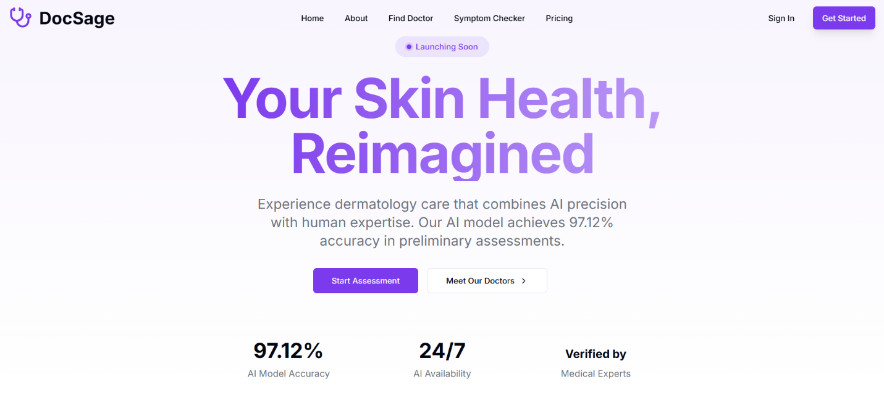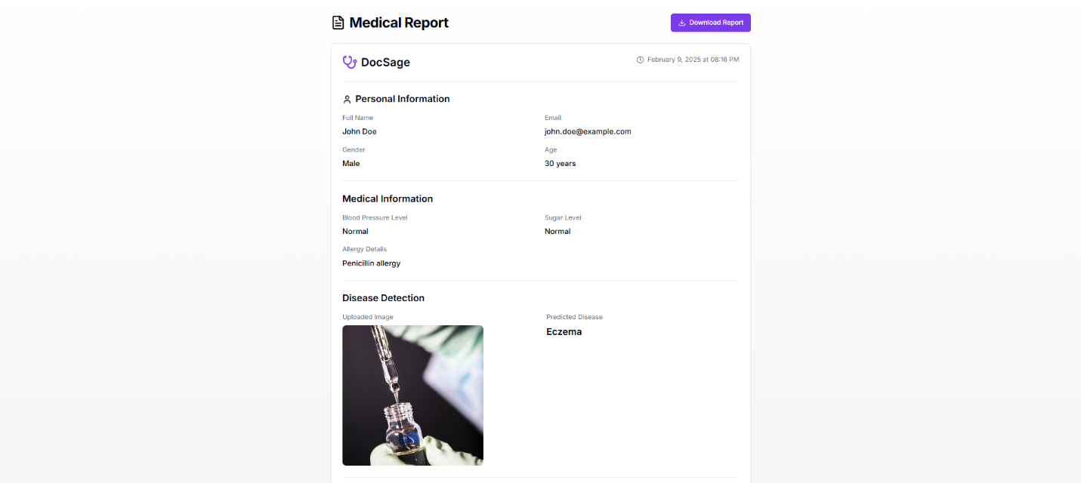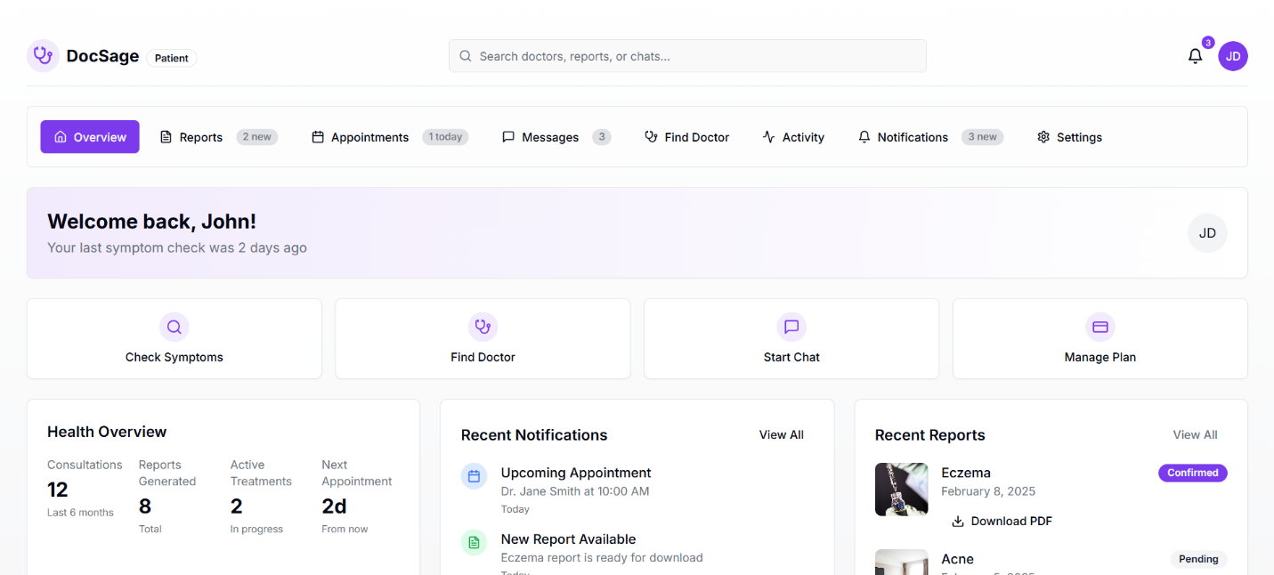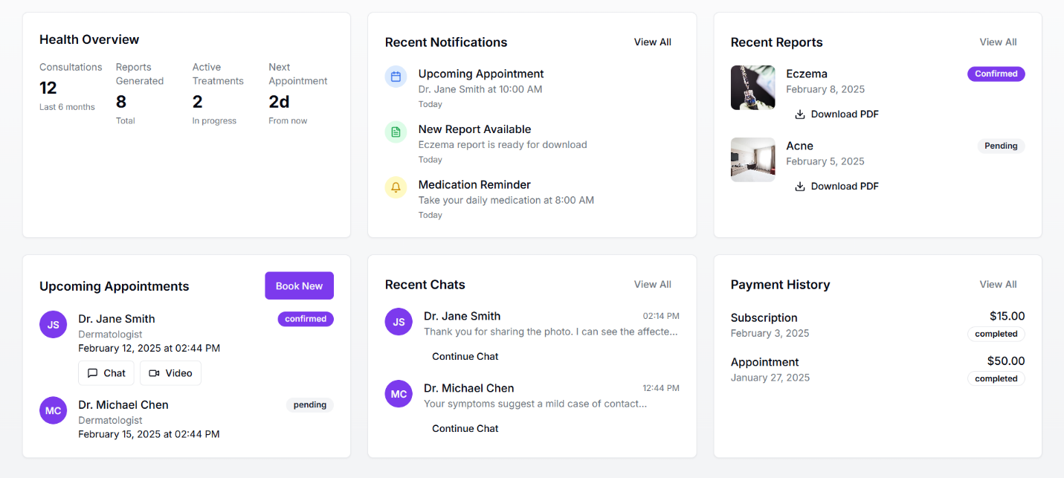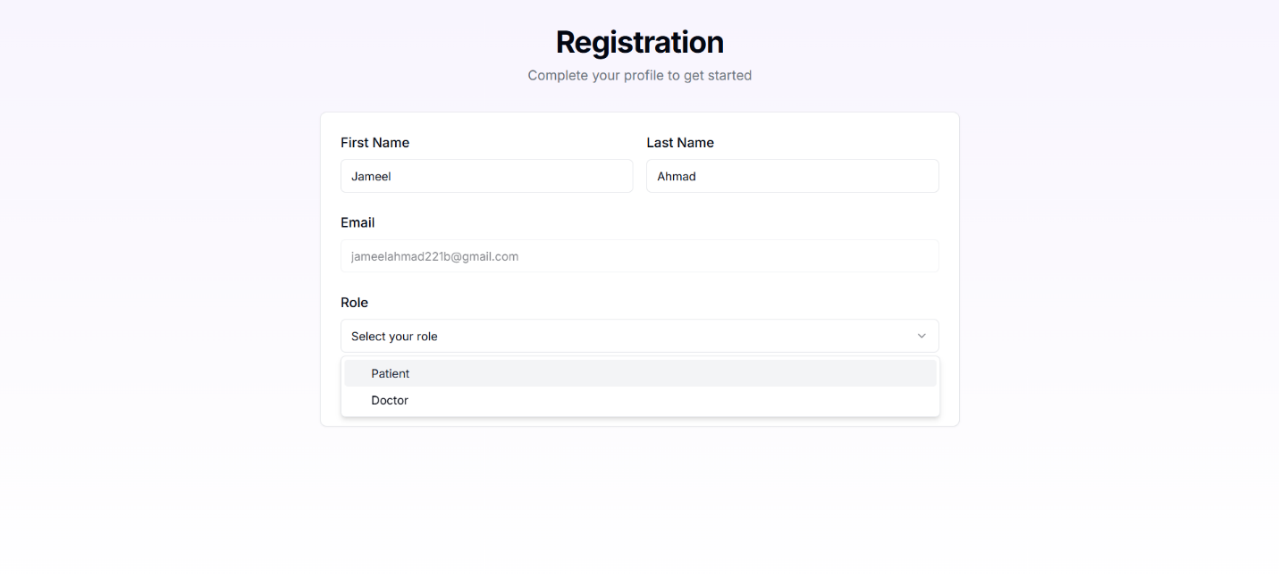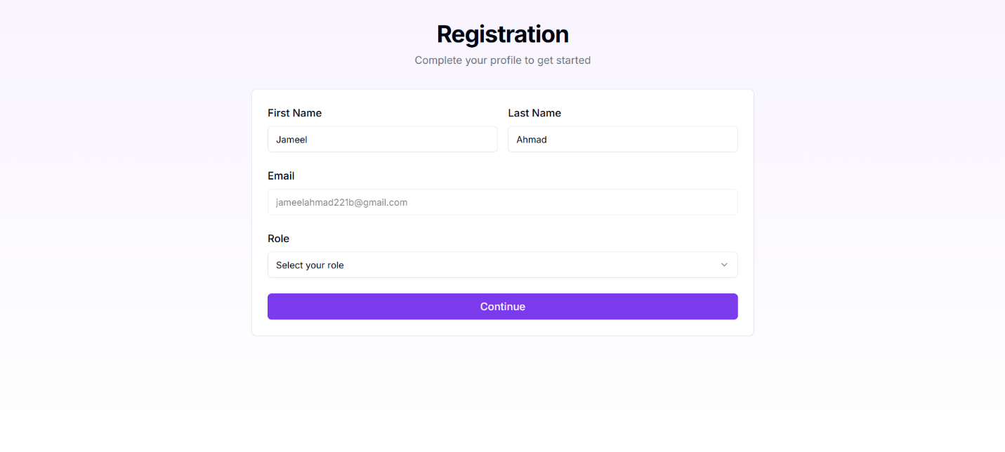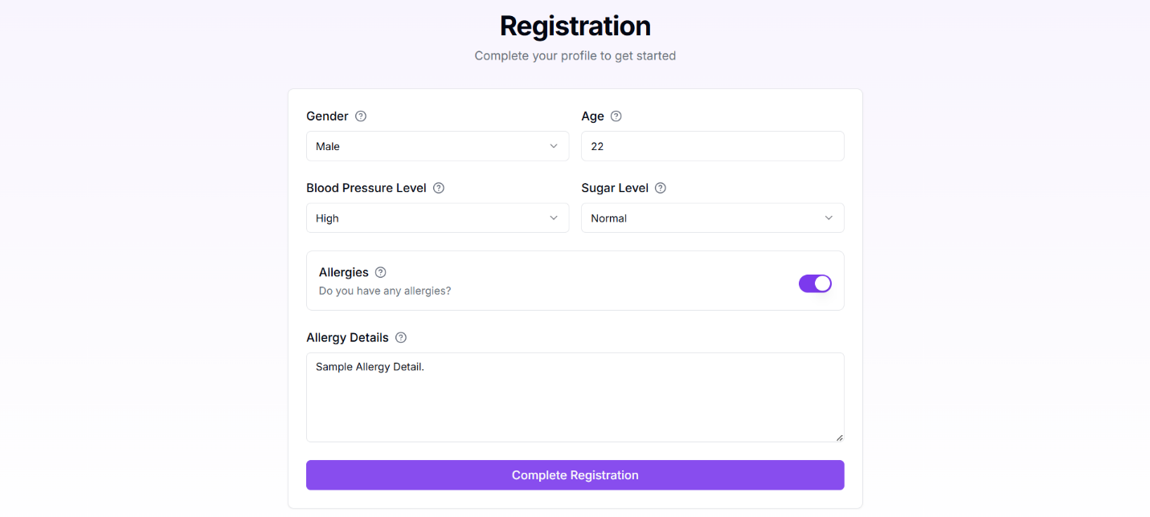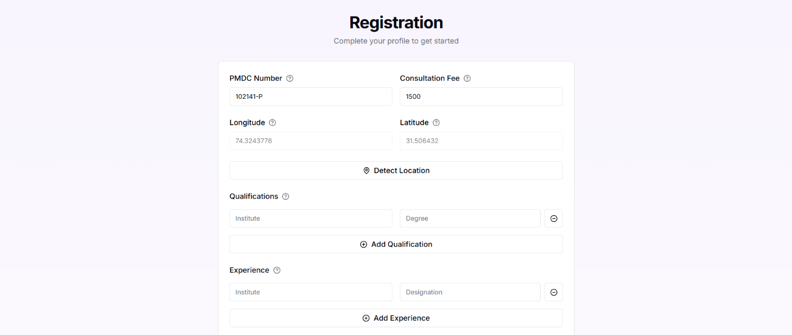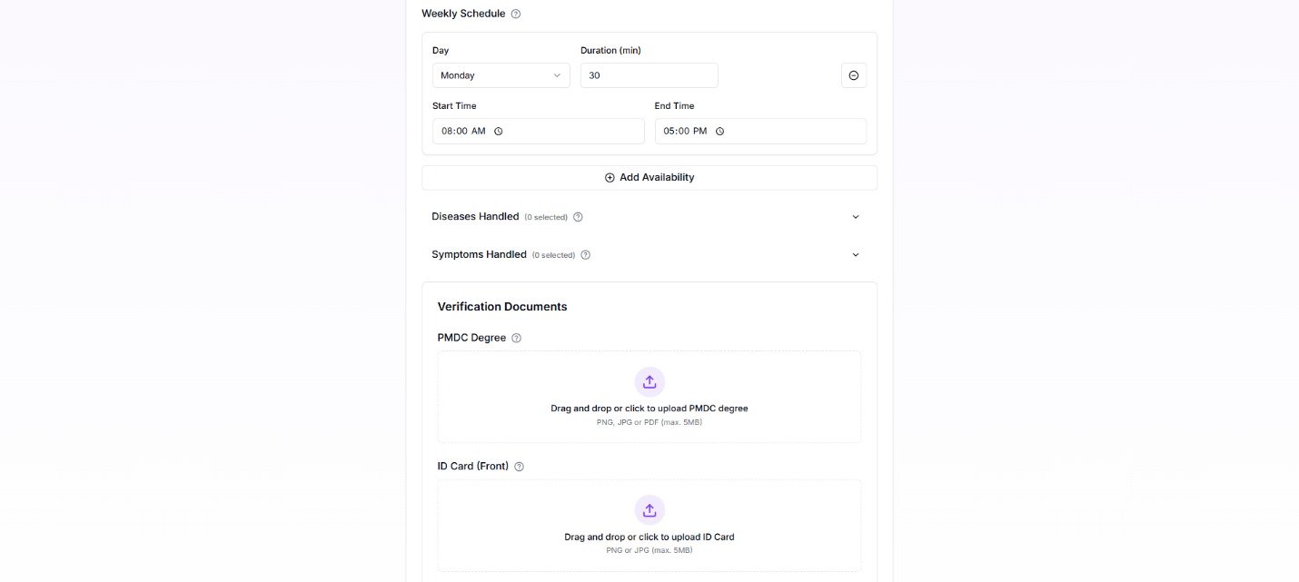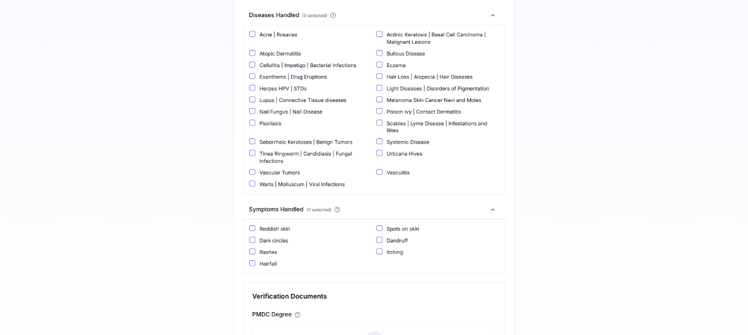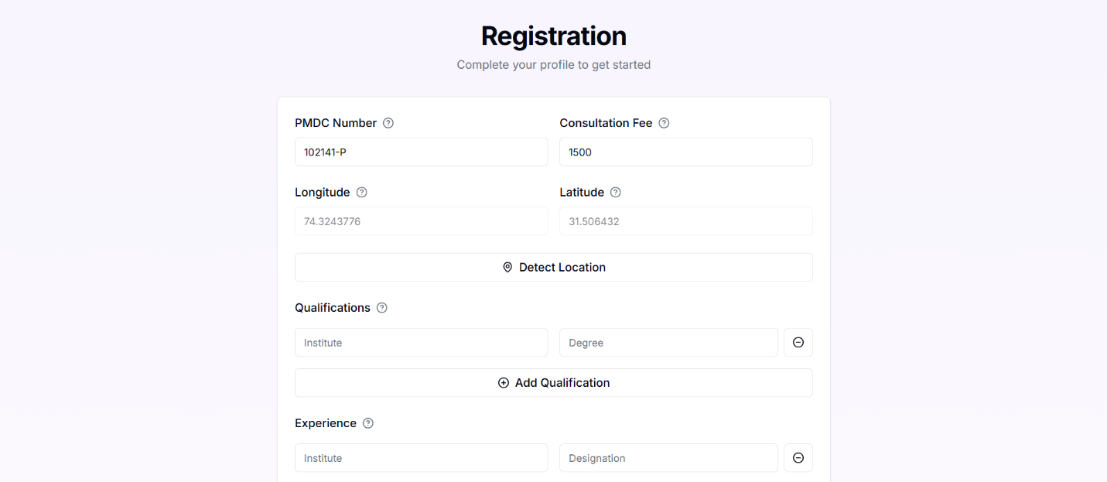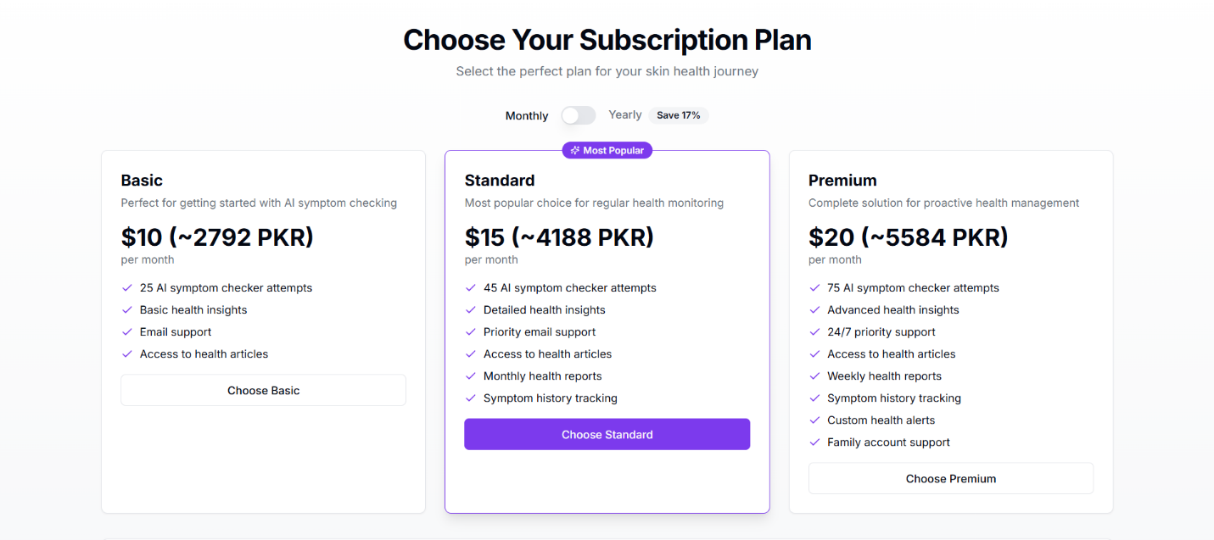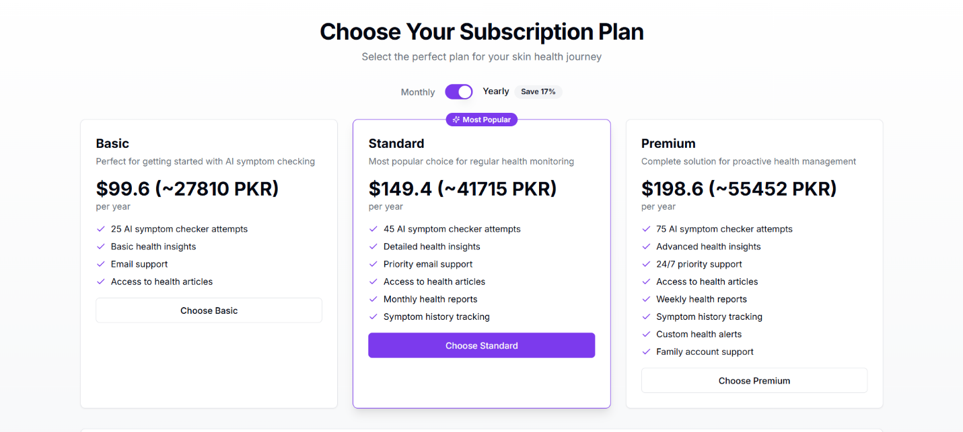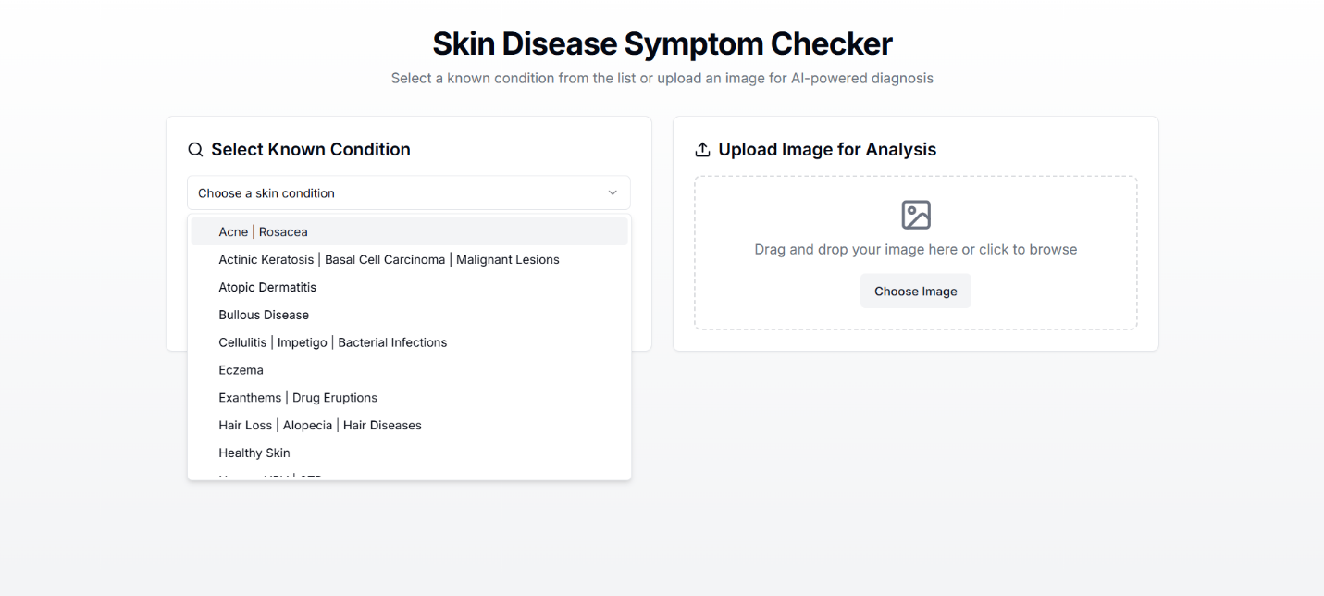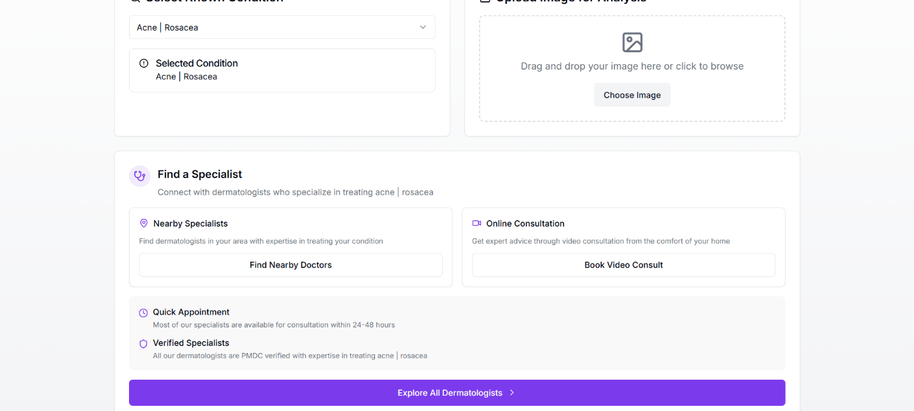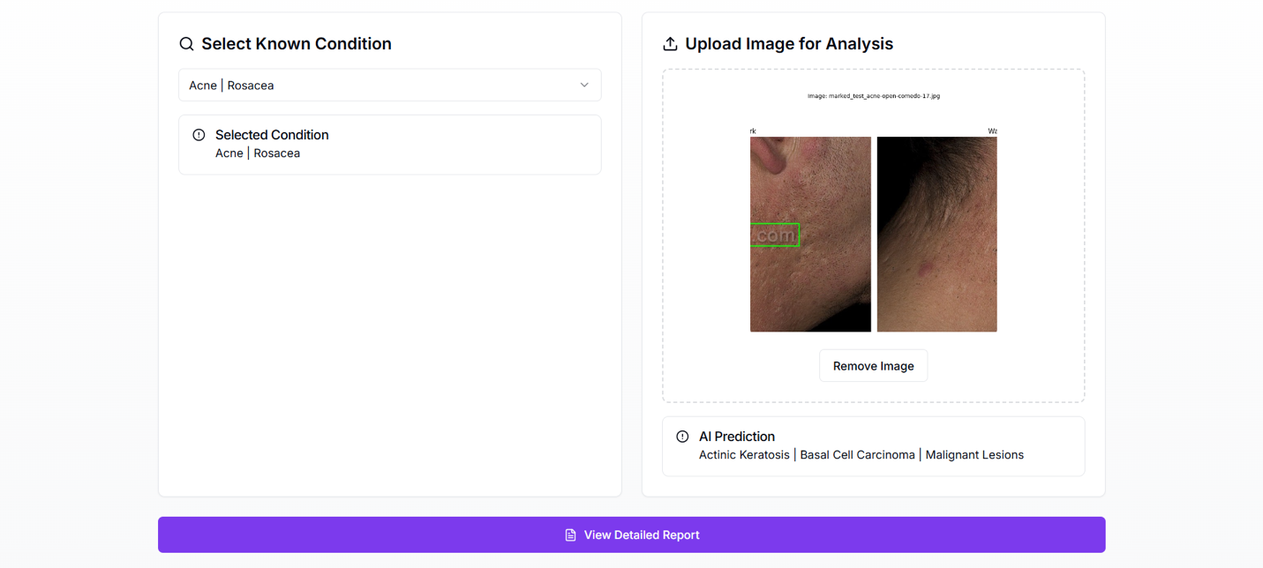

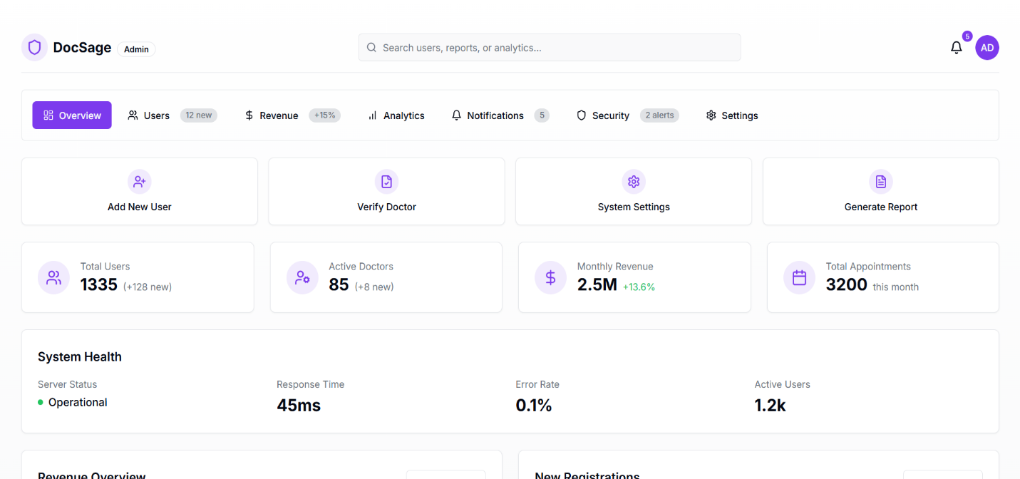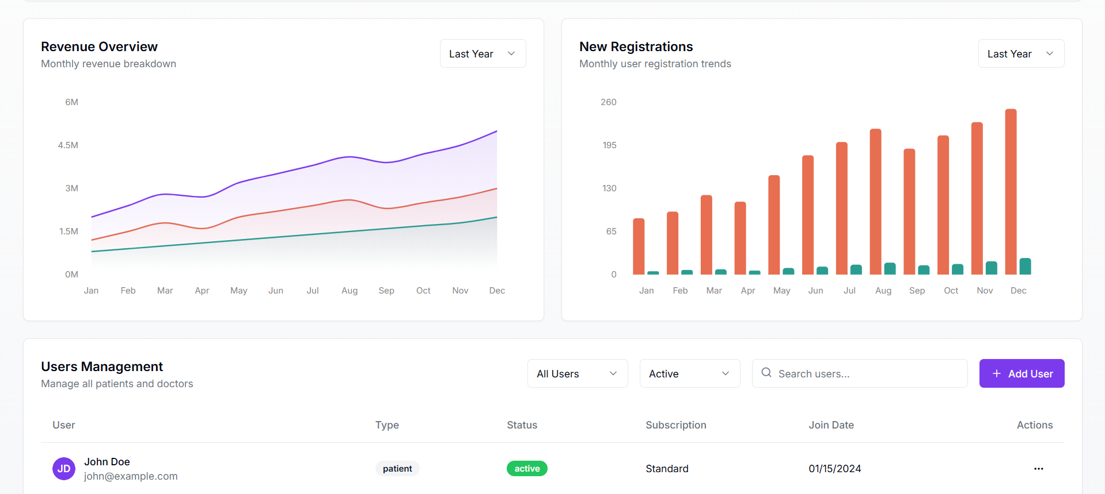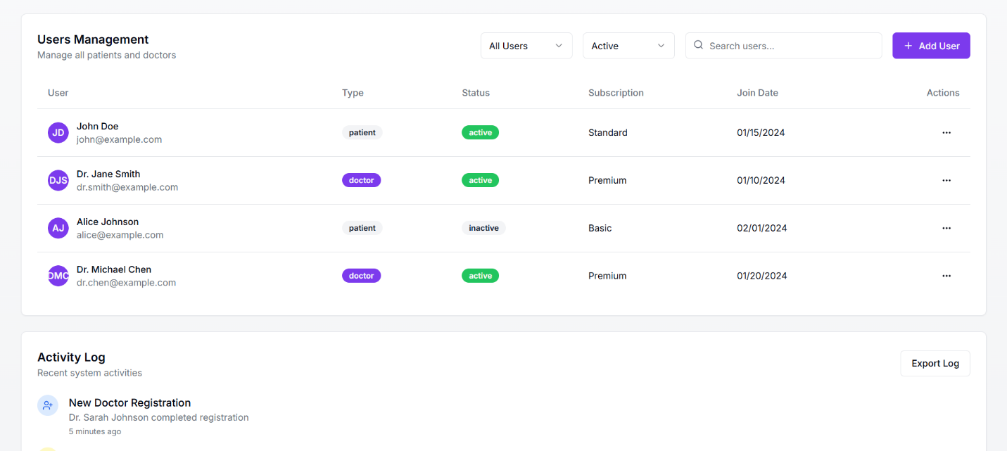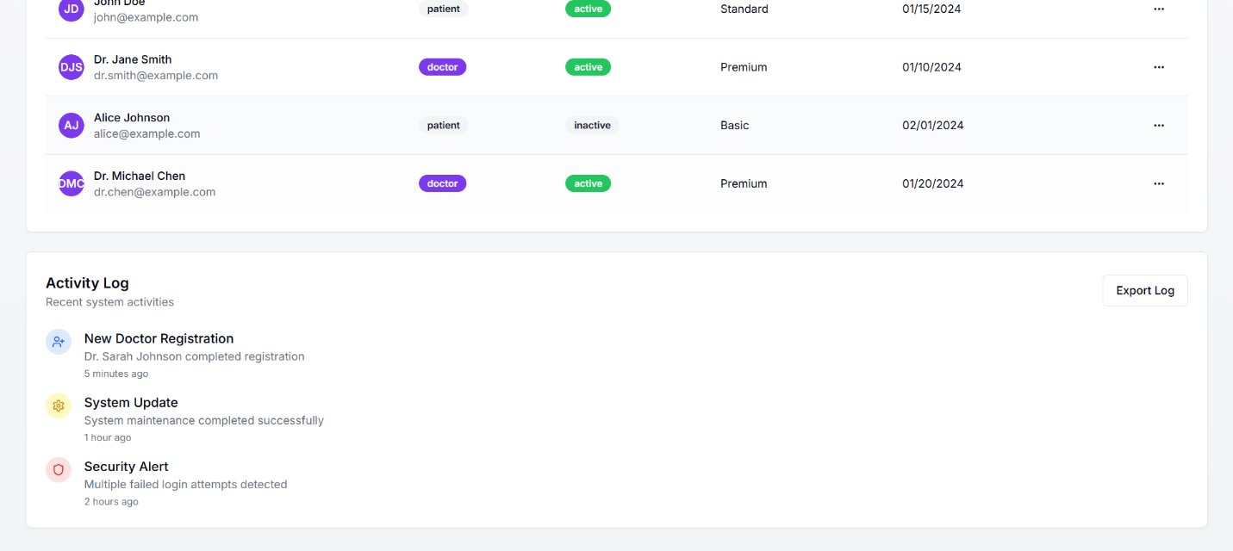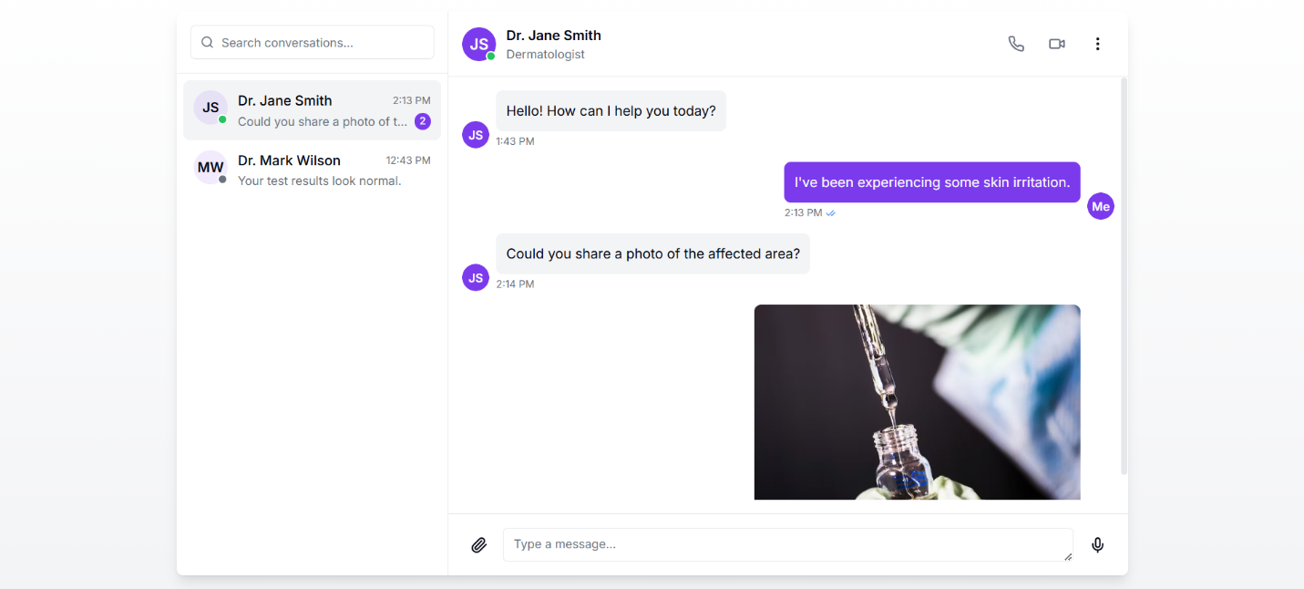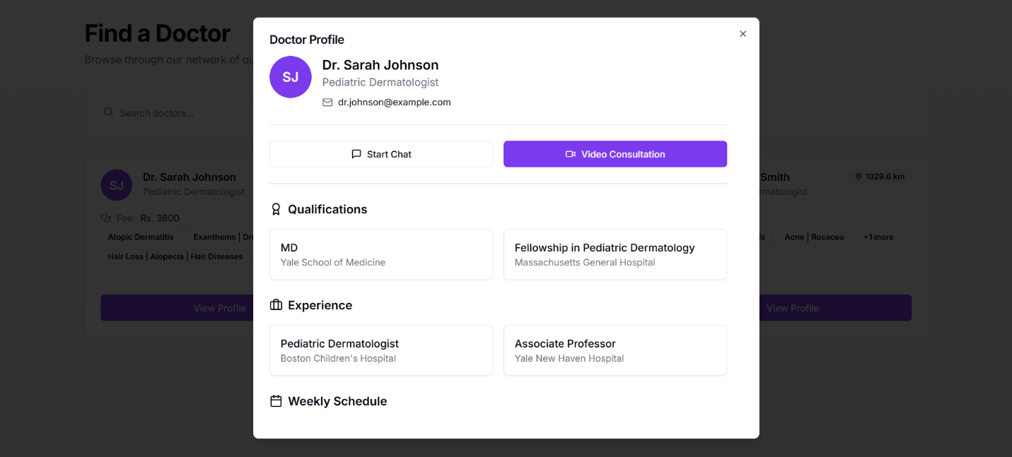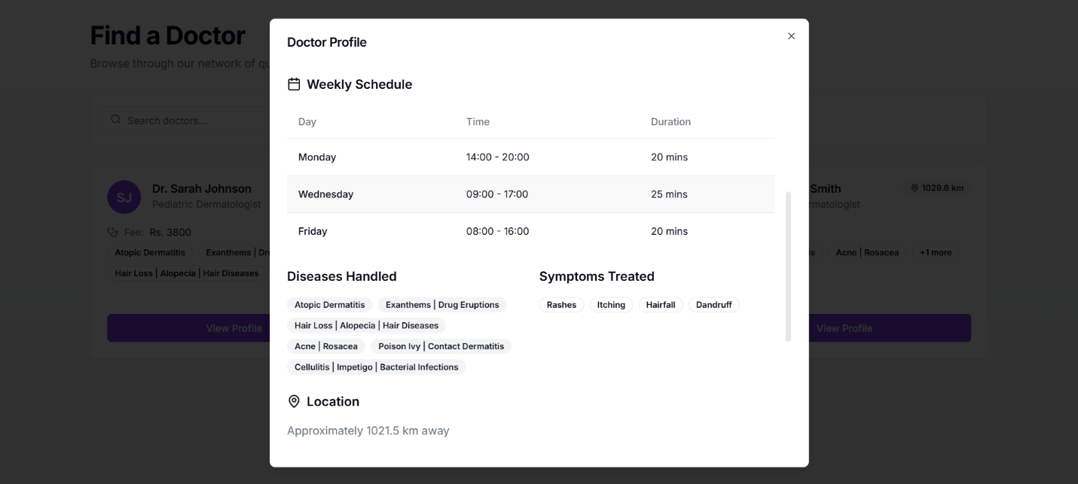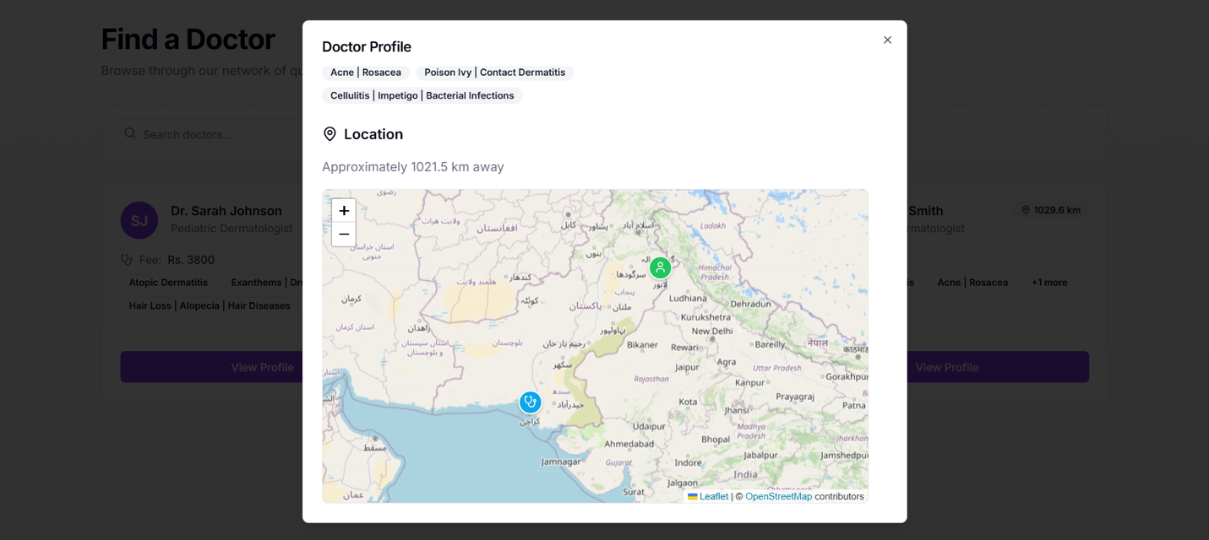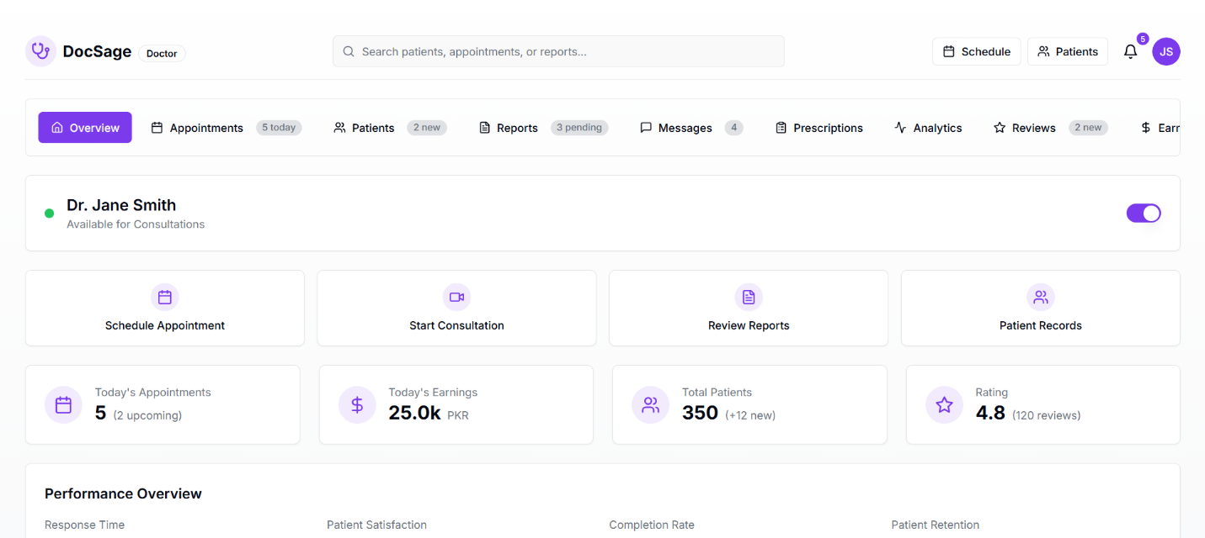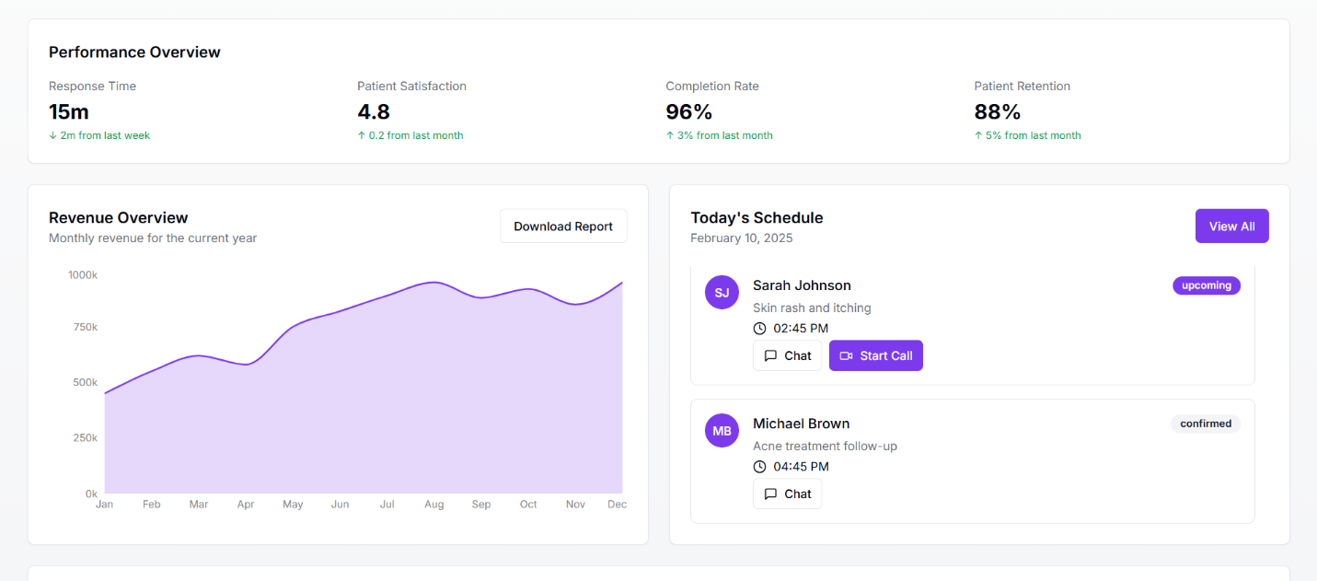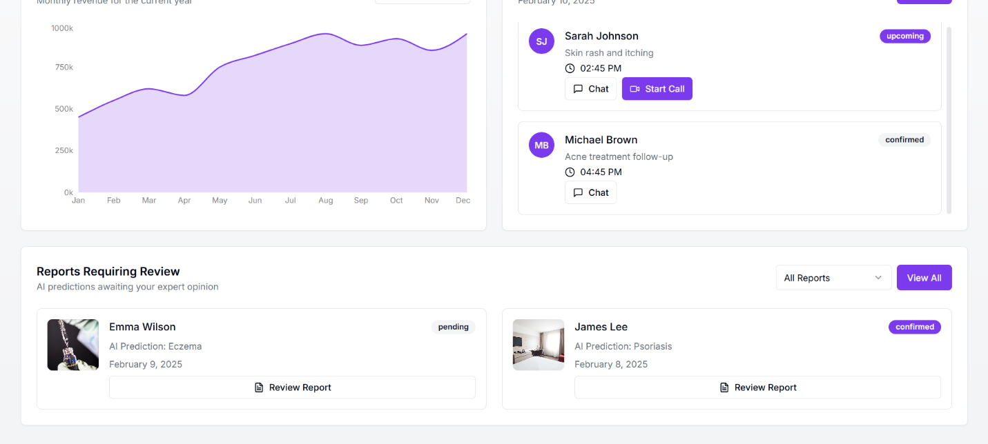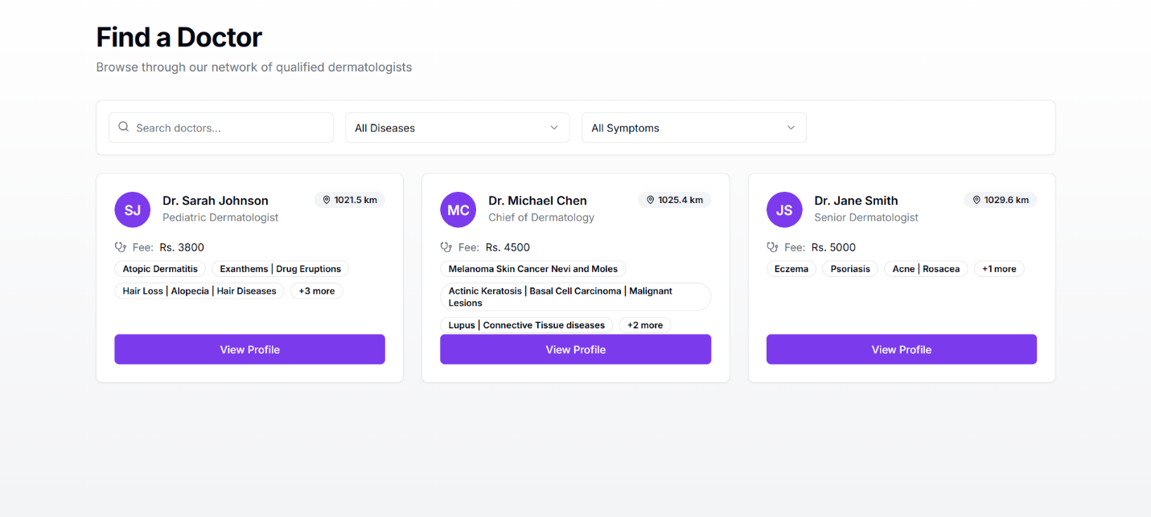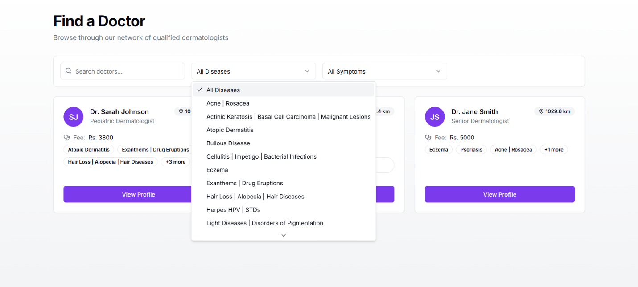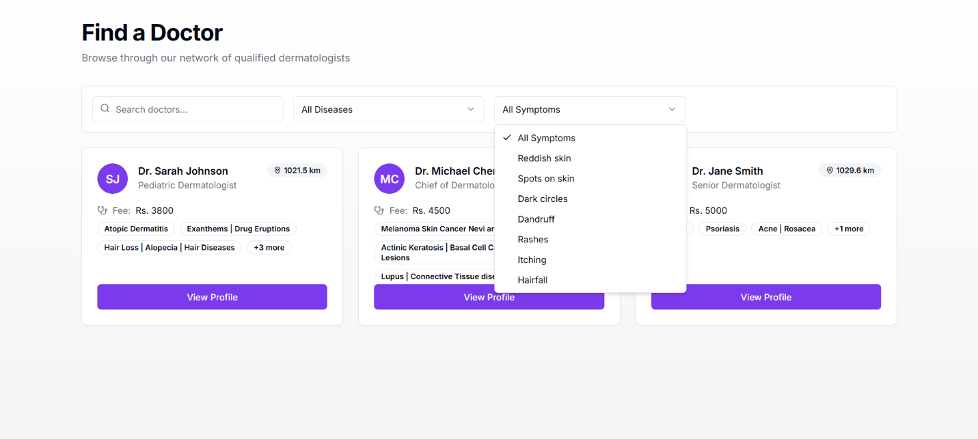

## **6.2. Sequence Diagram**

## **6.2 Sequence Diagrams**

### **6.2.1 Admin Perspective**

**Sign In Sequence Diagram**

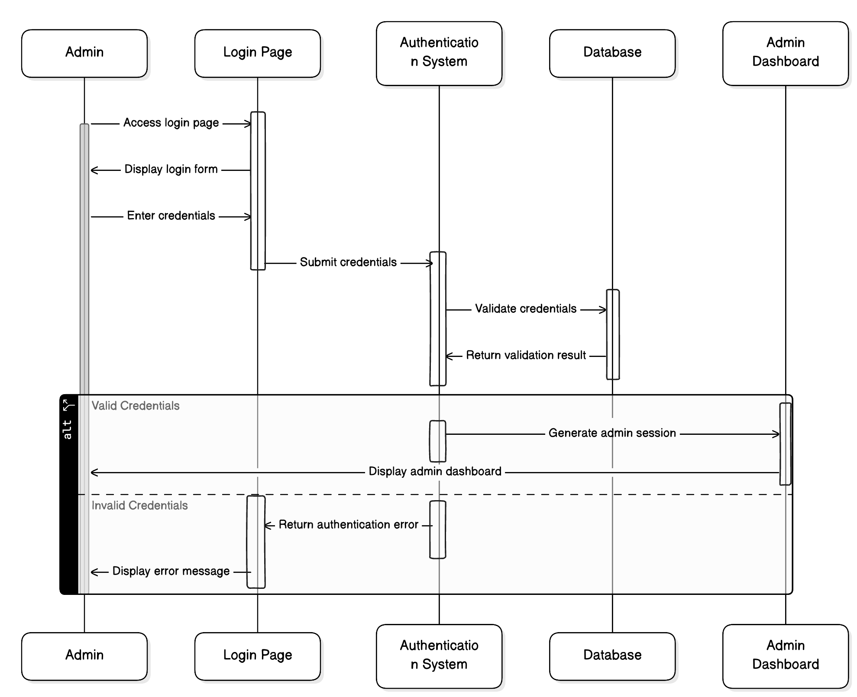

**Use Symptom Checker**

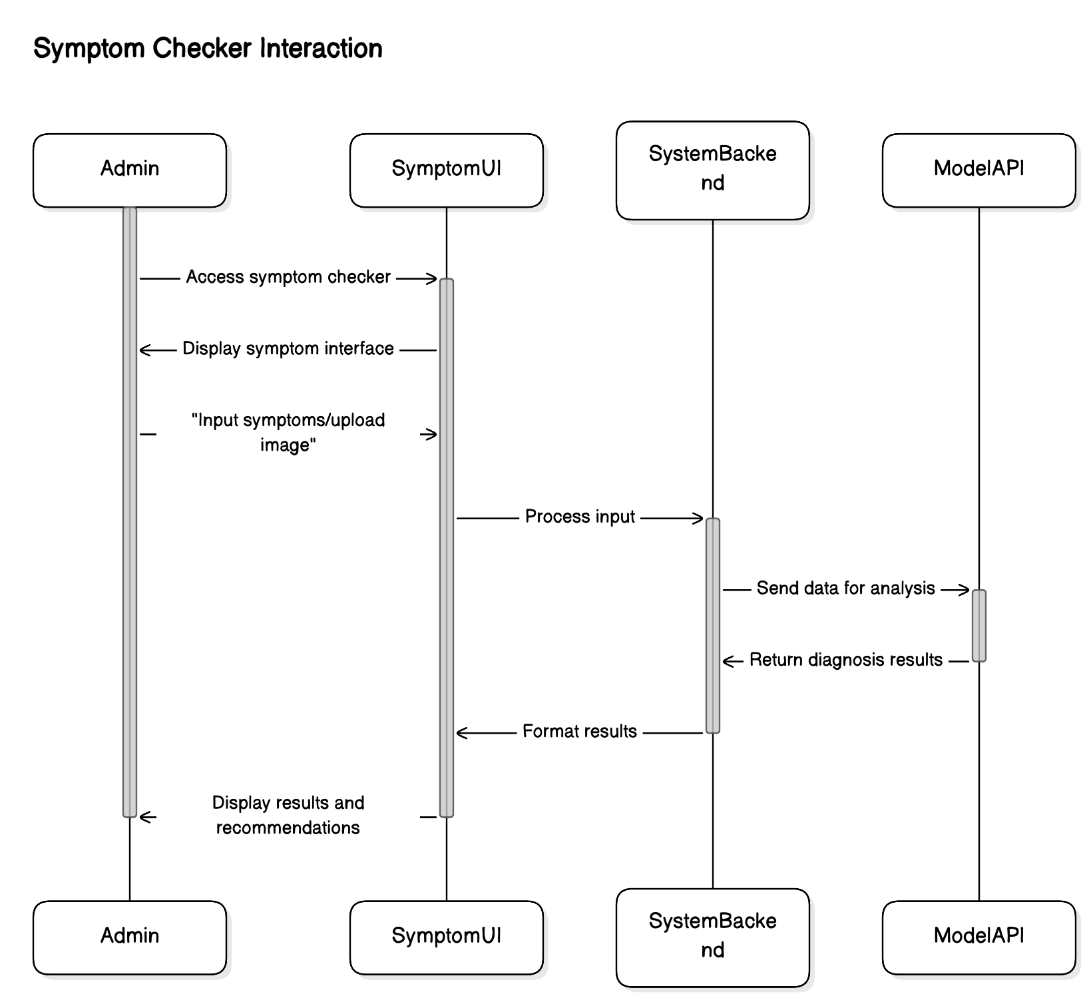

**Verify Doctors**

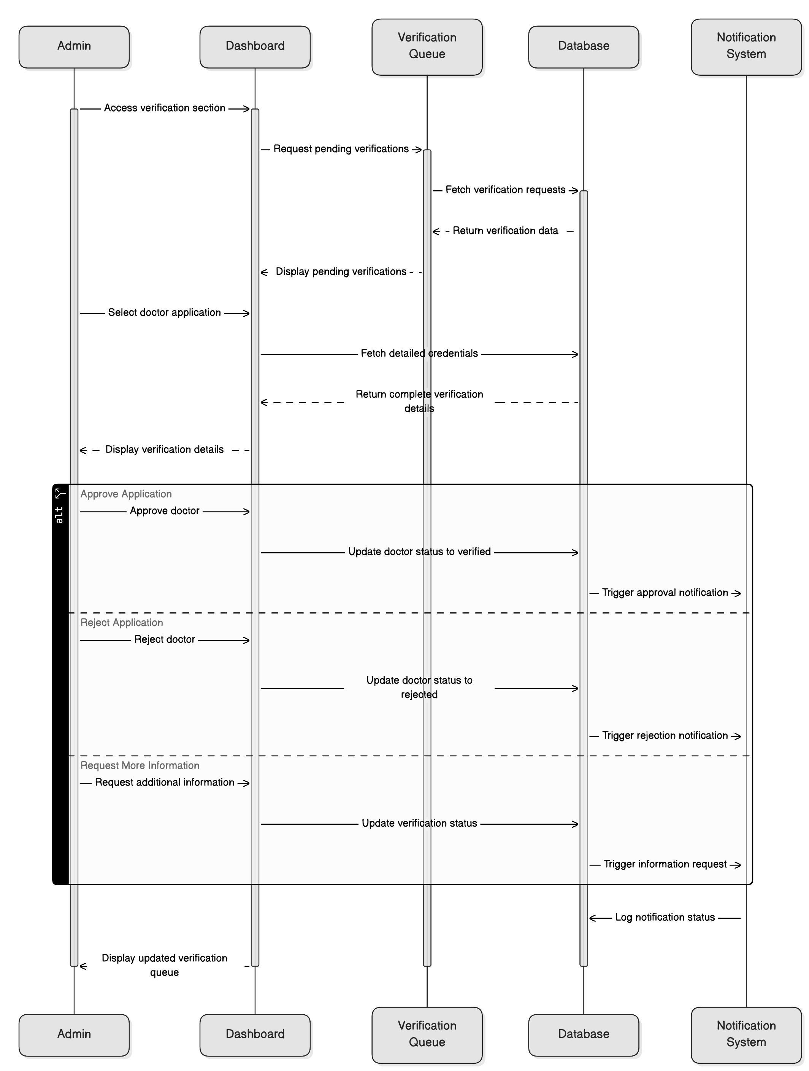

**View Pending Verification**

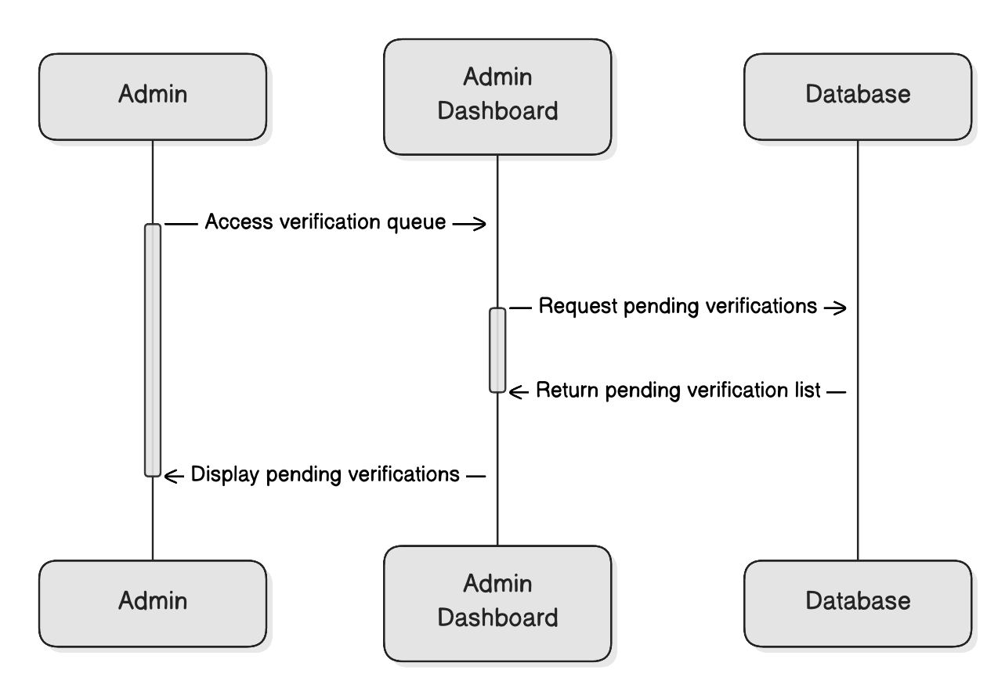

**Manage Own Profile:**

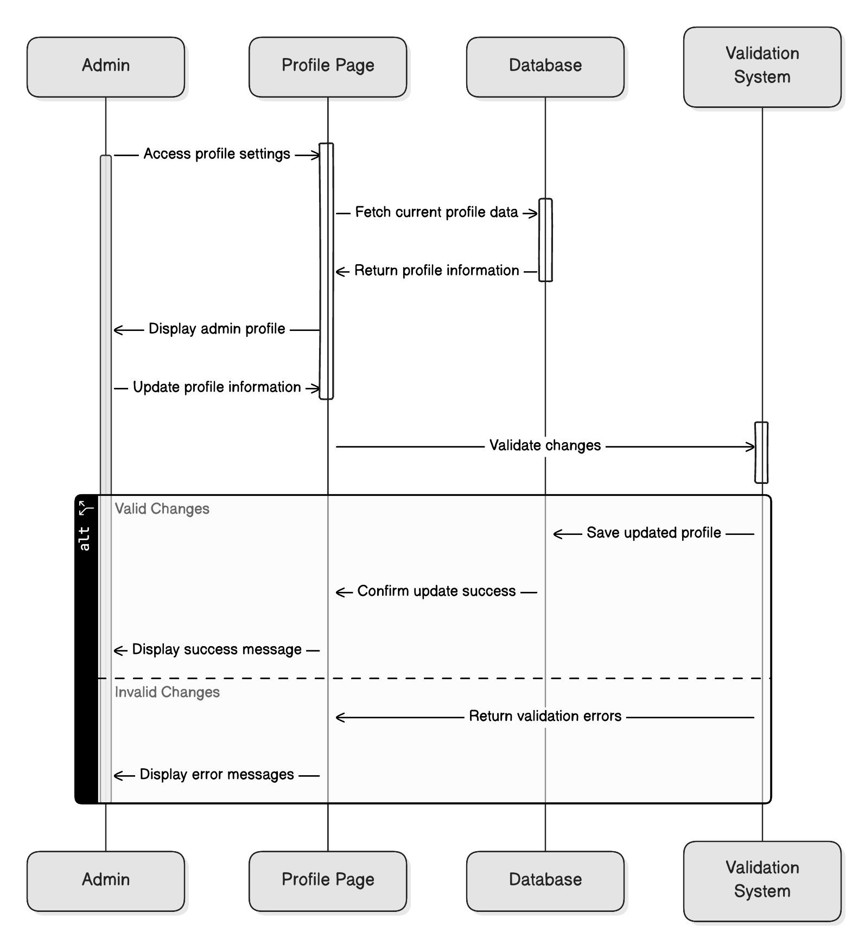

**Track New Registrations**

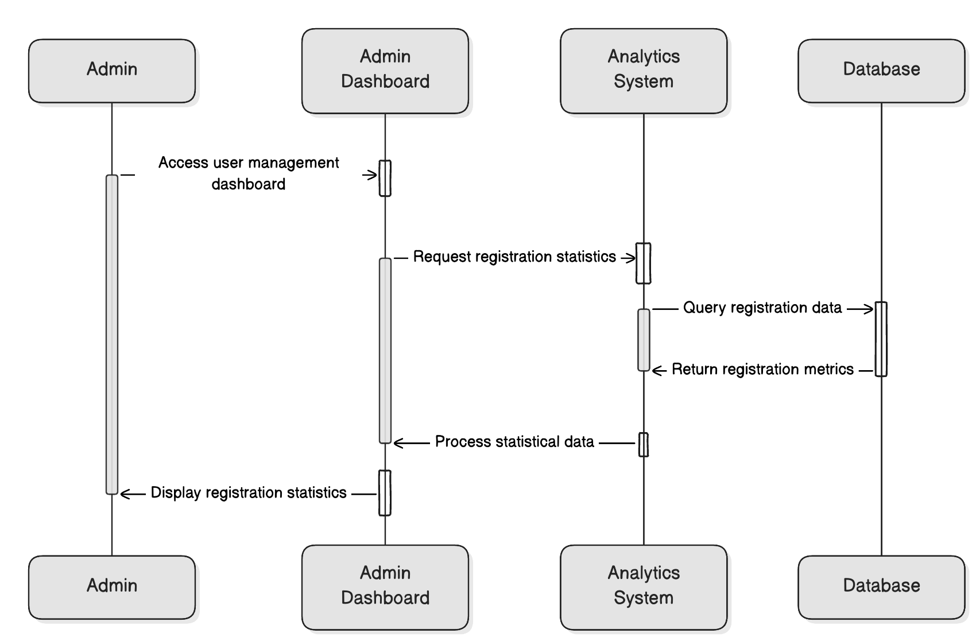

**View Total Revenue:**

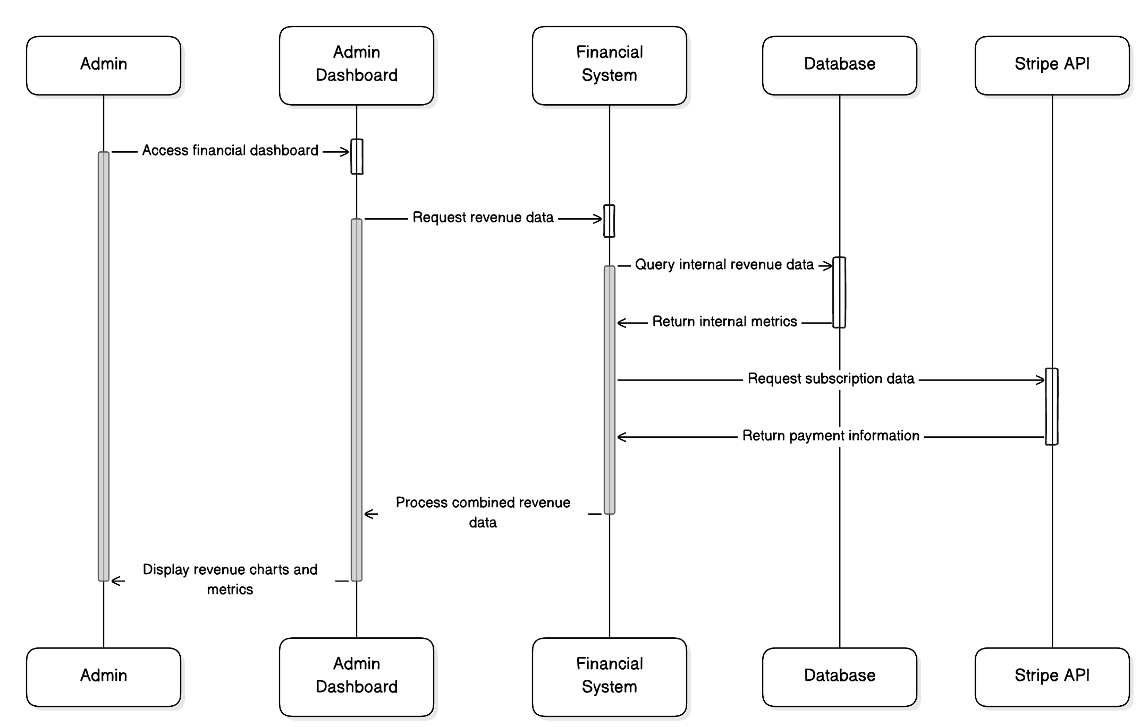

**Manage Users**

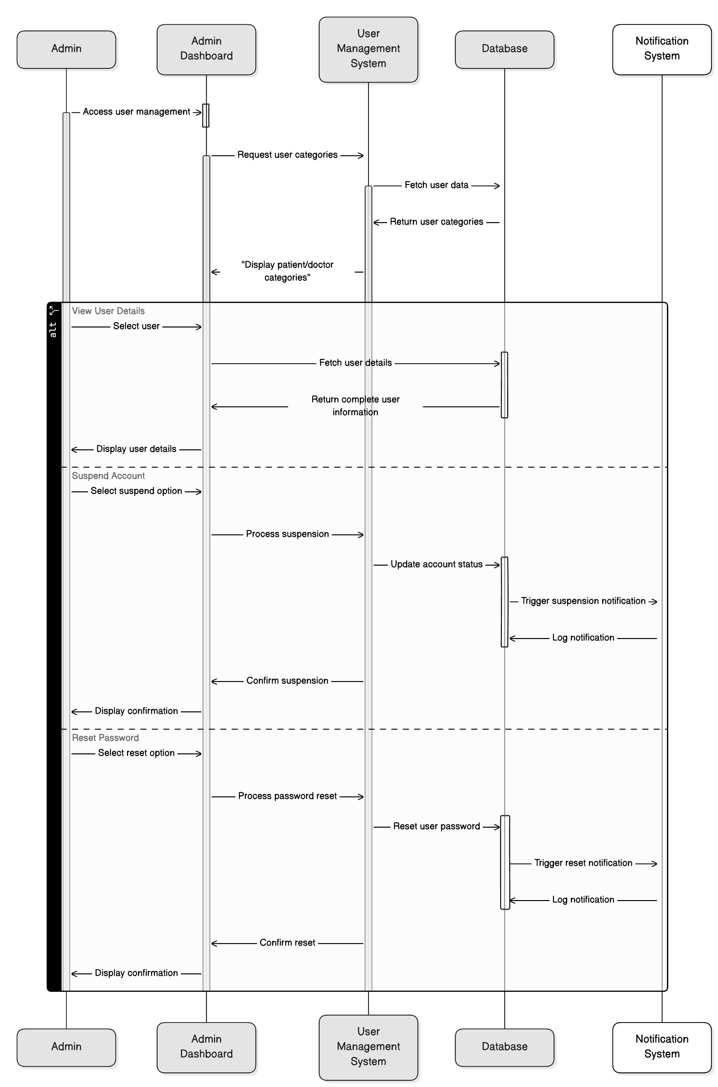

**Logout Sequence Diagram**

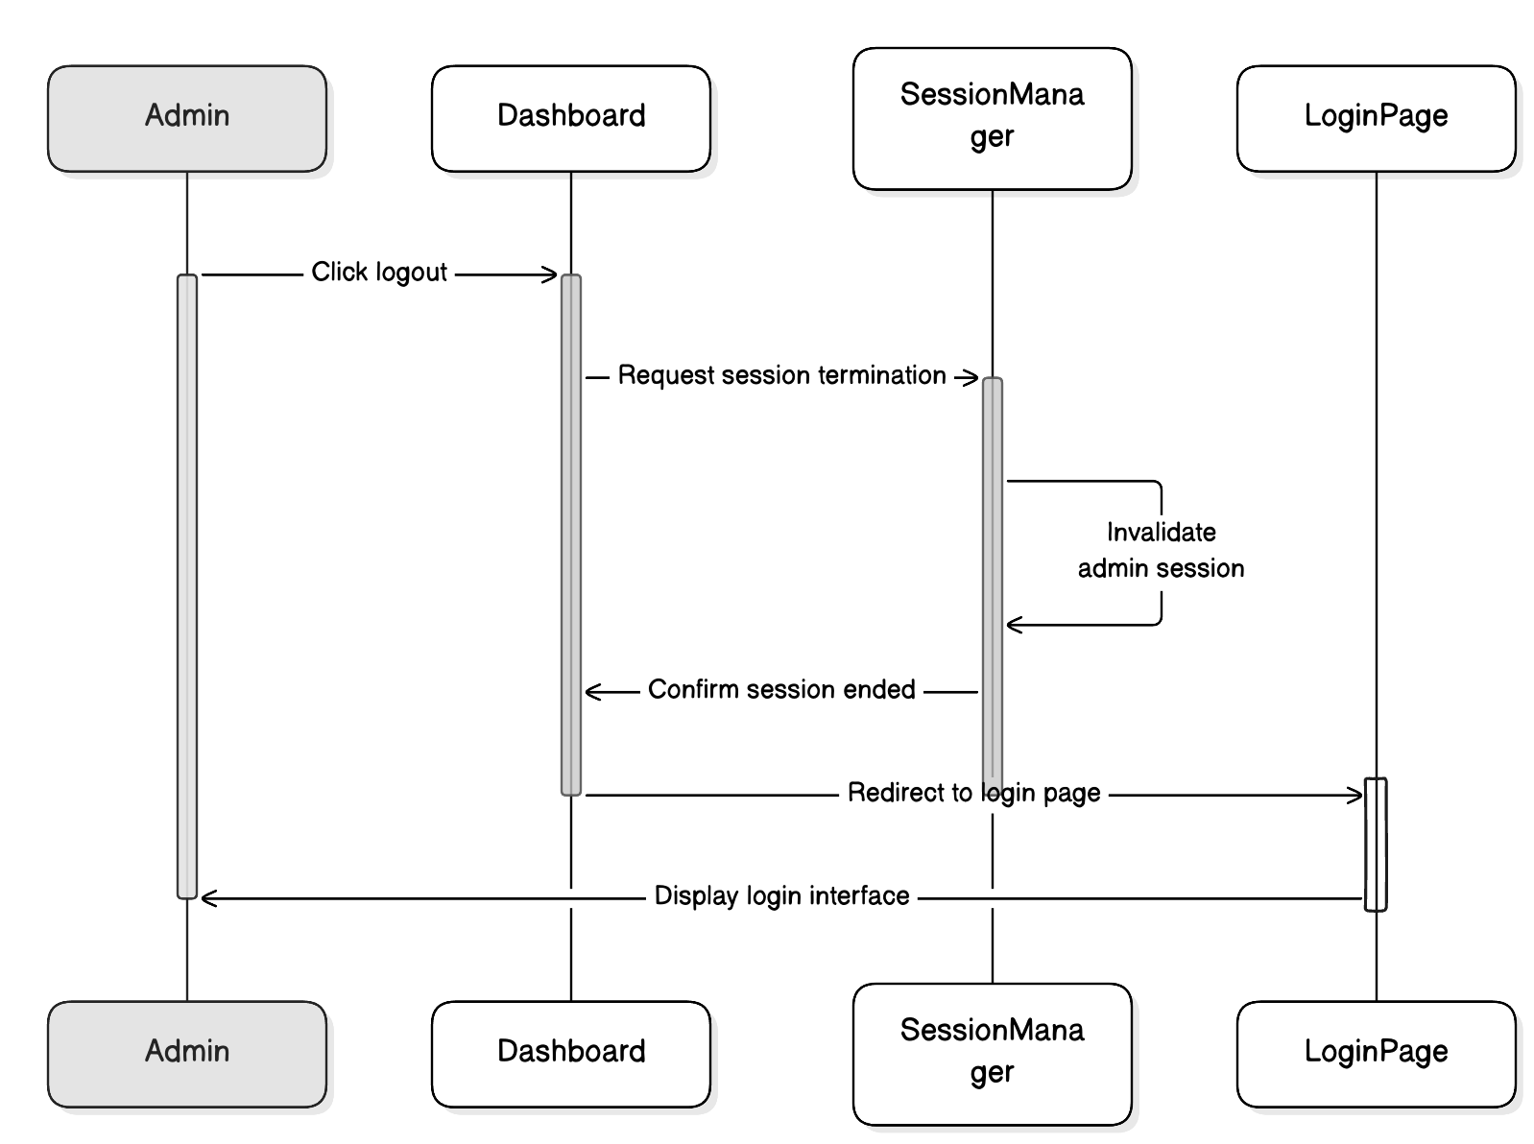

**View Articles Sequence Diagram**

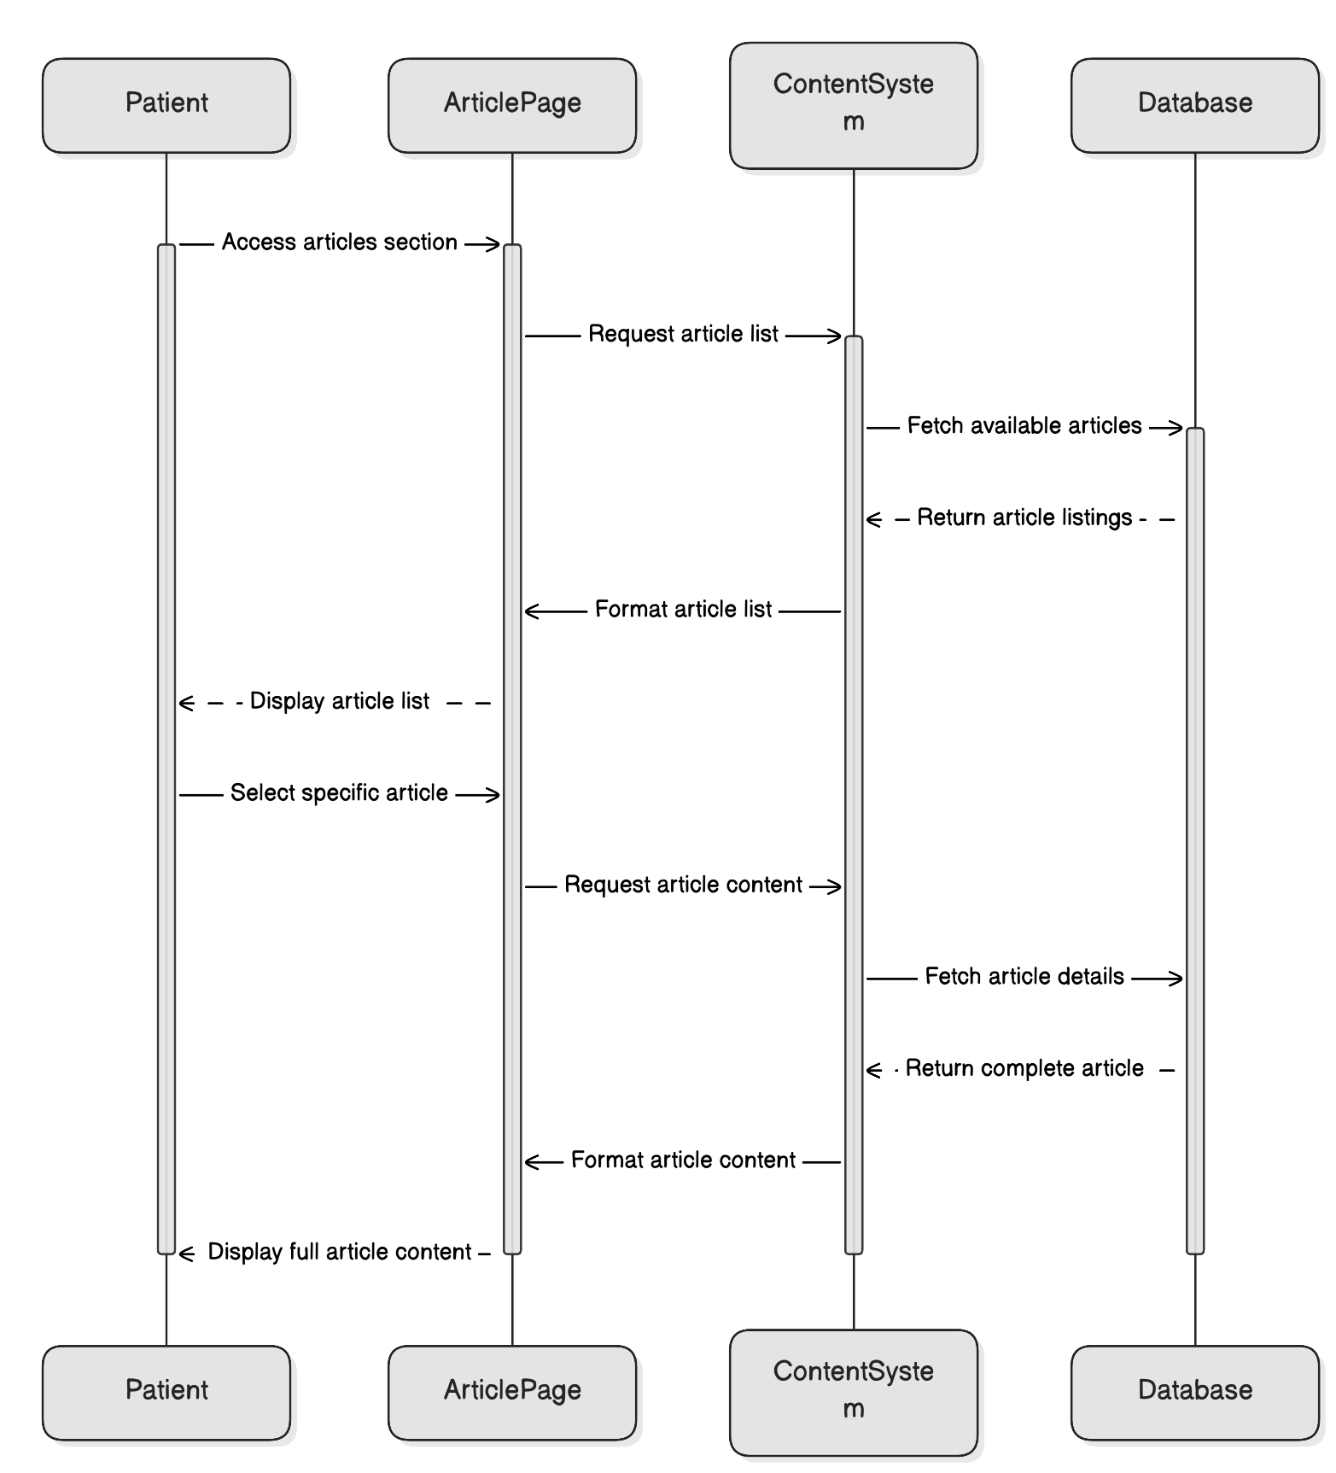

### **6.2.2 Doctor Perspective**

**Signup/Signin**

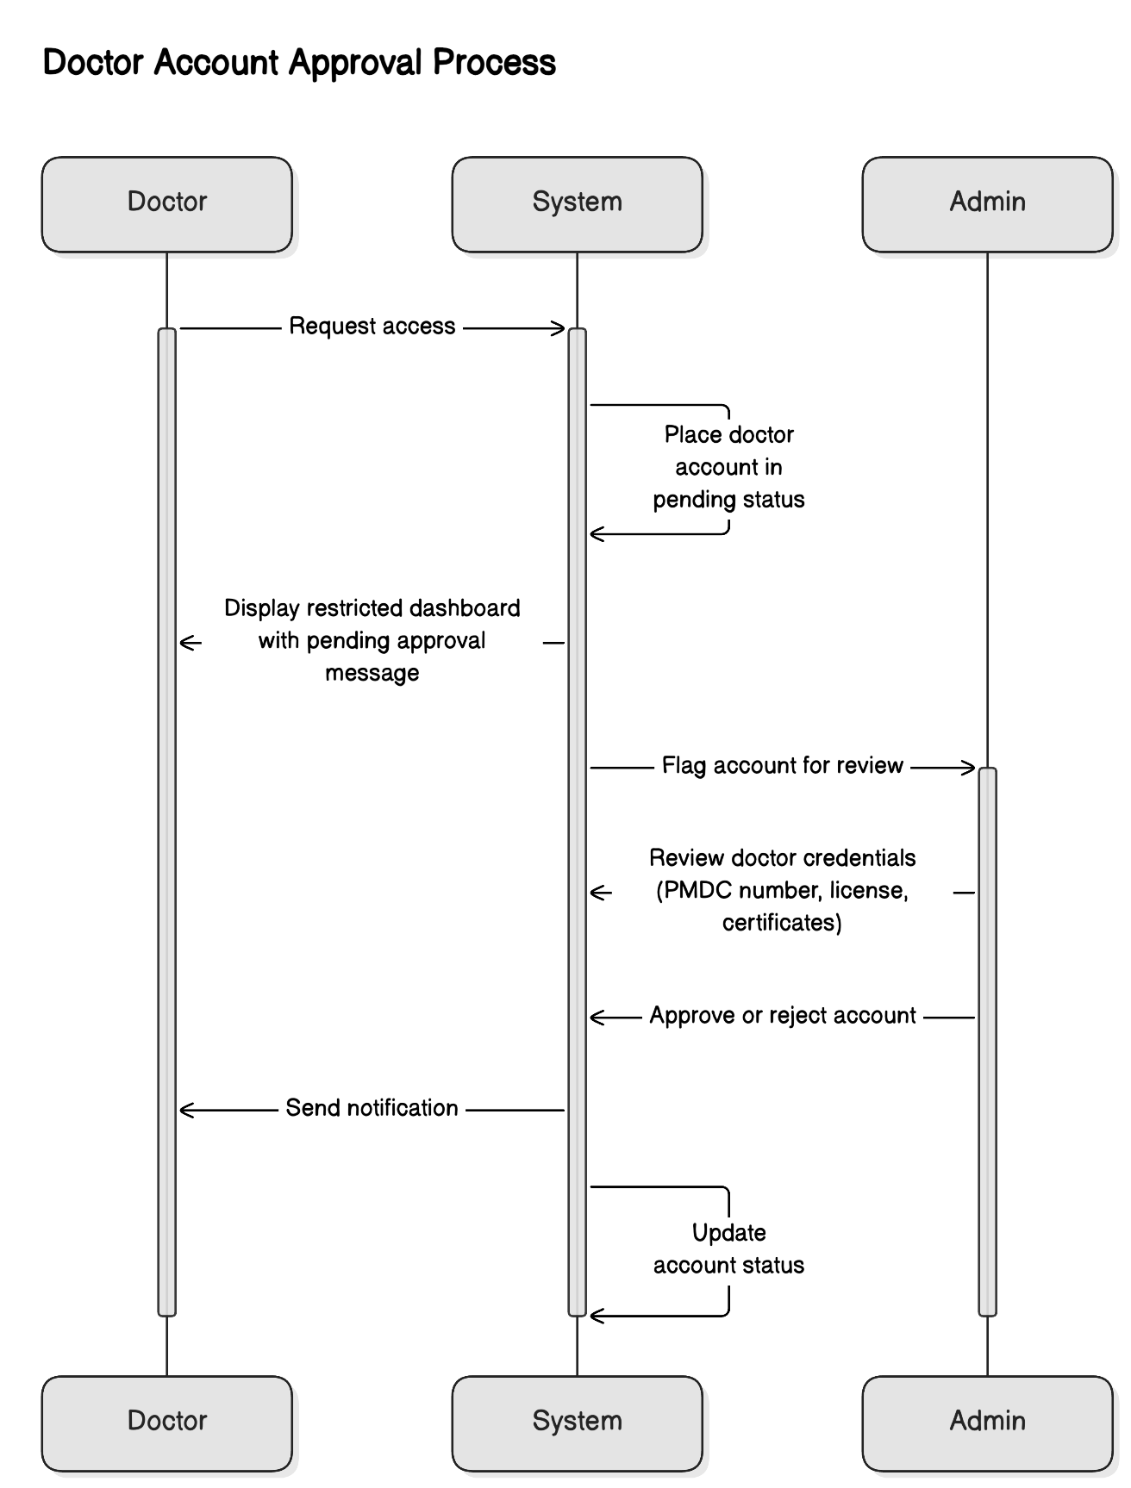

**Manage Profile**

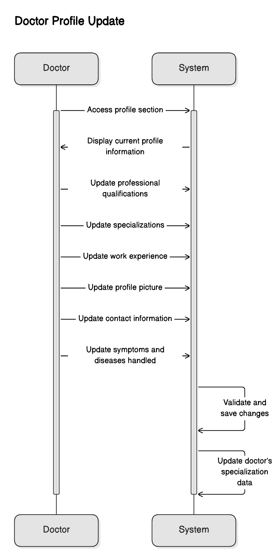

**Set Availability**

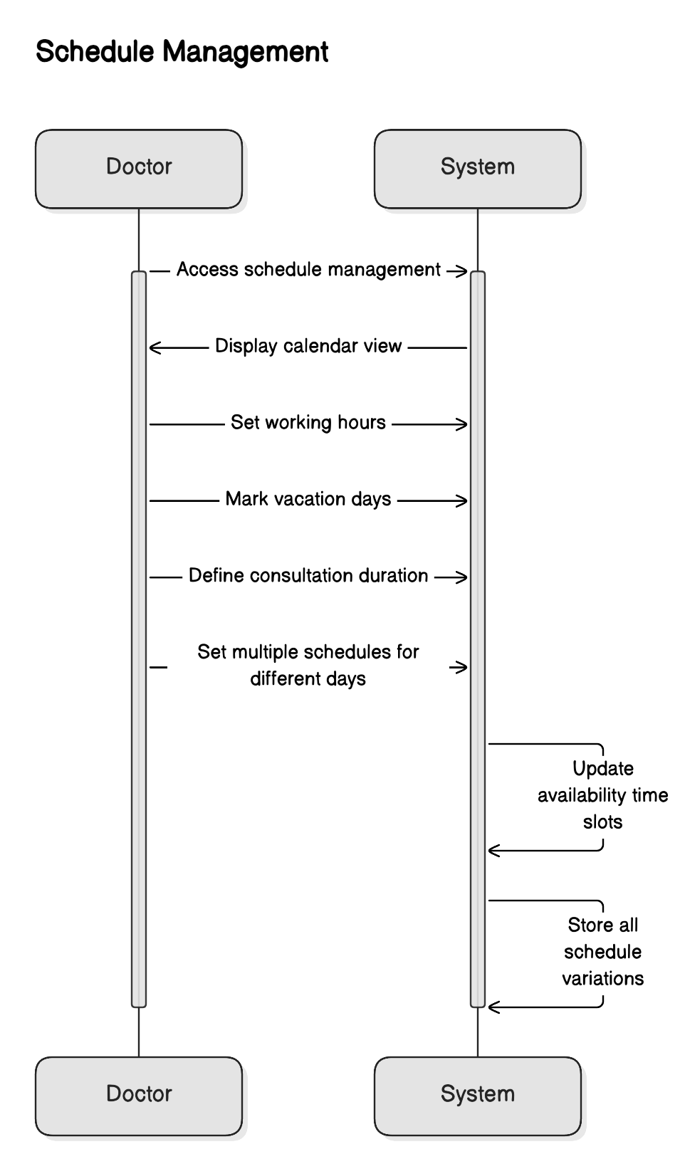

**Manage Appointments**

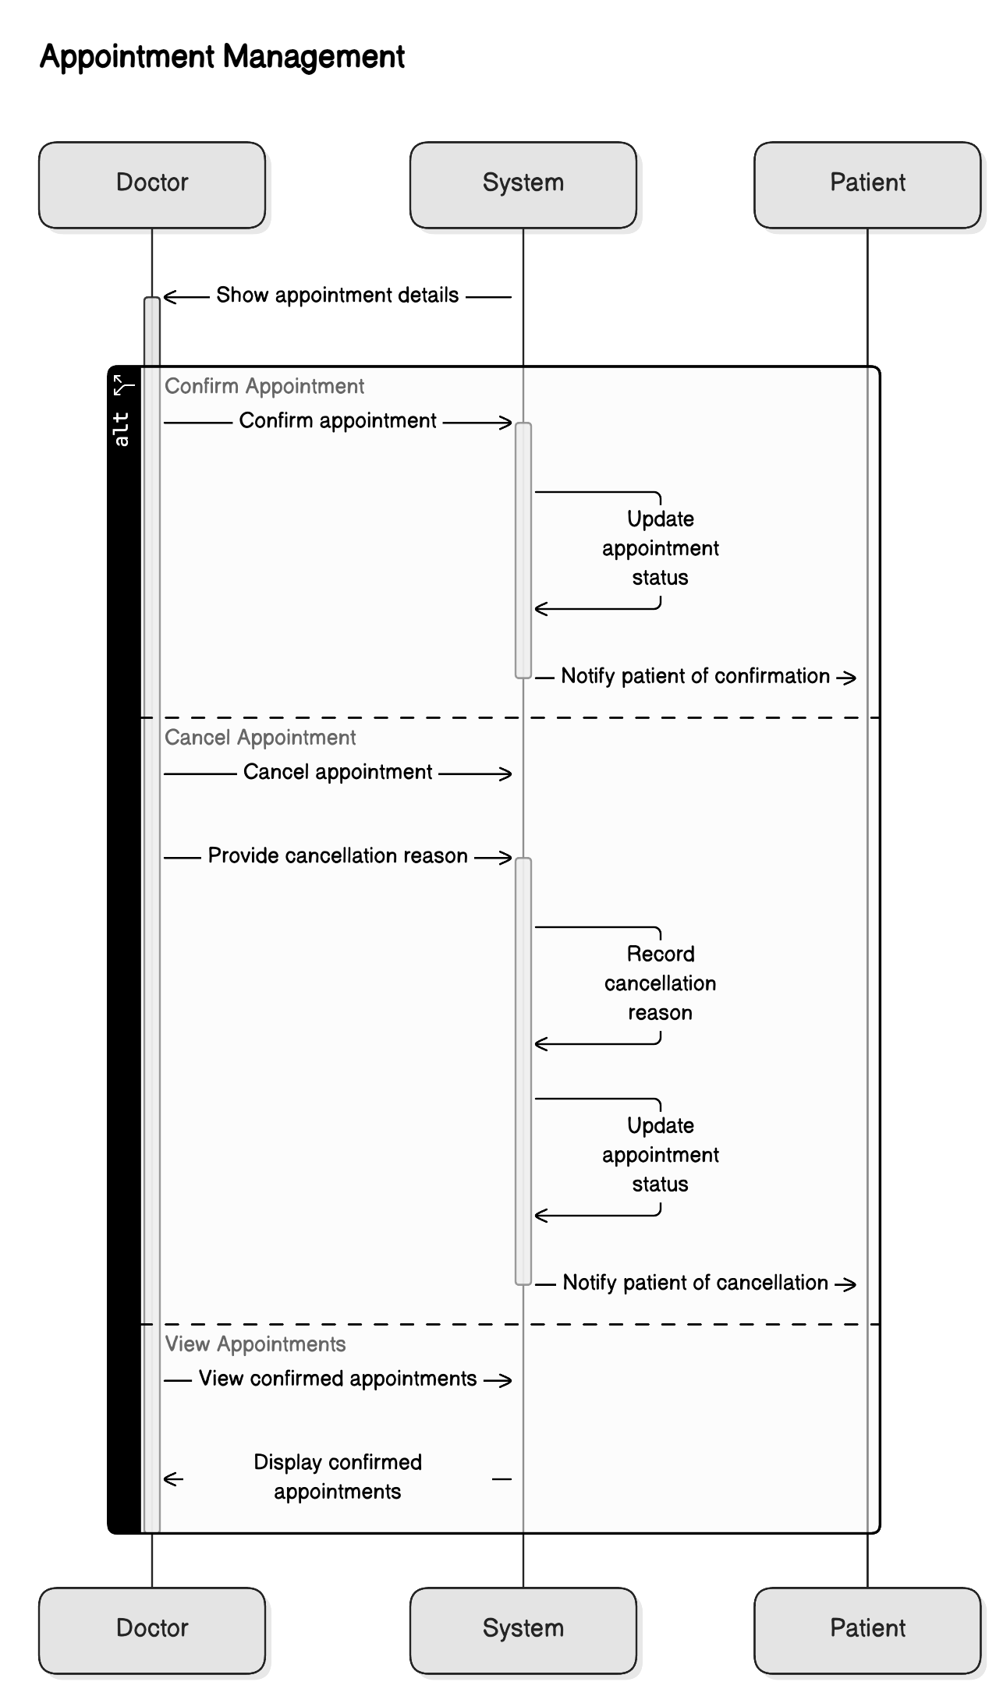

**Message Patients**

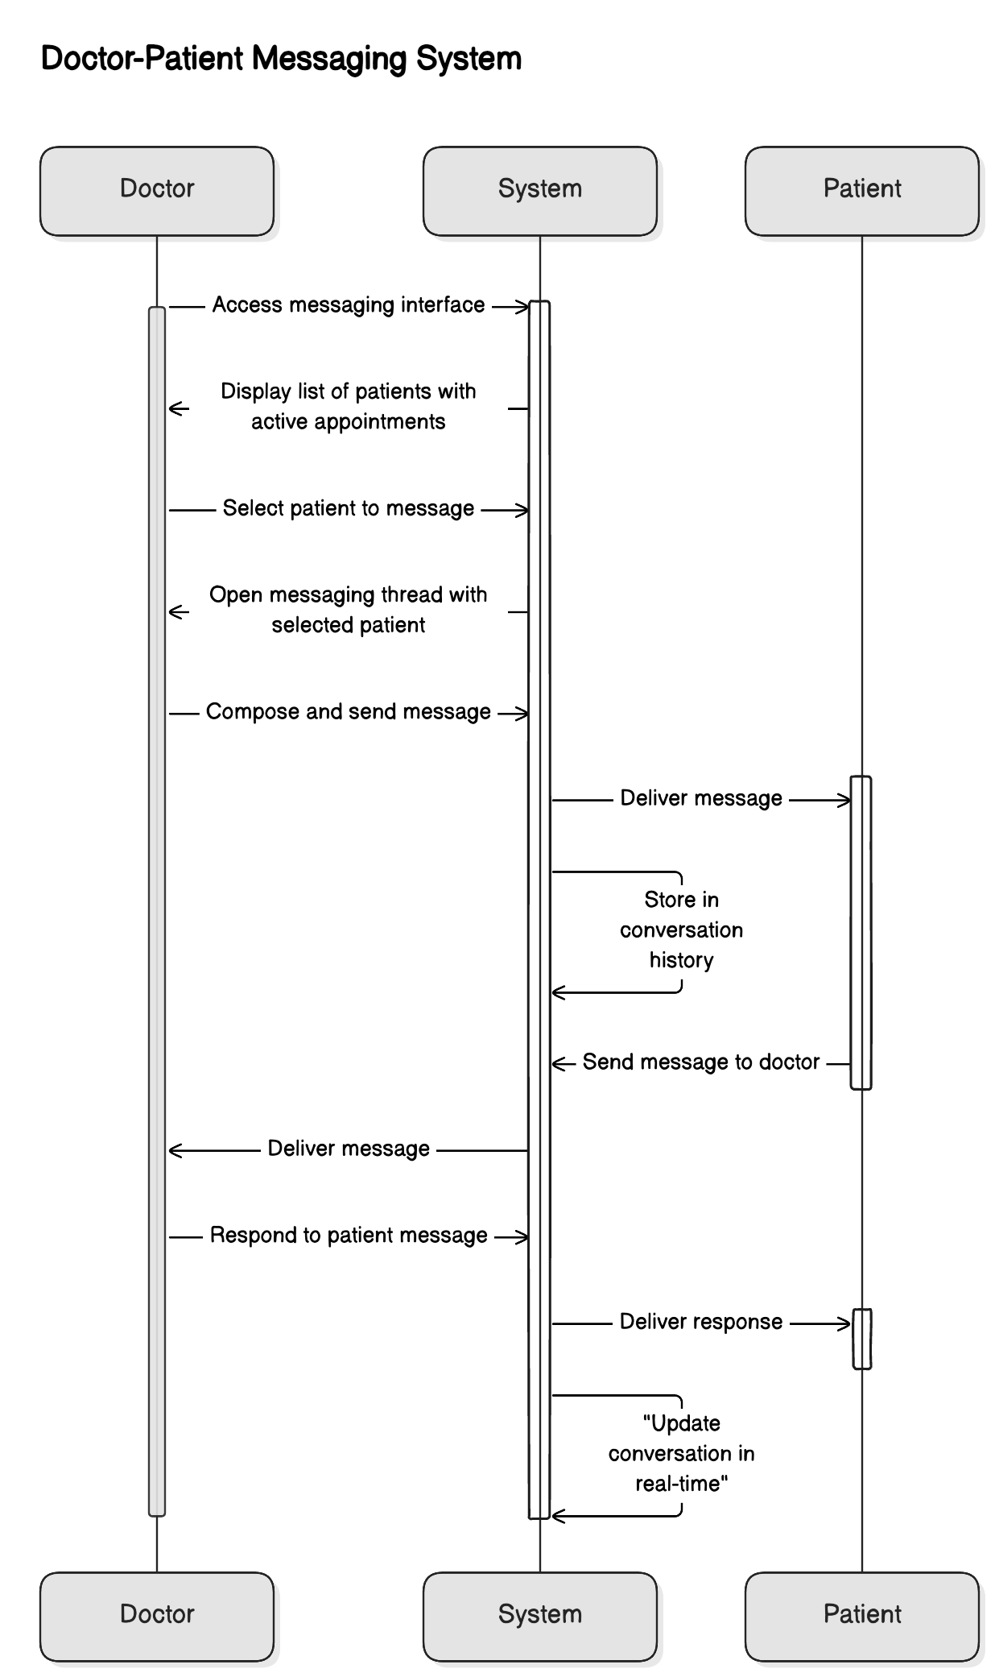

**Conduct Video Consultation**

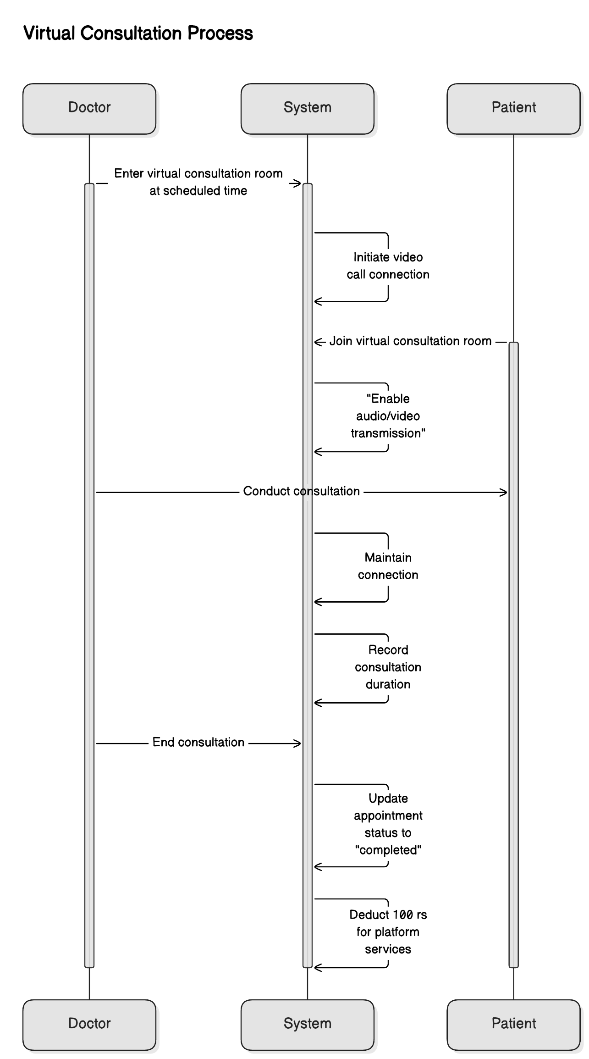

**Access Patient Record**

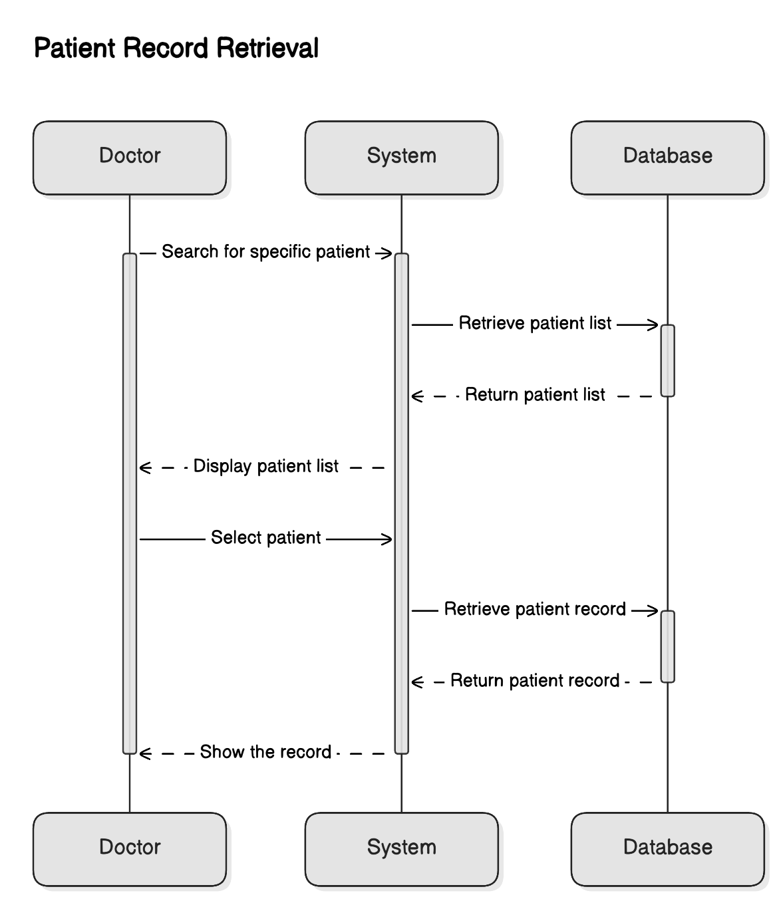

**Issue Prescription**

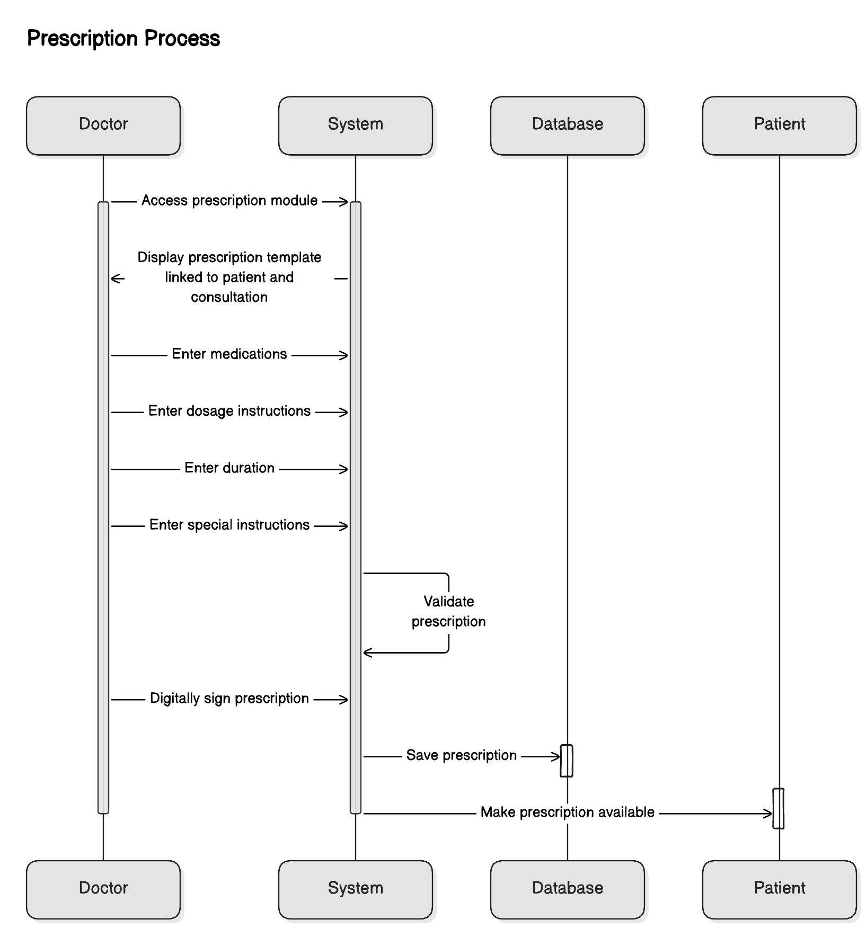

**Use Symptom Checker**

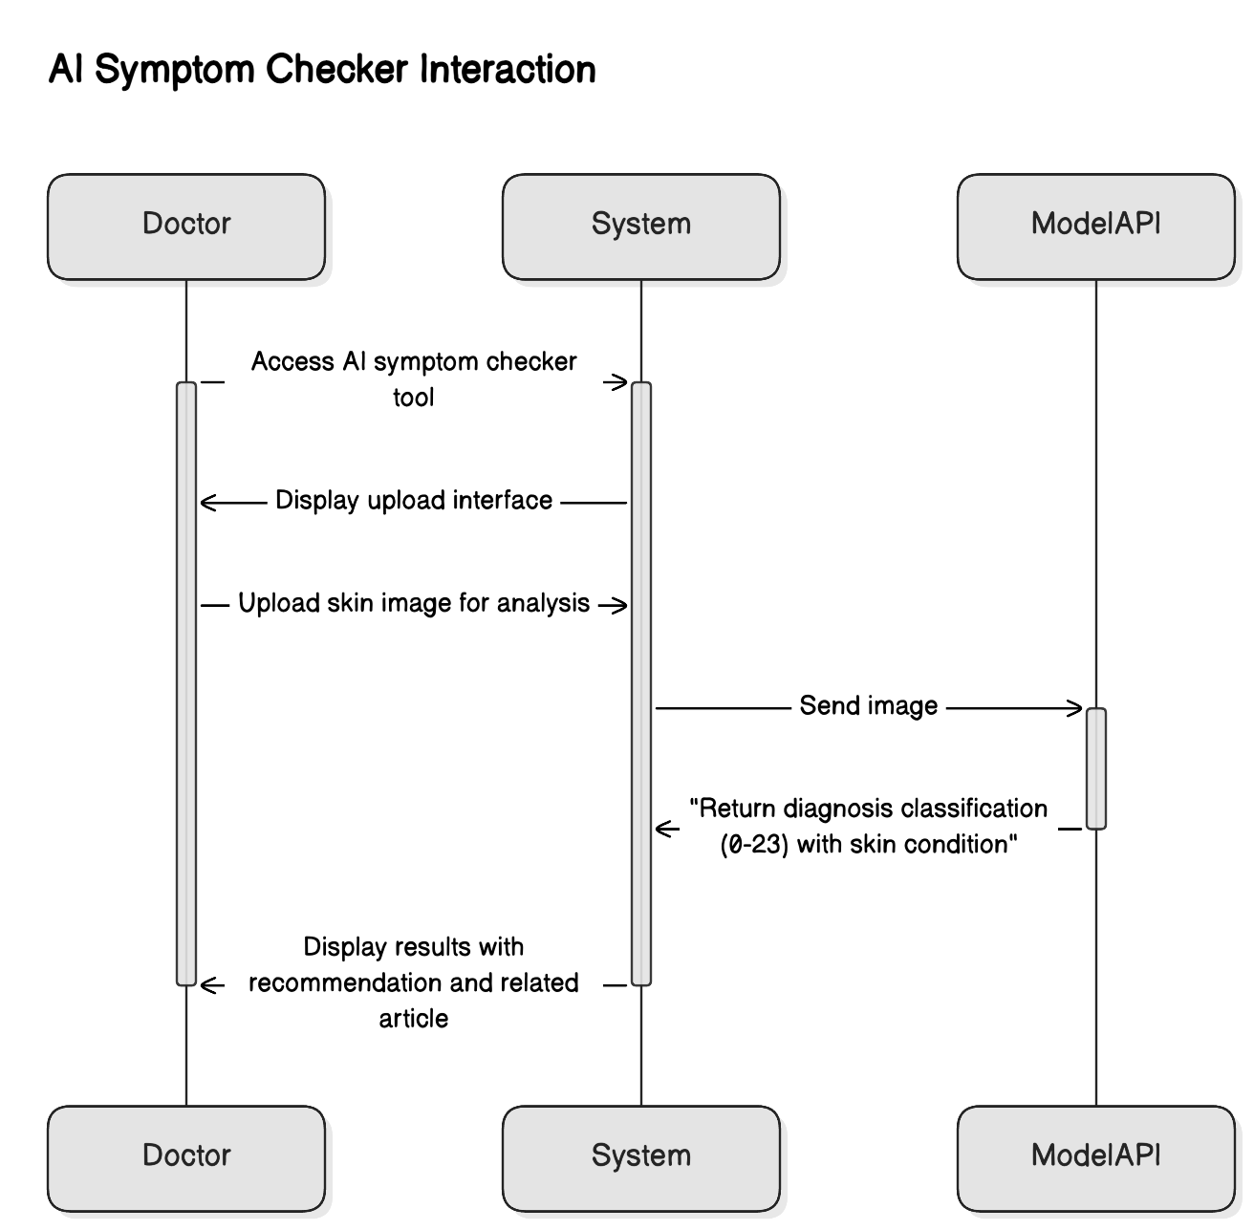

**Get Subscripition**

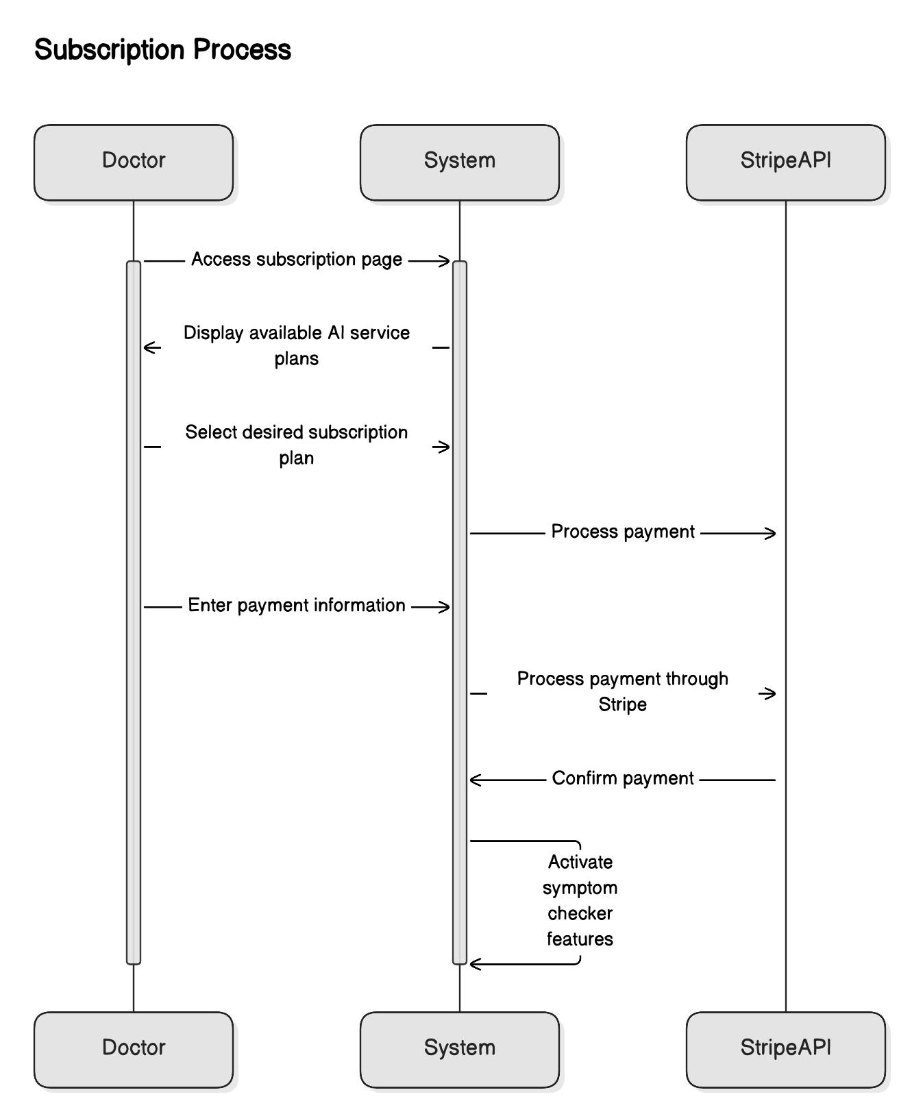

**Manage Payments**

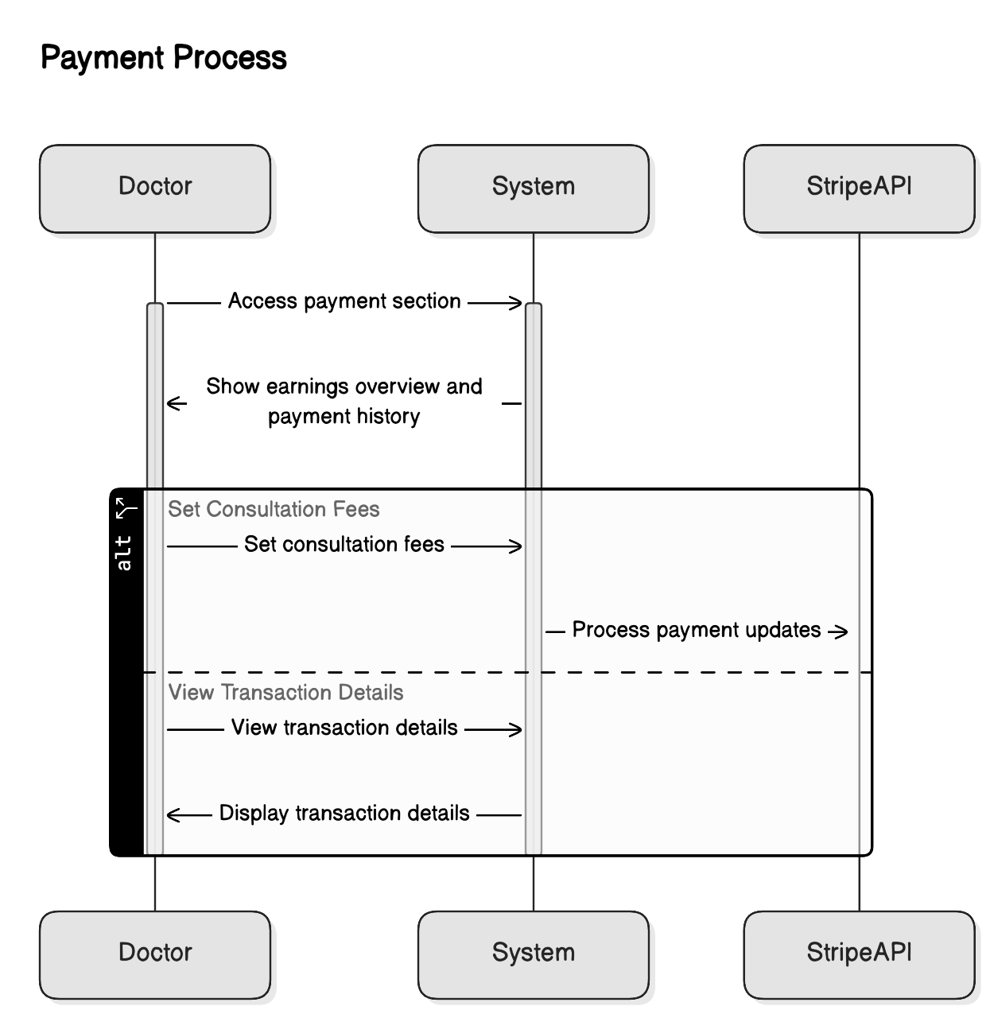

**View Articles**

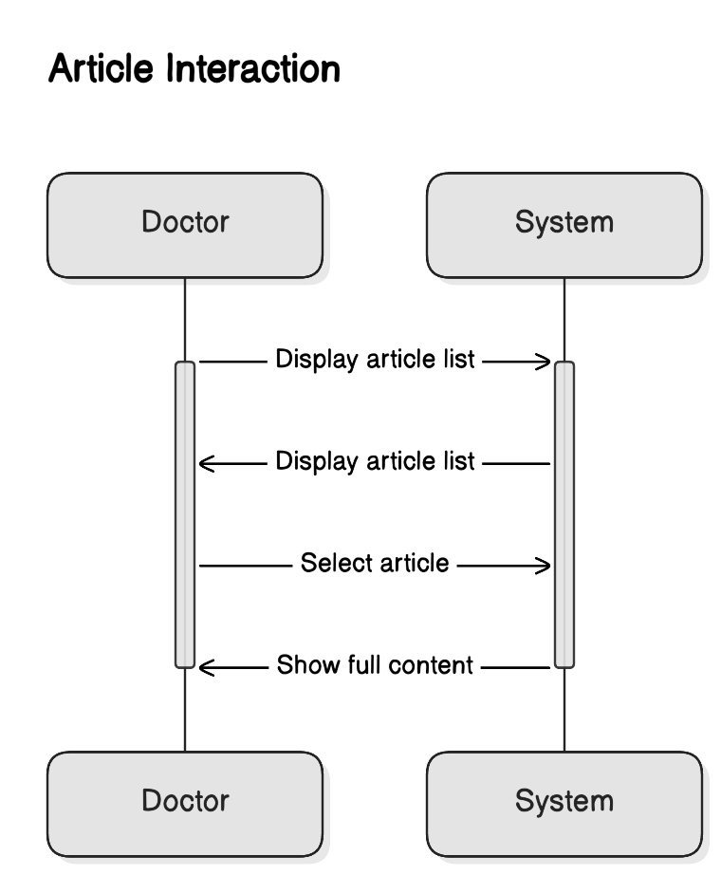

**Logout**

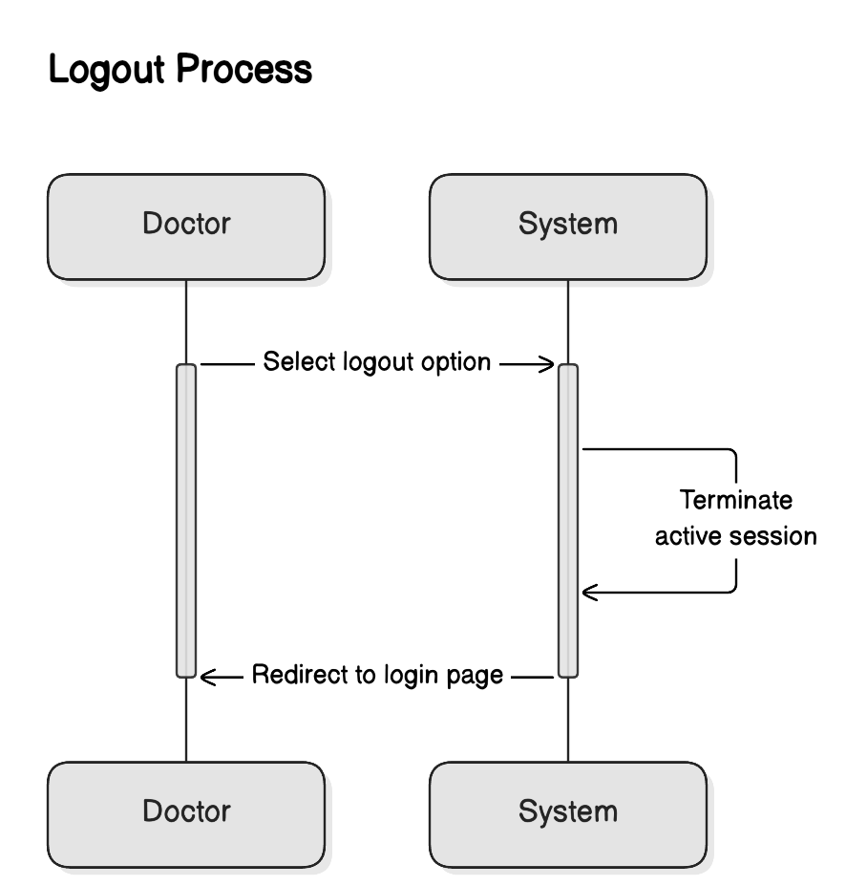

### **6.2.3 Patient Perspective**

**Patient Sign Up/Sign Sequence**

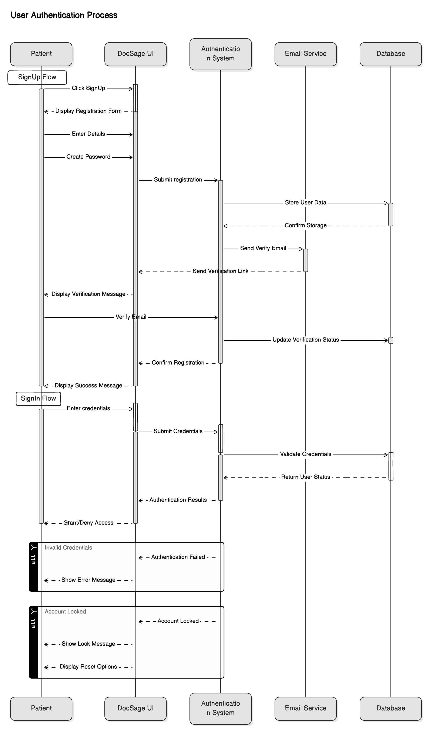

**Patient Profile Management Sequence**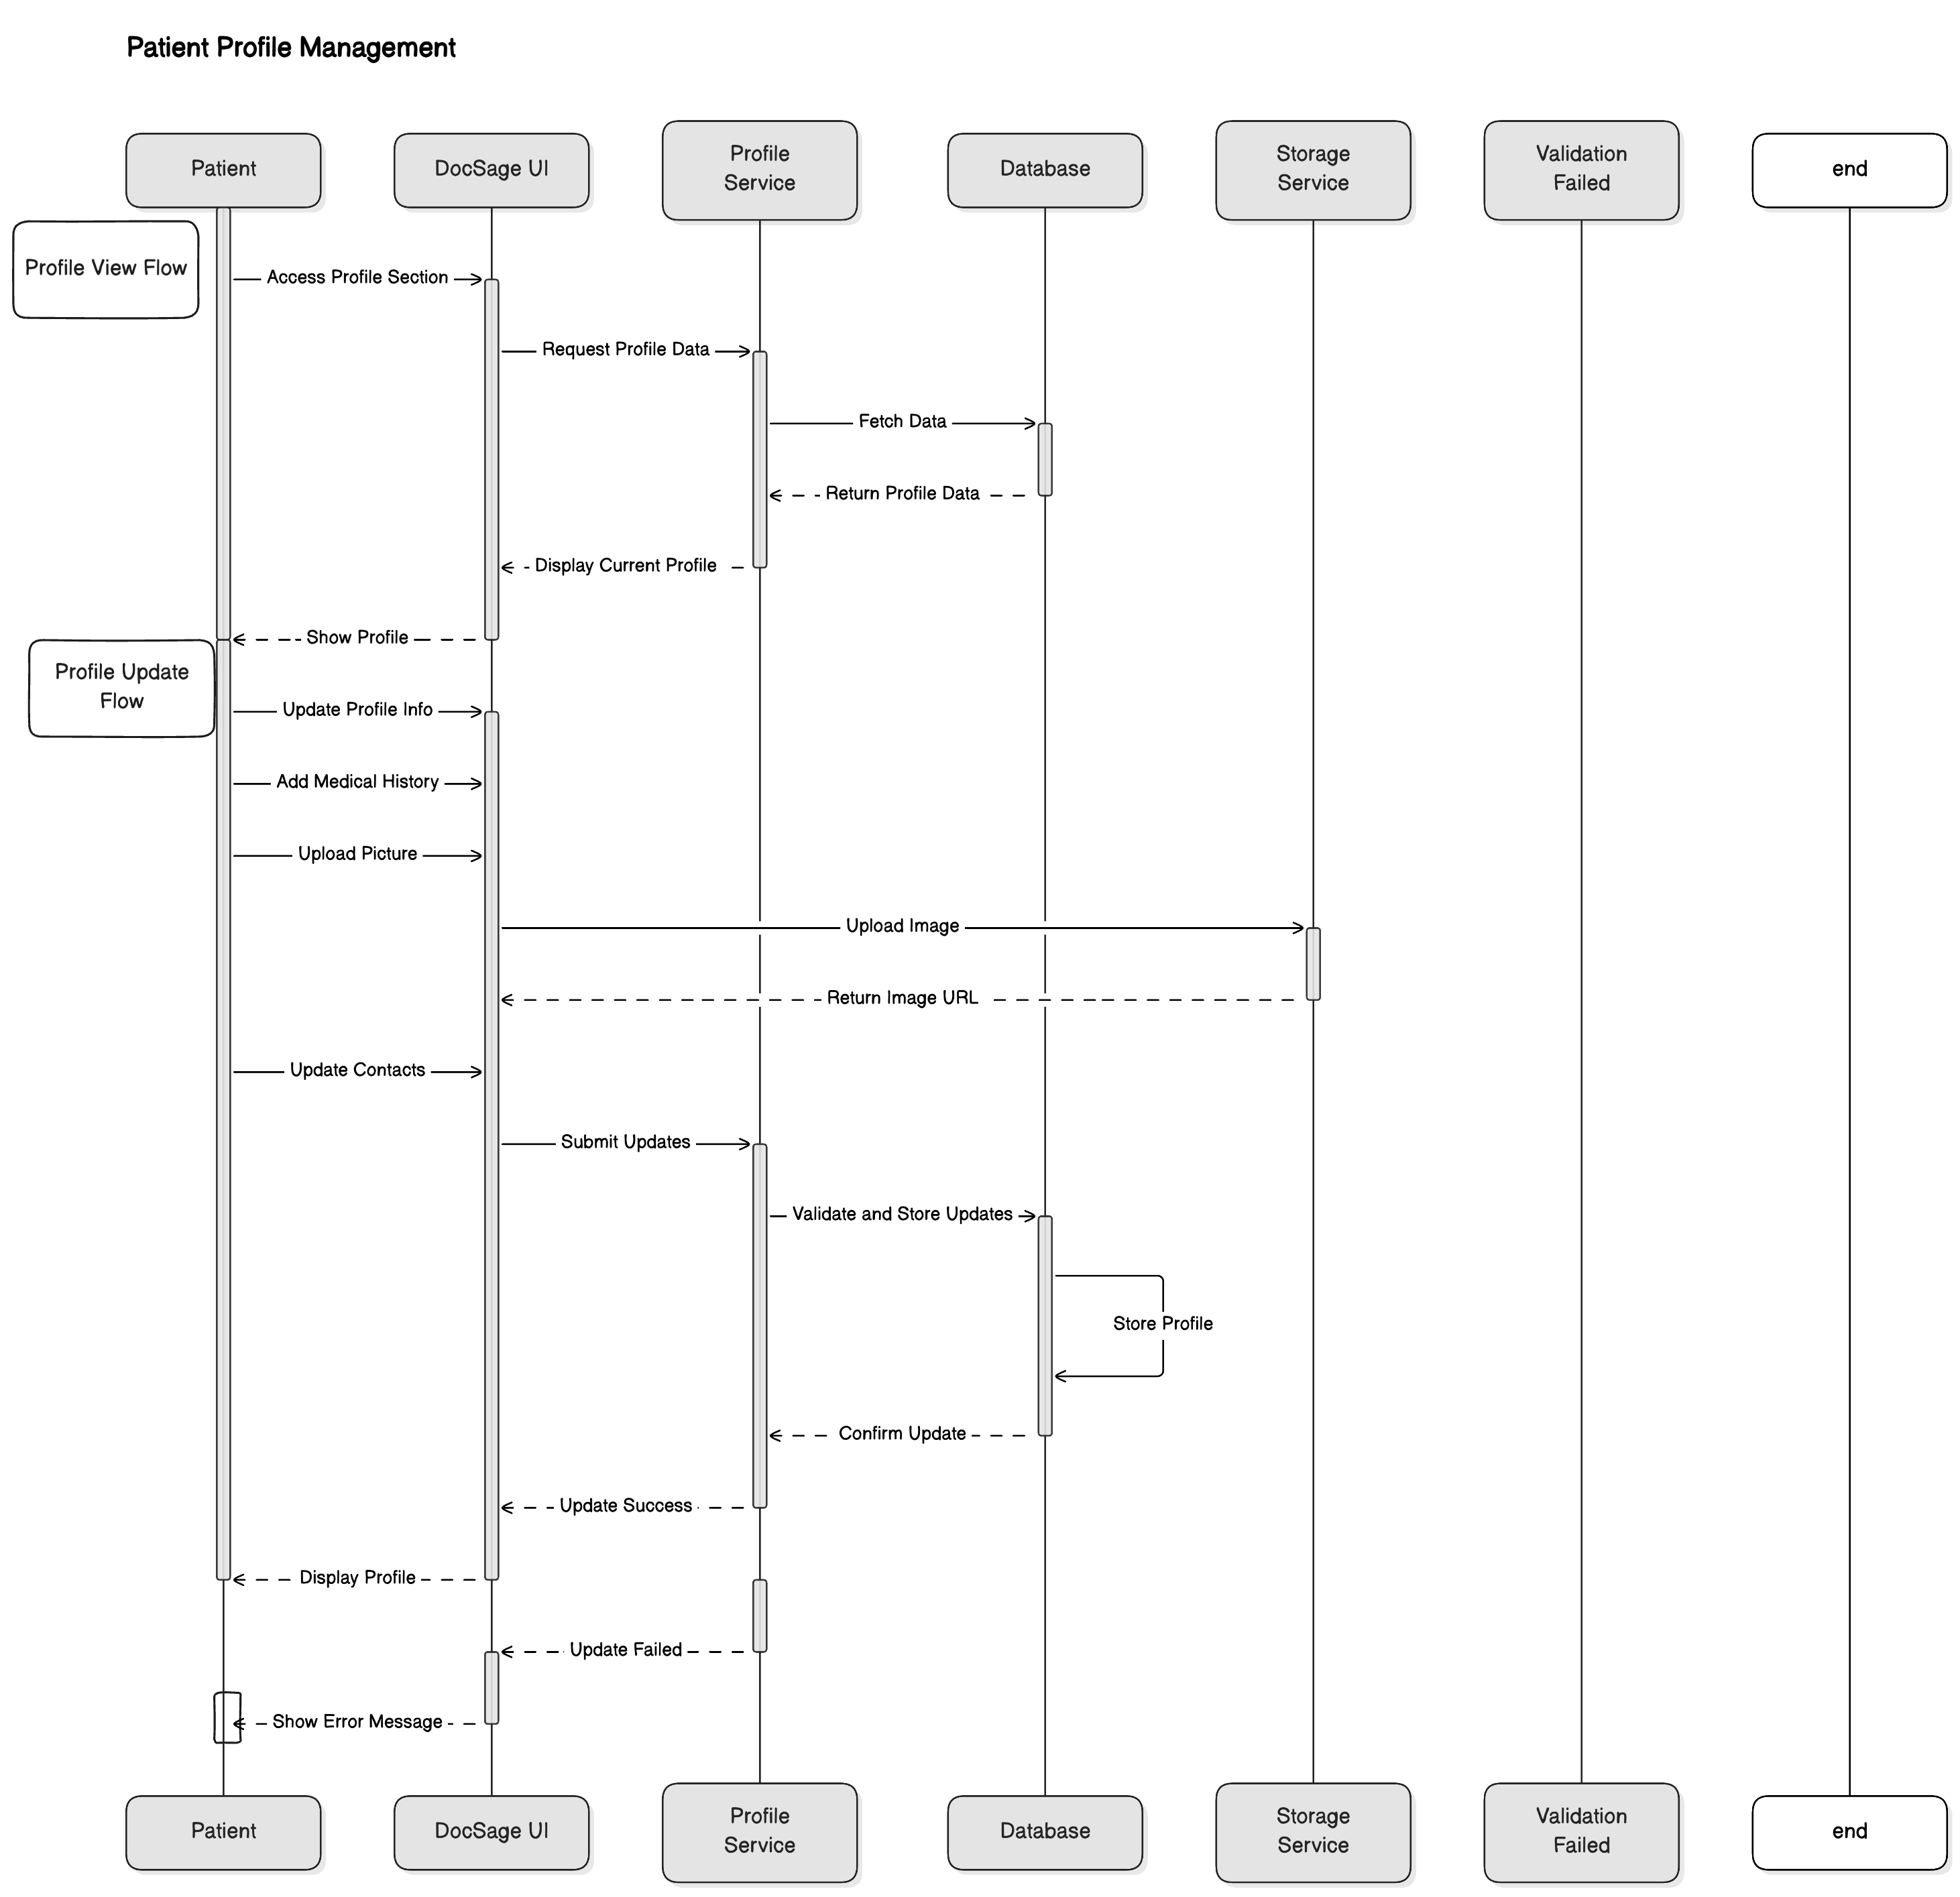

**Patient AI Service Subscription Sequence**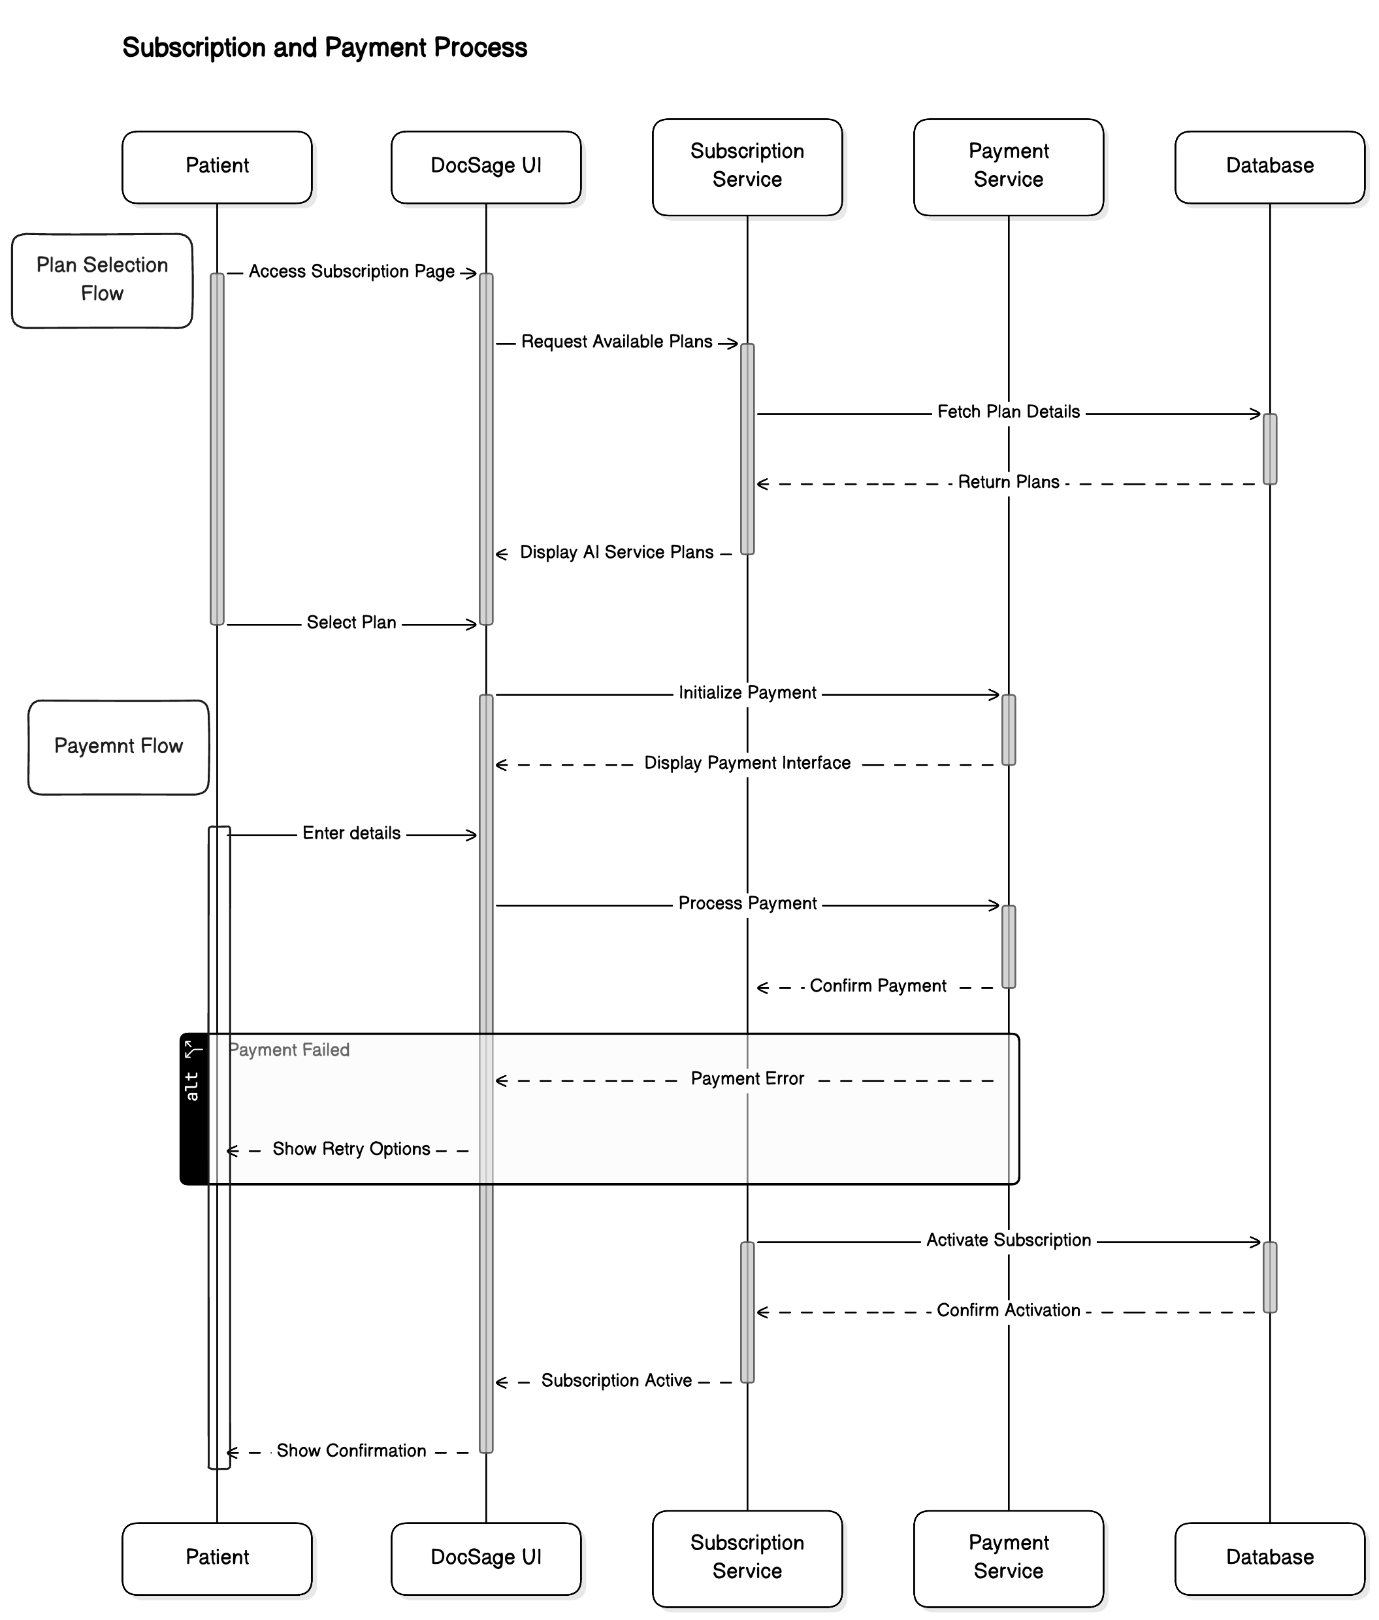

**Patient Image Upload Sequence**

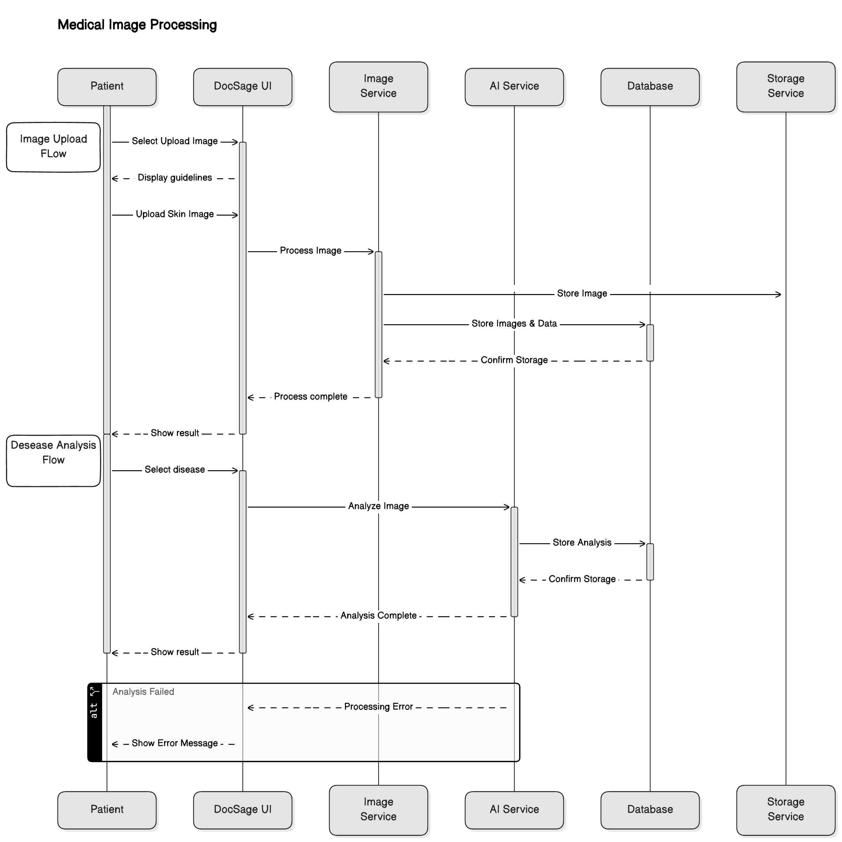

**Patient AI Diagnosis and Prescription View Sequence**

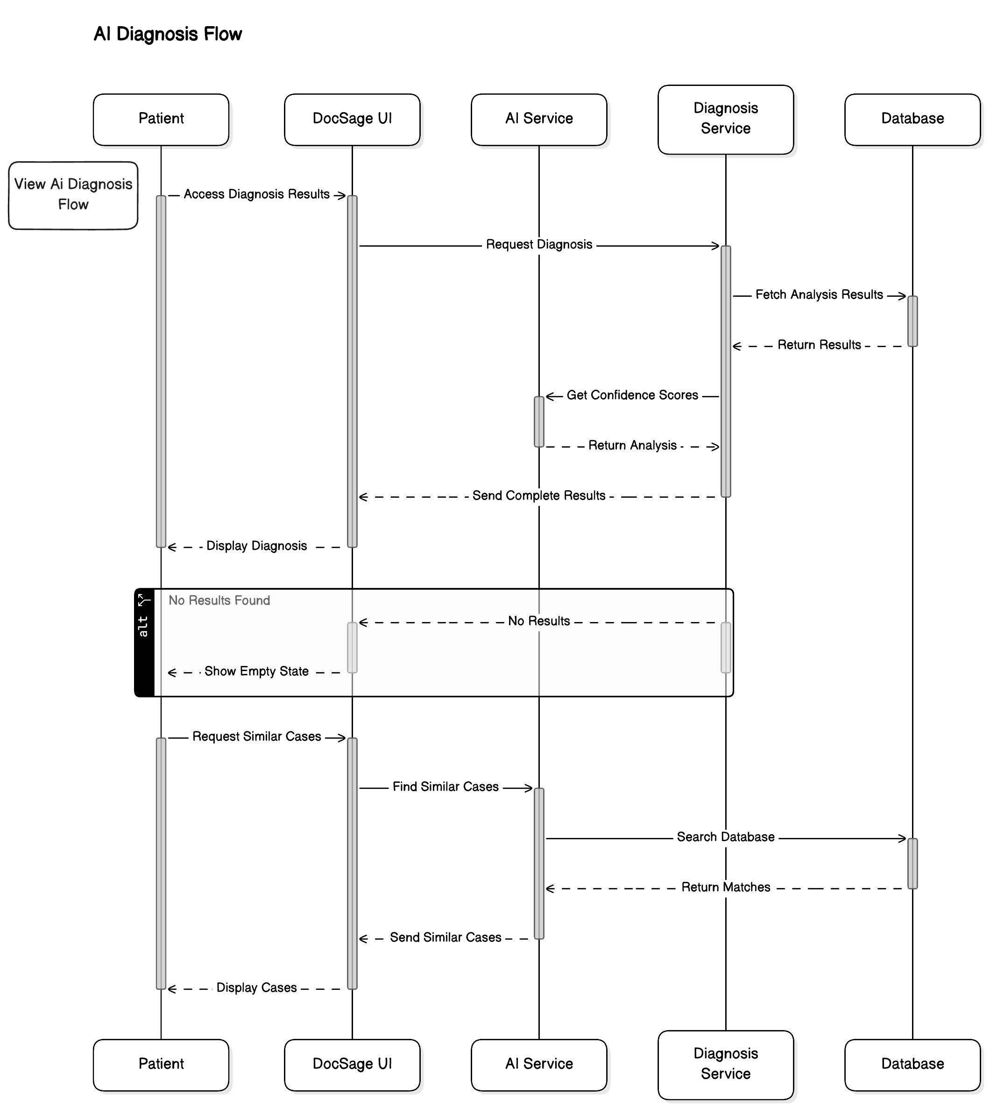

**Patient Prescription and Reports Management Sequence:**

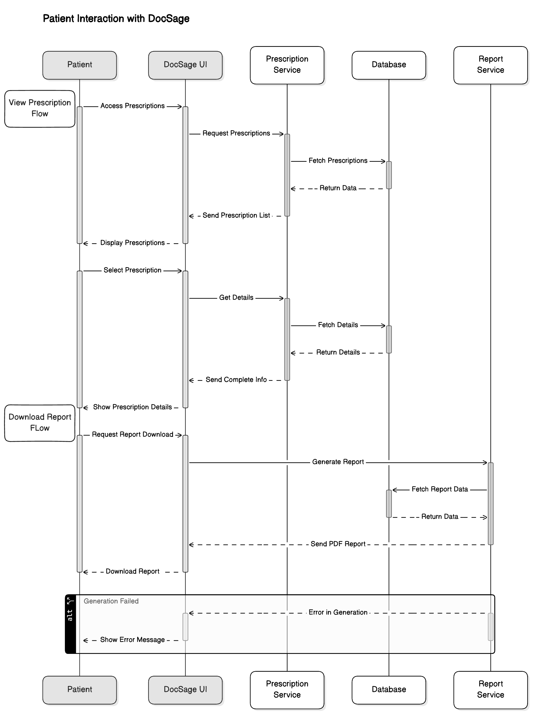

**Patient Symptom Checker and Video Consultation Sequence:**

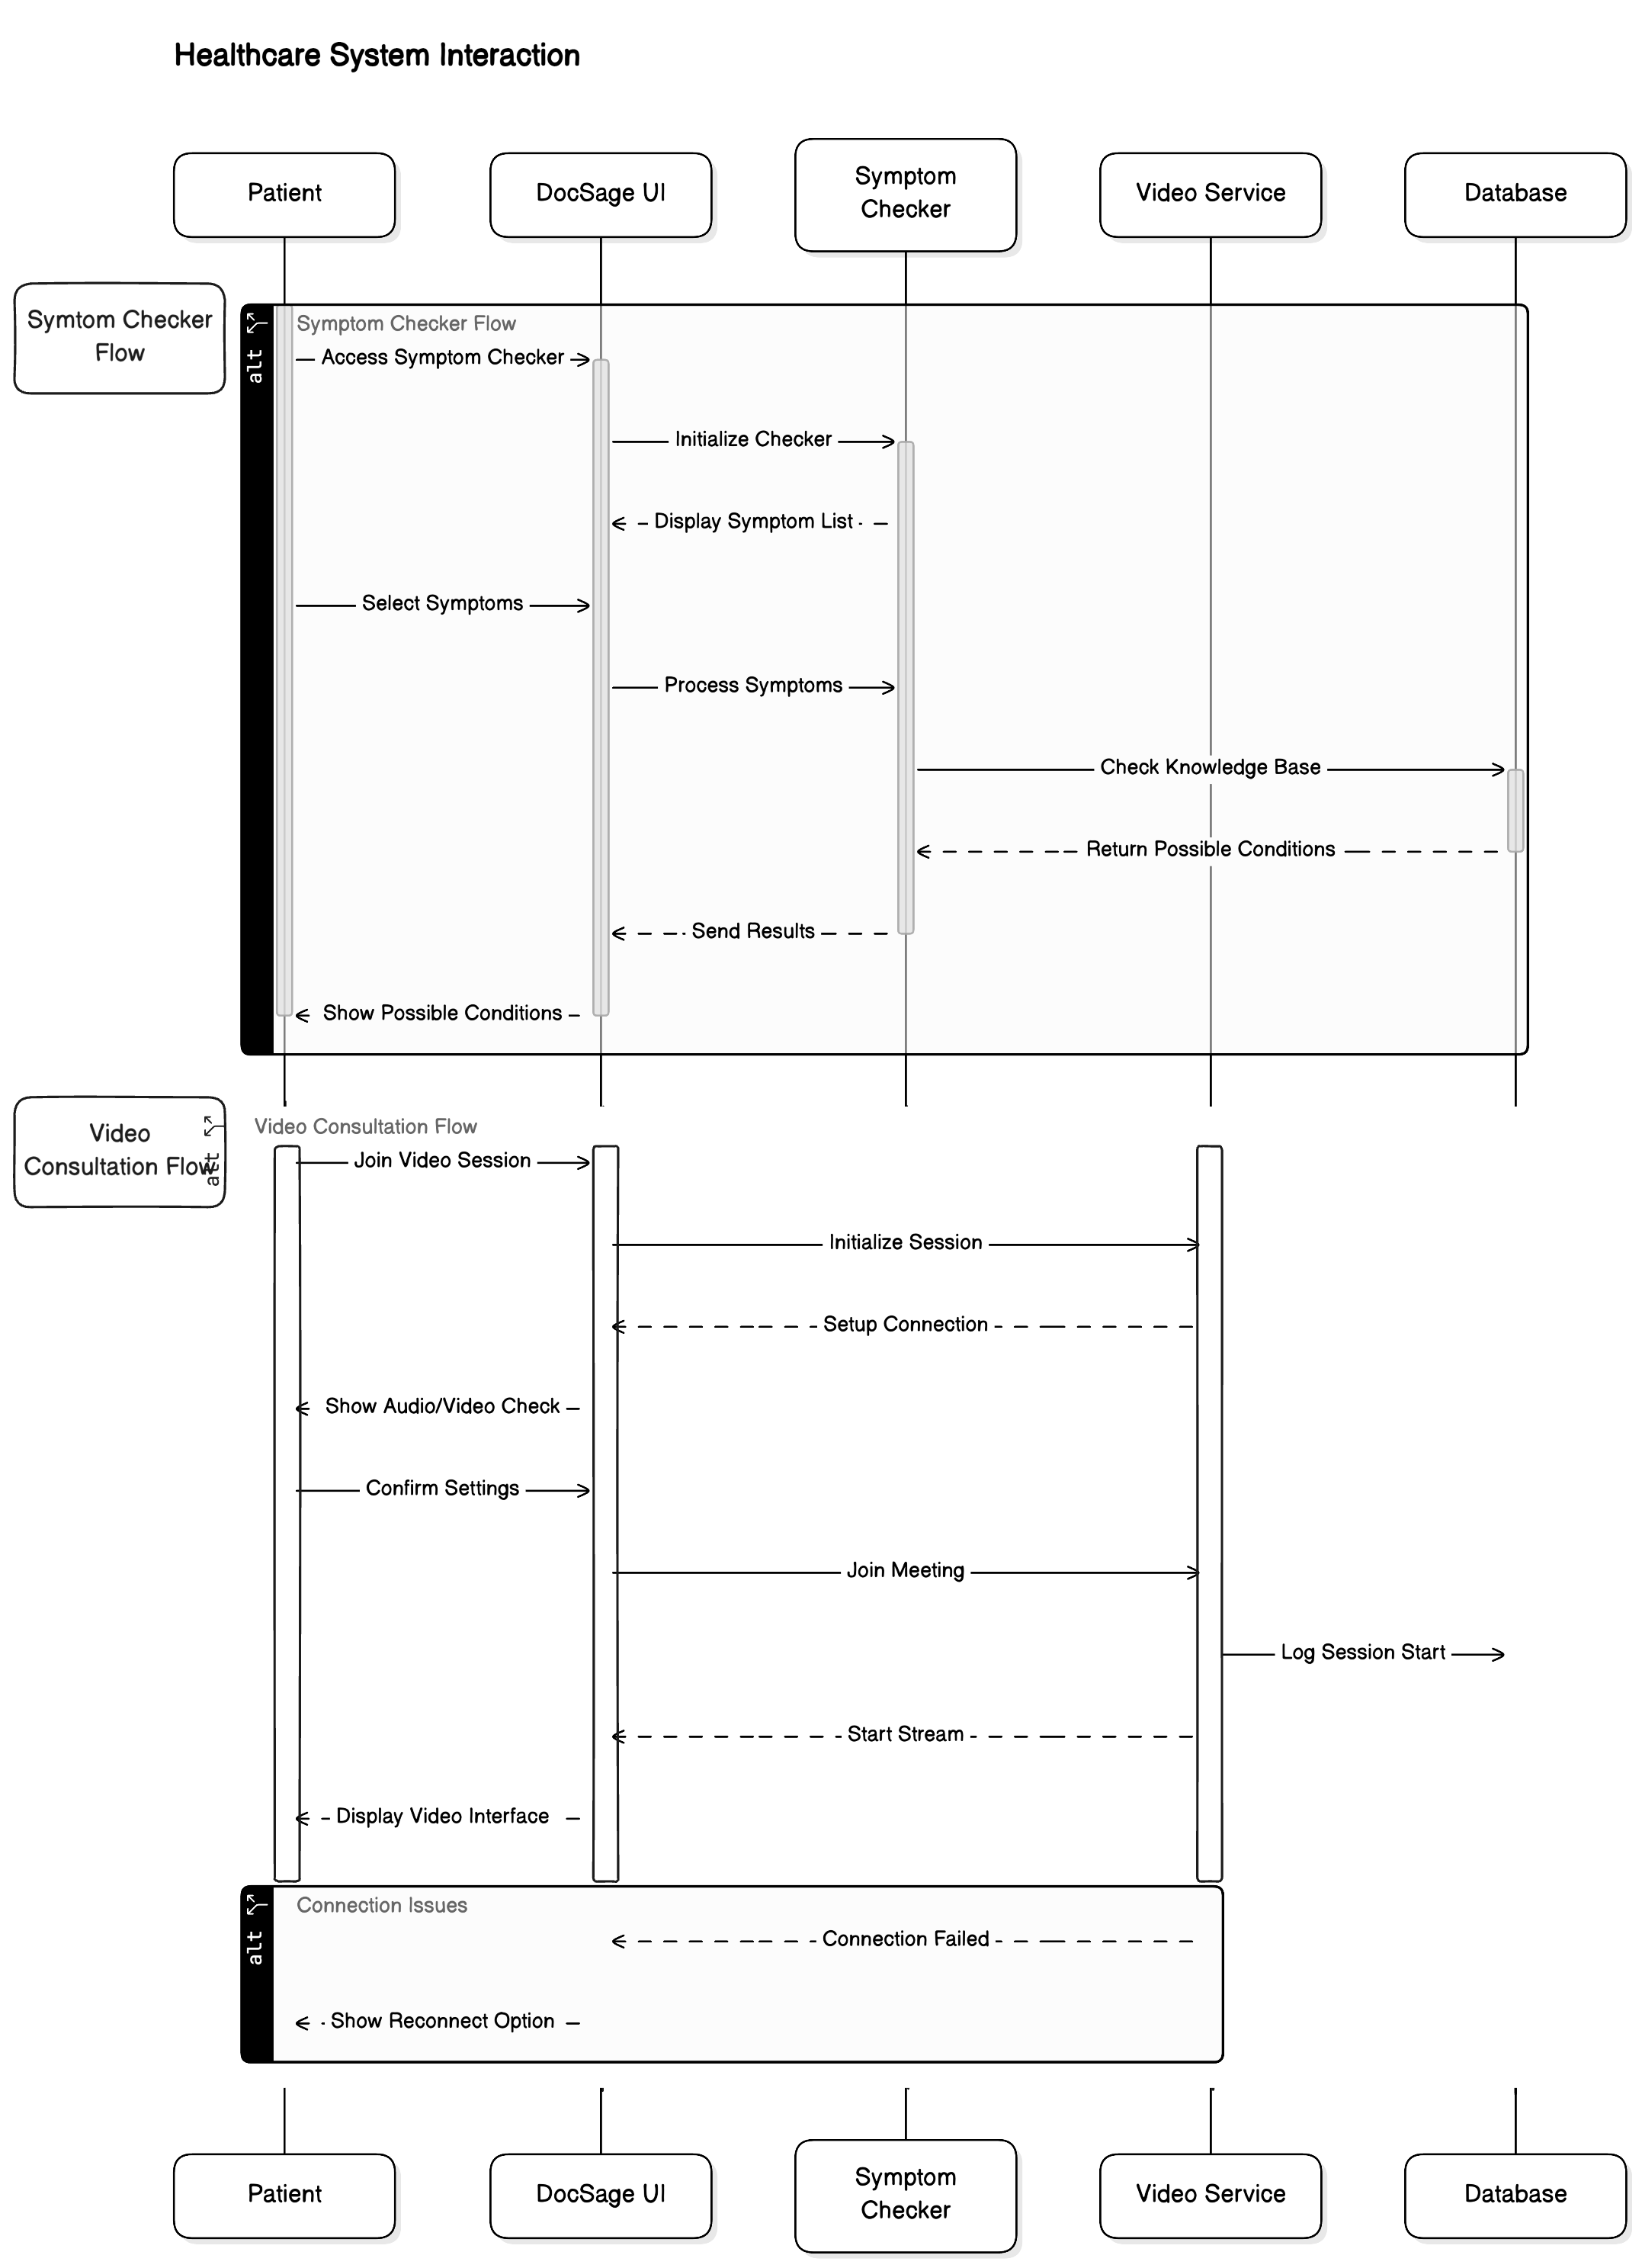

**Patient Appointment Booking and Doctor Messaging Sequence:**

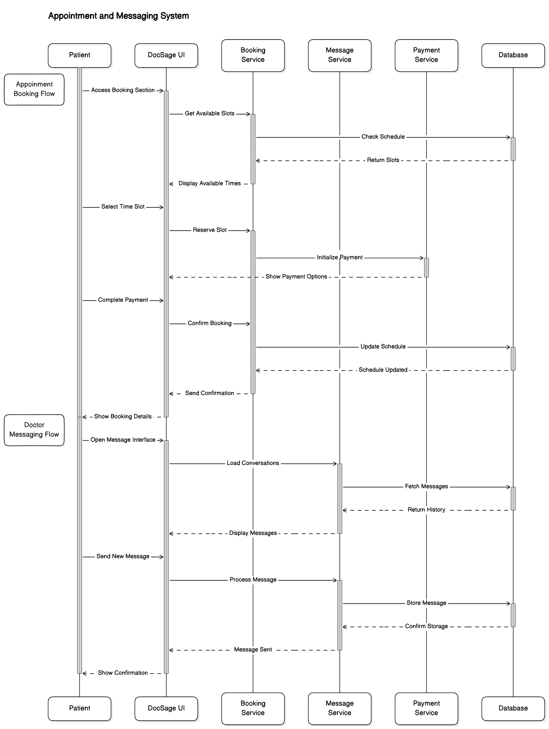

**Patient Article View and Logout Sequence**

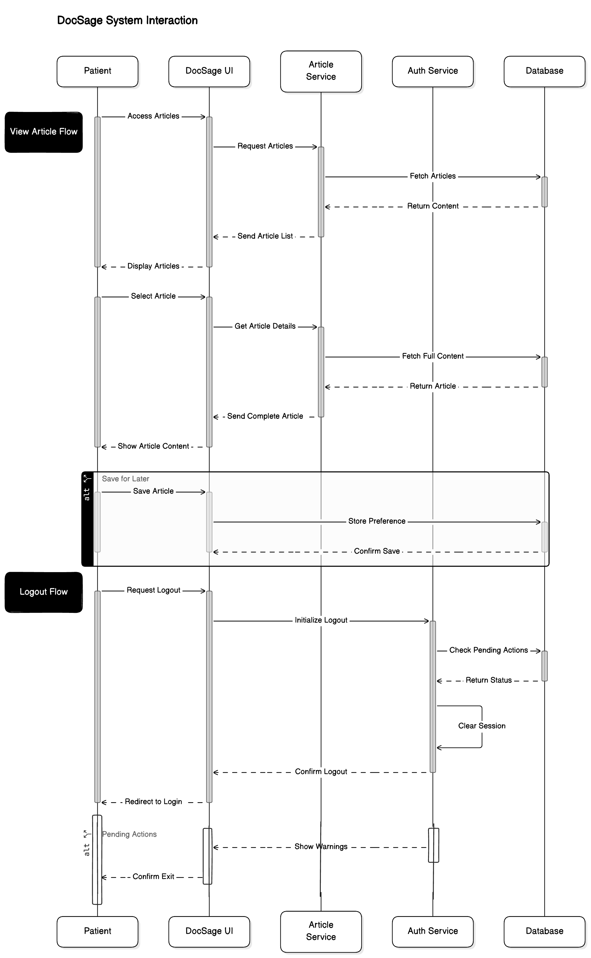

# **7. Project Plan**

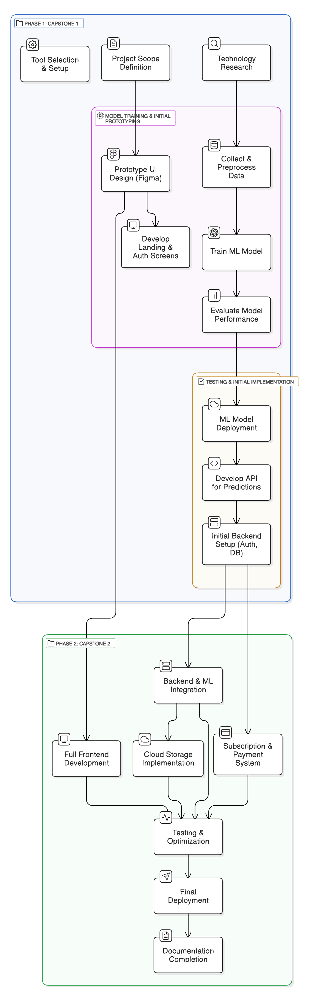

# **7. Testing Plan­­­**

## **7.1 Purpose of Testing**

This document outlines the comprehensive testing strategy for the Dermatology Consultation System, ensuring quality, reliability, and functionality across all components. The Purpose of this document is to make sure that the designed system is bug free

### **7.1.1 Project Overview**

A web-based platform facilitating: - Patient-doctor dermatology consultations - AI-powered skin disease diagnosis - Appointment scheduling and management - Prescription and medical report handling - Payment processing and subscription management

## **7.2 Scope of Testing**

### **7.2.1 In Scope**

* User authentication (Clerk integration)
* Patient management system
* Doctor management system
* Admin dashboard
* AI symptom checker
* Appointment scheduling
* Video consultation
* Payment processing (Stripe)
* Report generation
* Database operations
* API endpoints

# **8. Test Plan Strategy**

*The objective of this test plan is to ensure that there is a uniform understanding among anyone who reads the test plan, regarding the test methodology as well as the number of resources, schedules, etc.*

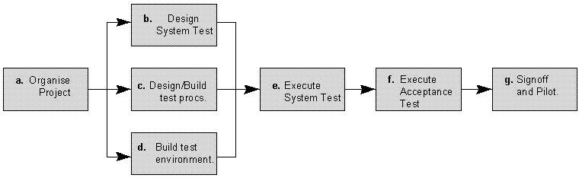

## **9.1 Unit Testing**

### **9.1.1. Participants**

* Nouman Shahid
* Usama

### **9.1.2. Methodology:**

* Jest testing framework
* Component-level testing
* Function-level testing
* Database query testing

## **9.2 Integration Testing**

### **9.2.1 Participants**

* Nouman Shahid
* Jameel Ahmad
* Usama

### **9.2.2 Methodology**

* API endpoint testing
* Service integration testing
* Database integration testing
* Third-party service integration testing

## **9.3 System Testing**

### **9.3.1 Participants:**

* Usama
* Jameel Ahmad

### **9.3.2 Methodology:**

* End-to-end scenario testing
* Performance testing
* Security testing
* User acceptance testing

# **10. Test Environment**

### **Development Environment:**

* Node.js server
* PostgreSQL database
* Prisma ORM
* Clerk authentication
* Stripe payment integration
* Cloud storage

### **Testing Tools:**

* Jest for unit testing
* Postman for API testing
* JMeter for performance testing
* Selenium for UI testing

# **11. Schedule**

|  |  |  |
| --- | --- | --- |
| **Testing Activities** | **Team Members** | **Deadline** |
| Test Plan Document | M. Umar Farooq | 05-02-25 |
| Test Case Template Design & Compilation | Usama, Nouman Shahid | 09-02-25 |
| Test Case Scenarios | M Umar Farooq, Nouman Shahid, Usama, Jameel Ahmad | 01-01-25 |
| Test Case execution | All Members of their respective test cases | 03-01-25 |
| Compilation of all test cases | M. Umar Farooq | 04-01-25 |
| Unit Tesing | Nouman Shahid, Usama, Jameel Ahmad | 10-01-25 |
| Integration Testing | Dr Fouqia Zafeer, M. Umar Farooq | 15-01-25 |
| System Testing | Dr Fouqia Zafeer, M. Umar Farooq | 20-01-25 |

# **12. Control Activities**

* Daily test status reports
* Weekly review meetings
* Bug tracking and monitoring
* Test case review sessions
* Quality gate reviews

# **13. Resources**

## **13.1 Human**

All team members fully participated in the whole work of the project including designing, implementing, Integrating and testing

## **13.2 Hardware**

No hardware was used in entire project testing.

## **13.3 Software**

* Selenium IDE
* Selenium Web Driver
* JMeter

# **14. Test Case Design and Description**

## **14.1 Admin Module**

**Test Case 1: Admin Sign In**

|  |  |  |  |  |  |  |  |
| --- | --- | --- | --- | --- | --- | --- | --- |
| **Test Case ID:** | | ATC-001 | | | | | |
| **QA Test Engineer** | | Muhammad Umar Farooq | | **Reviewed By** | | *Team DocSage* | |
| **Test case Version:** | | *1.0* | |  | | | |
| **Test Execution Date:** | | 20-01-2025 | | | | | |
| **Use Case Reference(s)** | | UC-A-001 | | | | | |
| **GUI Reference(s)** | | Admin Login Interface | | | | | |
| **Objective** | | To verify admin login functionality | | | | | |
| **Product / Version/ Module** | | *Version 1.0* | | | | | |
| **Environment:** | | The system should be properly connected to internet with supported browser | | | | | |
| **Assumptions:** | | Authentication service is running | | | | | |
| **Pre-Requisite:** | | Admin credentials exist in system | | | | | |
| **Test Case Description** | | This test case will validate the admin login process | | | | | |
| **Input Parameters** | **Expected Output** | | **Actual Output** | | **Test Conformance Status** | | **Possible Reason(s) in case of failure** |
| Valid admin credentials entered | System should grant access | | Access granted successfully | | Passed | | N/A |
| Invalid password entered | System should show error message | | Invalid credentials error | | Passed | | Authentication failed |

**Test Case 2: Access Symptom Checker**

|  |  |  |  |  |  |  |  |
| --- | --- | --- | --- | --- | --- | --- | --- |
| **Test Case ID:** | | ATC-002 | | | | | |
| **QA Test Engineer** | | Muhammad Umar Farooq | | **Reviewed By** | | *Team DocSage* | |
| **Test case Version:** | | *1.0* | |  | | | |
| **Test Execution Date:** | | 20-01-2025 | | | | | |
| **Use Case Reference(s)** | | UC-A-002 | | | | | |
| **GUI Reference(s)** | | Symptom Checker Page | | | | | |
| **Objective** | | To verify that the admin can access and use the symptom checker. | | | | | |
| **Product / Version/ Module** | | *Version 1.0* | | | | | |
| **Environment:** | | The system should be properly connected to internet with supported browser | | | | | |
| **Assumptions:** | | Authentication service is running | | | | | |
| **Pre-Requisite:** | | Admin must be logged in, and AI service must be operational. | | | | | |
| **Test Case Description** | | This test case will validate the symptom checker functionality. | | | | | |
| **Input Parameters** | **Expected Output** | | **Actual Output** | | **Test Conformance Status** | | **Possible Reason(s) in case of failure** |
| Symptoms input by admin | System processes input and returns results | | Results displayed successfully | | Passed | | N/A |

**Test Case 3: Verify Doctors**

|  |  |  |  |  |  |  |  |
| --- | --- | --- | --- | --- | --- | --- | --- |
| **Test Case ID:** | | ATC-003 | | | | | |
| **QA Test Engineer** | | Muhammad Umar Farooq | | **Reviewed By** | | *Team DocSage* | |
| **Test case Version:** | | *1.0* | |  | | | |
| **Test Execution Date:** | | 20-01-2025 | | | | | |
| **Use Case Reference(s)** | | UC-A-003 | | | | | |
| **GUI Reference(s)** | | Dashboard Page | | | | | |
| **Objective** | | To verify that the admin can review and approve/reject doctor verification requests. | | | | | |
| **Product / Version/ Module** | | *Version 1.0* | | | | | |
| **Environment:** | | The system should be properly connected to internet with supported browser | | | | | |
| **Assumptions:** | | Authentication service is running | | | | | |
| **Pre-Requisite:** | | Doctor verification requests exist. | | | | | |
| **Test Case Description** | | This test case will validate the doctor verification process. | | | | | |
| **Input Parameters** | **Expected Output** | | **Actual Output** | | **Test Conformance Status** | | **Possible Reason(s) in case of failure** |
| Admin reviews credentials | System displays verification details | | Verification details displayed | | Passed | | N/A |
| Admin approves/rejects request | System updates verification status | | Status updated successfully | | Passed | | N/A |

**Test Case 4: Manage Own Profile**

|  |  |  |  |  |  |  |  |
| --- | --- | --- | --- | --- | --- | --- | --- |
| **Test Case ID:** | | ATC-004 | | | | | |
| **QA Test Engineer** | | Muhammad Umar Farooq | | **Reviewed By** | | *Team DocSage* | |
| **Test case Version:** | | *1.0* | |  | | | |
| **Test Execution Date:** | | 20-01-2025 | | | | | |
| **Use Case Reference(s)** | | UC-A-005 | | | | | |
| **GUI Reference(s)** | | Profile Page | | | | | |
| **Objective** | | To verify that the admin can update their profile information. | | | | | |
| **Product / Version/ Module** | | *Version 1.0* | | | | | |
| **Environment:** | | The system should be properly connected to internet with supported browser | | | | | |
| **Assumptions:** | | Authentication service is running | | | | | |
| **Pre-Requisite:** | | Admin must be logged in | | | | | |
| **Test Case Description** | | This test case will validate the profile update functionality. | | | | | |
| **Input Parameters** | **Expected Output** | | **Actual Output** | | **Test Conformance Status** | | **Possible Reason(s) in case of failure** |
| Updated profile information | System validates and saves changes | | Changes saved successfully | | Passed | | N/A |

**Test Case 5: Manage Users**

|  |  |  |  |  |  |  |  |
| --- | --- | --- | --- | --- | --- | --- | --- |
| **Test Case ID:** | | ATC-005 | | | | | |
| **QA Test Engineer** | | Muhammad Umar Farooq | | **Reviewed By** | | *Team DocSage* | |
| **Test case Version:** | | *1.0* | |  | | | |
| **Test Execution Date:** | | 22-01-2025 | | | | | |
| **Use Case Reference(s)** | | UC-A-006 | | | | | |
| **GUI Reference(s)** | | Dashboard Page | | | | | |
| **Objective** | | To verify that the admin can manage user accounts. | | | | | |
| **Product / Version/ Module** | | *Version 1.0* | | | | | |
| **Environment:** | | The system should be properly connected to internet with supported browser | | | | | |
| **Assumptions:** | | Authentication service is running | | | | | |
| **Pre-Requisite:** | | Admin must be logged in. | | | | | |
| **Test Case Description** | | This test case will validate the user management functionality. | | | | | |
| **Input Parameters** | **Expected Output** | | **Actual Output** | | **Test Conformance Status** | | **Possible Reason(s) in case of failure** |
| Admin accesses user dashboard | System displays user categories | | Categories displayed successfully | | Passed | | N/A |
| Admin views user | System processes action | | Action completed successfully | | Passed | | N/A |

**Test Case 6: View Total Revenue**

|  |  |  |  |  |  |  |  |
| --- | --- | --- | --- | --- | --- | --- | --- |
| **Test Case ID:** | | ATC-006 | | | | | |
| **QA Test Engineer** | | Muhammad Umar Farooq | | **Reviewed By** | | *Team DocSage* | |
| **Test case Version:** | | *1.0* | |  | | | |
| **Test Execution Date:** | | 22-01-2025 | | | | | |
| **Use Case Reference(s)** | | UC-A-007 | | | | | |
| **GUI Reference(s)** | | Dashboard Page | | | | | |
| **Objective** | | To verify that the admin can view total revenue. | | | | | |
| **Product / Version/ Module** | | *Version 1.0* | | | | | |
| **Environment:** | | The system should be properly connected to internet with supported browser | | | | | |
| **Assumptions:** | | Authentication service is running | | | | | |
| **Pre-Requisite:** | | Financial transactions exist. | | | | | |
| **Test Case Description** | | This test case will validate revenue viewing functionality. | | | | | |
| **Input Parameters** | **Expected Output** | | **Actual Output** | | **Test Conformance Status** | | **Possible Reason(s) in case of failure** |
| Admin views revenue dashboard | System displays revenue metrics | | Revenue metrics displayed successfully | | Passed | | N/A |

**Test case 7: View Articles**

|  |  |  |  |  |  |  |  |
| --- | --- | --- | --- | --- | --- | --- | --- |
| **Test Case ID:** | | DTC-007 | | | | | |
| **QA Test Engineer** | | Muhammad Umar Farooq | | **Reviewed By** | | *Team DocSage* | |
| **Test case Version:** | | *1.0* | |  | | | |
| **Test Execution Date:** | | 12-02-2025 | | | | | |
| **Use Case Reference(s)** | | UC-D-007 | | | | | |
| **GUI Reference(s)** | | Articles Page | | | | | |
| **Objective** | | To verify health information access | | | | | |
| **Product / Version/ Module** | | *Version 1.0* | | | | | |
| **Environment:** | | System with article database | | | | | |
| **Assumptions:** | | Articles are available in system | | | | | |
| **Pre-Requisite:** | | Doctor is logged in and accessing articles | | | | | |
| **Test Case Description** | | This test case will validate the article viewing process | | | | | |
| **Input Parameters** | **Expected Output** | | **Actual Output** | | **Test Conformance Status** | | **Possible Reason(s) in case of failure** |
| Access articles page | System displays article list | | Article list displayed | | Passed | | N/A |
| Select article | System shows full content | | Full content displayed | | Passed | | N/A |
| Search for specific article | System displays search results | | Search results shown | | Passed | | N/A |
|  |  | |  | |  | |  |

**Test Case 8: Logout**

|  |  |  |  |  |  |  |  |
| --- | --- | --- | --- | --- | --- | --- | --- |
| **Test Case ID:** | | ATC-008 | | | | | |
| **QA Test Engineer** | | Muhammad Umar Farooq | | **Reviewed By** | | *Team DocSage* | |
| **Test case Version:** | | *1.0* | |  | | | |
| **Test Execution Date:** | | 22-01-2025 | | | | | |
| **Use Case Reference(s)** | | UC-A-0078 | | | | | |
| **GUI Reference(s)** | | All Pages | | | | | |
| **Objective** | | To verify that the admin can successfully log out. | | | | | |
| **Product / Version/ Module** | | *Version 1.0* | | | | | |
| **Environment:** | | The system should be properly connected to internet with supported browser | | | | | |
| **Assumptions:** | | Authentication service is running | | | | | |
| **Pre-Requisite:** | | Admin must be logged in | | | | | |
| **Test Case Description** | | This test case will validate the logout functionality. | | | | | |
| **Input Parameters** | **Expected Output** | | **Actual Output** | | **Test Conformance Status** | | **Possible Reason(s) in case of failure** |
| Admin clicks logout | System ends session and redirects to login page | | Logout successful | | Passed | | N/A |

**Test case 9:** View Pending Verification

|  |  |  |  |  |  |  |  |
| --- | --- | --- | --- | --- | --- | --- | --- |
| **Test Case ID:** | | ATC-008 | | | | | |
| **QA Test Engineer** | | Muhammad Umar Farooq | | **Reviewed By** | | *Team DocSage* | |
| **Test case Version:** | | *1.0* | |  | | | |
| **Test Execution Date:** | | 22-01-2025 | | | | | |
| **Use Case Reference(s)** | | UC-A-004 | | | | | |
| **GUI Reference(s)** | | Dashboard Page | | | | | |
| **Objective** | | To verify that the admin can view pending doctor verification requests. | | | | | |
| **Product / Version/ Module** | | *Version 1.0* | | | | | |
| **Environment:** | | The system should be properly connected to internet with supported browser | | | | | |
| **Assumptions:** | | Authentication service is running | | | | | |
| **Pre-Requisite:** | | Admin must be logged in and verification requests must exist | | | | | |
| **Test Case Description** | | This test case will validate the admin's ability to view the verification queue | | | | | |
| **Input Parameters** | **Expected Output** | | **Actual Output** | | **Test Conformance Status** | | **Possible Reason(s) in case of failure** |
| Admin accesses verification queue | System displays pending verifications | | Pending verifications displayed | | Passed | | N/A |
| No pending verifications exist | System shows empty verification queue with appropriate message | | Empty queue message displayed | | Passed | | N/A |
| Large number of verification requests | System paginates results properly | | Pagination working as expected | | Passed | | N/A |

**Test Case 10: Track New Registrations**

|  |  |  |  |  |  |  |  |
| --- | --- | --- | --- | --- | --- | --- | --- |
| **Test Case ID:** | | ATC-009 | | | | | |
| **QA Test Engineer** | | Muhammad Umar Farooq | | **Reviewed By** | | *Team DocSage* | |
| **Test case Version:** | | *1.0* | |  | | | |
| **Test Execution Date:** | | 23-01-2025 | | | | | |
| **Use Case Reference(s)** | | UC-A-006 | | | | | |
| **GUI Reference(s)** | | Dashboard Page | | | | | |
| **Objective** | | To verify that the admin can view pending doctor verification requests. | | | | | |
| **Product / Version/ Module** | | *Version 1.0* | | | | | |
| **Environment:** | | The system should be properly connected to internet with supported browser | | | | | |
| **Assumptions:** | | Authentication service is running | | | | | |
| **Pre-Requisite:** | | Admin must be logged in and new registrations must exist | | | | | |
| **Test Case Description** | | This test case will validate the admin's ability to track new registrations | | | | | |
| **Input Parameters** | **Expected Output** | | **Actual Output** | | **Test Conformance Status** | | **Possible Reason(s) in case of failure** |
| Admin accesses registration statistics | System displays registration analytics | | Registration data displayed | | Passed | | N/A |

## 

## **14.2 Doctor Module**

**Test case 1: SignUp/Signin Page**

|  |
| --- |

|  |  |  |  |  |  |  |  |
| --- | --- | --- | --- | --- | --- | --- | --- |
| **Test Case ID:** | | DTC-001 | | | | | |
| **QA Test Engineer** | | Muhammad Umar Farooq | | **Reviewed By** | | *Team DocSage* | |
| **Test case Version:** | | *1.0* | |  | | | |
| **Test Execution Date:** | | 12-02-2025 | | | | | |
| **Use Case Reference(s)** | | UC-D-001 | | | | | |
| **GUI Reference(s)** | | Sign Up/Sign In Page | | | | | |
| **Objective** | | To verify doctor sign up and sign in with professional credentials | | | | | |
| **Product / Version/ Module** | | *Version 1.0* | | | | | |
| **Environment:** | | The system should be properly connected to internet with supported browser | | | | | |
| **Assumptions:** | | Database server is running and Clerk authentication service is available | | | | | |
| **Pre-Requisite:** | | User has accessed the sign up/sign in page | | | | | |
| **Test Case Description** | | his test case will validate the doctor registration and login process | | | | | |
| **Input Parameters** | **Expected Output** | | **Actual Output** | | **Test Conformance Status** | | **Possible Reason(s) in case of failure** |
| Valid medical credentials and license for sign up | System validates credentials successfully | | Credentials verified | | Passed | | N/A |
| Complete personal/professional details, uploaded license and credentials | System saves information and triggers admin verification | | Registration submitted for verification | | Passed | | N/A |
| Valid registered email and password for sign in | | System validates credentials and grants appropriate access | | Access granted based on verification status | | Passed | | Fee below minimum limit of 200 |
| Invalid PMDC format entered | System should show validation error | | PMDC format error displayed | | Passed | | Invalid PMDC number format |
| Missing required documentation | System should show document validation error | | Document error displayed | |  | | Required documents not uploaded |

**Test case 2: Await Approval Test Case**

|  |  |  |  |  |  |  |  |
| --- | --- | --- | --- | --- | --- | --- | --- |
| **Test Case ID:** | | DTC-002 | | | | | |
| **QA Test Engineer** | | Muhammad Umar Farooq | | **Reviewed By** | | *Team DocSage* | |
| **Test case Version:** | | *1.0* | |  | | | |
| **Test Execution Date:** | | 12-02-2025 | | | | | |
| **Use Case Reference(s)** | | UC-D-002 | | | | | |
| **GUI Reference(s)** | | Dashboard (restricted view) | | | | | |
| **Objective** | | To verify the account verification process for doctors | | | | | |
| **Product / Version/ Module** | | *Version 1.0* | | | | | |
| **Environment:** | | System with admin review functionality | | | | | |
| **Assumptions:** | | Doctor has completed sign-up and initial authentication | | | | | |
| **Pre-Requisite:** | | Doctor account is in pending status | | | | | |
| **Test Case Description** | | This test case will validate the doctor account verification process | | | | | |
| **Input Parameters** | **Expected Output** | | **Actual Output** | | **Test Conformance Status** | | **Possible Reason(s) in case of failure** |
| New doctor account license for sign up | System displays restricted dashboard with pending message credentials successfully | | Restricted dashboard displayed | | Passed | | N/A |
| Admin reviews PMDC number | System flags for admin review | | Account flagged for review | | Passed | | N/A |
| Admin reviews license documentation | Admin can view uploaded documents | | Documents accessible to admin | | Passed | | N/A |
| Admin approves account | System updates to approved status and notifies doctor | | Account approved and notification sent | | Passed | | N/A |
| Admin rejects account | System updates to rejected status and notifies doctor | | Account rejected and notification sent | | Passed | | N/A |

**Test case 3: Manage Profile Test Case**

|  |  |  |  |  |  |  |  |
| --- | --- | --- | --- | --- | --- | --- | --- |
| **Test Case ID:** | | DTC-003 | | | | | |
| **QA Test Engineer** | | Muhammad Umar Farooq | | **Reviewed By** | | *Team DocSage* | |
| **Test case Version:** | | *1.0* | |  | | | |
| **Test Execution Date:** | | 12-02-2025 | | | | | |
| **Use Case Reference(s)** | | UC-D-003 | | | | | |
| **GUI Reference(s)** | | Dashboard Page - Profile Section | | | | | |
| **Objective** | | To verify doctor can update and manage professional profile | | | | | |
| **Product / Version/ Module** | | *Version 1.0* | | | | | |
| **Environment:** | | System with profile management functionality | | | | | |
| **Assumptions:** | | Doctor account is verified and active | | | | | |
| **Pre-Requisite:** | | Doctor is logged into the system | | | | | |
| **Test Case Description** | | This test case will validate the profile management functionality | | | | | |
| **Input Parameters** | **Expected Output** | | **Actual Output** | | **Test Conformance Status** | | **Possible Reason(s) in case of failure** |
| Access profile section | System displays current profile information | | Profile information displayed | | Passed | | N/A |
| Update professional qualifications | System validates and saves changes | | Qualifications updated | | Passed | | N/A |
| Update specializations | System validates and saves changes | | Specializations updated | | Passed | | N/A |
|  |  | |  | |  | |  |

**Test case 4: Set Availability Test Case**

|  |  |  |  |  |  |  |  |
| --- | --- | --- | --- | --- | --- | --- | --- |
| **Test Case ID:** | | DTC-004 | | | | | |
| **QA Test Engineer** | | Muhammad Umar Farooq | | **Reviewed By** | | *Team DocSage* | |
| **Test case Version:** | | *1.0* | |  | | | |
| **Test Execution Date:** | | 12-02-2025 | | | | | |
| **Use Case Reference(s)** | | UC-D-002 | | | | | |
| **GUI Reference(s)** | | Dashboard Page - Schedule Management | | | | | |
| **Objective** | | To verify doctor can set and manage availability slots | | | | | |
| **Product / Version/ Module** | | *Version 1.0* | | | | | |
| **Environment:** | | System with calendar functionality | | | | | |
| **Assumptions:** | | Doctor account is verified and active | | | | | |
| **Pre-Requisite:** | | Doctor is logged in and accessing availability settings | | | | | |
| **Test Case Description** | | This test case will validate the availability management functionality | | | | | |
| **Input Parameters** | **Expected Output** | | **Actual Output** | | **Test Conformance Status** | | **Possible Reason(s) in case of failure** |
| Access schedule management | System displays calendar view | | Calendar view displayed | | Passed | | N/A |
| Set working hours | System updates availability time slots | | Time slots updated | | Passed | | N/A |
| Define consultation duration | System updates appointment duration | | Duration updated | | Passed | | N/A |
| Set multiple schedules for different days | System stores all schedule variations | | Multiple schedules saved | | Passed | | N/A |

**Test case 5: Manage Appointments Test Case**

|  |  |  |  |  |  |  |  |
| --- | --- | --- | --- | --- | --- | --- | --- |
| **Test Case ID:** | | DTC-005 | | | | | |
| **QA Test Engineer** | | Muhammad Umar Farooq | | **Reviewed By** | | *Team DocSage* | |
| **Test case Version:** | | *1.0* | |  | | | |
| **Test Execution Date:** | | 12-02-2025 | | | | | |
| **Use Case Reference(s)** | | UC-D-005 | | | | | |
| **GUI Reference(s)** | | Dashboard Page - Appointments | | | | | |
| **Objective** | | To verify doctor can manage patient appointments | | | | | |
| **Product / Version/ Module** | | *Version 1.0* | | | | | |
| **Environment:** | | System with notification functionality | | | | | |
| **Assumptions:** | | Active appointments exist in the system | | | | | |
| **Pre-Requisite:** | | Doctor is logged in and accessing appointment management | | | | | |
| **Test Case Description** | | This test case will validate the appointment management process | | | | | |
| **Input Parameters** | **Expected Output** | | **Actual Output** | | **Test Conformance Status** | | **Possible Reason(s) in case of failure** |
| View appointment details | System shows appointment details | | Details displayed | | Passed | | N/A |
| Confirm pending appointment | System updates status and notifies patient | | Status updated; notification sent | | Passed | | N/A |
| Cancel appointment without reason | System prompts for required reason | | Reason required message shown | | Passed | | Cancellation reason required |
| Cancel appointment with reason | System updates status and notifies patient | | Status updated; notification sent | | Passed | | N/A |
| View confirmed appointments | System displays confirmed appointments | | Confirmed appointments shown | | Passed | | N/A |

**Test case 6: Message Patients Test Case**

|  |  |  |  |  |  |  |  |
| --- | --- | --- | --- | --- | --- | --- | --- |
| **Test Case ID:** | | DTC-006 | | | | | |
| **QA Test Engineer** | | Muhammad Umar Farooq | | **Reviewed By** | | *Team DocSage* | |
| **Test case Version:** | | *1.0* | |  | | | |
| **Test Execution Date:** | | 12-02-2025 | | | | | |
| **Use Case Reference(s)** | | UC-D-006 | | | | | |
| **GUI Reference(s)** | | Chat Page | | | | | |
| **Objective** | | To verify doctor can message patients with active appointments | | | | | |
| **Product / Version/ Module** | | *Version 1.0* | | | | | |
| **Environment:** | | System with messaging functionality | | | | | |
| **Assumptions:** | | Confirmed appointments exist in the system | | | | | |
| **Pre-Requisite:** | | Doctor is logged in and accessing messaging interface | | | | | |
| **Test Case Description** | | This test case will validate the patient communication process | | | | | |
| **Input Parameters** | **Expected Output** | | **Actual Output** | | **Test Conformance Status** | | **Possible Reason(s) in case of failure** |
| Access messaging interface | System displays list of patients with active appointments | | Patient list displayed | | Passed | | N/A |
| Select patient to message | System opens messaging thread with selected patient | | Thread opened | | Passed | | N/A |
| Compose and send message | System delivers message and stores in history | | Message delivered and stored | | Passed | | Cancellation reason required |
| Receive patient message | System displays message in real-time | | Message displayed | | Passed | | N/A |
| Respond to patient message | System updates conversation in real-time | | | Conversation updated | | Passed | | N/A |

**Test case 7: Conduct Video Consultations Test Case**

|  |  |  |  |  |  |  |  |
| --- | --- | --- | --- | --- | --- | --- | --- |
| **Test Case ID:** | | DTC-007 | | | | | |
| **QA Test Engineer** | | Muhammad Umar Farooq | | **Reviewed By** | | *Team DocSage* | |
| **Test case Version:** | | *1.0* | |  | | | |
| **Test Execution Date:** | | 12-02-2025 | | | | | |
| **Use Case Reference(s)** | | UC-D-007 | | | | | |
| **GUI Reference(s)** | | Chat Page - Video Interface | | | | | |
| **Objective** | | To verify video consultation functionality | | | | | |
| **Product / Version/ Module** | | *Version 1.0* | | | | | |
| **Environment:** | | System with video streaming capability | | | | | |
| **Assumptions:** | | Stable internet connection and scheduled video appointment exists | | | | | |
| **Pre-Requisite:** | | Appointment time has arrived | | | | | |
| **Test Case Description** | | This test case will validate the video consultation process | | | | | |
| **Input Parameters** | **Expected Output** | | **Actual Output** | | **Test Conformance Status** | | **Possible Reason(s) in case of failure** |
| Enter virtual consultation room | System initiates video call connection | | Connection initiated | | Passed | | N/A |
| Establish connection with patient | System enables audio/video transmission | | A/V transmission enabled | | Passed | | N/A |
| Conduct consultation | System maintains connection and records duration | | Connection maintained | | Passed | | Cancellation reason required |
| End consultation | System updates status to "completed" and deducts platform fee | | Status updated, fee deducted | | Passed | | N/A |
| Network interruption | System shows reconnection prompt | | Reconnection handled | | Passed | | Connection stability issues |

**Test case 8: Access Patient Records Test Case**

|  |  |  |  |  |  |  |  |
| --- | --- | --- | --- | --- | --- | --- | --- |
| **Test Case ID:** | | DTC-008 | | | | | |
| **QA Test Engineer** | | Muhammad Umar Farooq | | **Reviewed By** | | *Team DocSage* | |
| **Test case Version:** | | *1.0* | |  | | | |
| **Test Execution Date:** | | 12-02-2025 | | | | | |
| **Use Case Reference(s)** | | UC-D-008 | | | | | |
| **GUI Reference(s)** | | Dashboard Page - Patient Records | | | | | |
| **Objective** | | To verify doctor can access patient records | | | | | |
| **Product / Version/ Module** | | *Version 1.0* | | | | | |
| **Environment:** | | System with patient database functionality | | | | | |
| **Assumptions:** | | Doctor has patients with active/past consultations | | | | | |
| **Pre-Requisite:** | | Doctor is logged in and accessing patient records | | | | | |
| **Test Case Description** | | This test case will validate the patient record access process | | | | | |
| **Input Parameters** | **Expected Output** | | **Actual Output** | | **Test Conformance Status** | | **Possible Reason(s) in case of failure** |
| Search for specific patient | System displays patient list | | Patient list displayed | | Passed | | N/A |
| Select patient | System shows the comprehensive record | | Patient record displayed | | Passed | | N/A |

**Test case 9: Issue Prescriptions Test Case**

|  |  |  |  |  |  |  |  |
| --- | --- | --- | --- | --- | --- | --- | --- |
| **Test Case ID:** | | DTC-009 | | | | | |
| **QA Test Engineer** | | Muhammad Umar Farooq | | **Reviewed By** | | *Team DocSage* | |
| **Test case Version:** | | *1.0* | |  | | | |
| **Test Execution Date:** | | 12-02-2025 | | | | | |
| **Use Case Reference(s)** | | UC-D-009 | | | | | |
| **GUI Reference(s)** | | Prescription Page | | | | | |
| **Objective** | | To verify doctor can create and issue prescriptions | | | | | |
| **Product / Version/ Module** | | *Version 1.0* | | | | | |
| **Environment:** | | System with prescription management functionality | | | | | |
| **Assumptions:** | | Completed consultation exists | | | | | |
| **Pre-Requisite:** | | Doctor has completed patient consultation | | | | | |
| **Test Case Description** | | This test case will validate the prescription creation process | | | | | |
| **Input Parameters** | **Expected Output** | | **Actual Output** | | **Test Conformance Status** | | **Possible Reason(s) in case of failure** |
| Access prescription module | System displays prescription template linked to patient | | Template displayed | | Passed | | N/A |
| Enter medications | System validates entry | | Entry validated | | Passed | | N/A |
| Enter dosage instructions | System validates entry | | Entry validated | | Passed | | N/A |

**Test case 10: Use AI Symptom Checker Test Case**

|  |  |  |  |  |  |  |  |
| --- | --- | --- | --- | --- | --- | --- | --- |
| **Test Case ID:** | | DTC-010 | | | | | |
| **QA Test Engineer** | | Muhammad Umar Farooq | | **Reviewed By** | | *Team DocSage* | |
| **Test case Version:** | | *1.0* | |  | | | |
| **Test Execution Date:** | | 12-02-2025 | | | | | |
| **Use Case Reference(s)** | | UC-D-010 | | | | | |
| **GUI Reference(s)** | | Symptom Checker Page | | | | | |
| **Objective** | | To verify AI-assisted diagnostic functionality | | | | | |
| **Product / Version/ Module** | | *Version 1.0* | | | | | |
| **Environment:** | | System with AI integration | | | | | |
| **Assumptions:** | | Doctor has active subscription to symptom checker service | | | | | |
| **Pre-Requisite:** | | Doctor is logged in and accessing symptom checker | | | | | |
| **Test Case Description** | | This test case will validate the AI symptom checker process | | | | | |
| **Input Parameters** | **Expected Output** | | **Actual Output** | | **Test Conformance Status** | | **Possible Reason(s) in case of failure** |
| Access AI symptom checker tool | System displays upload interface | | Upload interface displayed | | Passed | | N/A |
| Upload skin image for analysis | System sends image to AI model API | | Image sent to API | | Passed | | N/A |
| Process valid image | AI model returns diagnosis classification with skin condition | | Diagnosis returned | | Passed | | N/A |
| View results | System displays results with recommendation and related article | | Results displayed with recommendations | | Passed | | N/A |
| Access symptom checker without subscription | System prompts for subscription | | Subscription prompt shown | | Passed | | No active subscription |
|  |  | |  | |  | |  |

**Test case 11: Get Subscription Test Case**

|  |  |  |  |  |  |  |  |
| --- | --- | --- | --- | --- | --- | --- | --- |
| **Test Case ID:** | | DTC-011 | | | | | |
| **QA Test Engineer** | | Muhammad Umar Farooq | | **Reviewed By** | | *Team DocSage* | |
| **Test case Version:** | | *1.0* | |  | | | |
| **Test Execution Date:** | | 12-02-2025 | | | | | |
| **Use Case Reference(s)** | | UC-D-011 | | | | | |
| **GUI Reference(s)** | | Subscription Page | | | | | |
| **Objective** | | To verify subscription process for AI service | | | | | |
| **Product / Version/ Module** | | *Version 1.0* | | | | | |
| **Environment:** | | System with payment processing | | | | | |
| **Assumptions:** | | Doctor is verified and logged in | | | | | |
| **Pre-Requisite:** | | Doctor is accessing subscription page | | | | | |
| **Test Case Description** | | This test case will validate the subscription process | | | | | |
| **Input Parameters** | **Expected Output** | | **Actual Output** | | **Test Conformance Status** | | **Possible Reason(s) in case of failure** |
| Access subscription page | System displays available AI service plans | | Plans displayed | | Passed | | N/A |
| Select desired subscription plan | System processes selection | | Selection processed | | Passed | | N/A |
| Enter valid payment information | System processes payment through Stripe | | Payment processed | | Passed | | N/A |
| Payment confirmation | System activates symptom checker features | | Features activated | | Passed | | N/A |
| Enter invalid payment information | System shows payment error | | Payment error displayed | | Passed | | Invalid payment details |
| Cancel during payment process | System aborts subscription process | | Process aborted | | Passed | | N/A |

**Test case 12: Manage Payments Test Case**

|  |  |  |  |  |  |  |  |
| --- | --- | --- | --- | --- | --- | --- | --- |
| **Test Case ID:** | | DTC-012 | | | | | |
| **QA Test Engineer** | | Muhammad Umar Farooq | | **Reviewed By** | | *Team DocSage* | |
| **Test case Version:** | | *1.0* | |  | | | |
| **Test Execution Date:** | | 12-02-2025 | | | | | |
| **Use Case Reference(s)** | | UC-D-012 | | | | | |
| **GUI Reference(s)** | | Dashboard Page - Payments | | | | | |
| **Objective** | | To verify payment management functionality | | | | | |
| **Product / Version/ Module** | | *Version 1.0* | | | | | |
| **Environment:** | | System with financial tracking | | | | | |
| **Assumptions:** | | Doctor has payment activity | | | | | |
| **Pre-Requisite:** | | Doctor is logged in and accessing payment section | | | | | |
| **Test Case Description** | | This test case will validate the payment management process | | | | | |
| **Input Parameters** | **Expected Output** | | **Actual Output** | | **Test Conformance Status** | | **Possible Reason(s) in case of failure** |
| Access payment section | System shows earnings overview and payment history | | Overview and history displayed | | Passed | | N/A |
| Set consultation fee to valid amount | System processes fee update | | Fee updated | | Passed | | N/A |

**Test case 13: View Articles Test Case**

|  |  |  |  |  |  |  |  |
| --- | --- | --- | --- | --- | --- | --- | --- |
| **Test Case ID:** | | DTC-013 | | | | | |
| **QA Test Engineer** | | Muhammad Umar Farooq | | **Reviewed By** | | *Team DocSage* | |
| **Test case Version:** | | *1.0* | |  | | | |
| **Test Execution Date:** | | 12-02-2025 | | | | | |
| **Use Case Reference(s)** | | UC-D-013 | | | | | |
| **GUI Reference(s)** | | Articles Page | | | | | |
| **Objective** | | To verify health information access | | | | | |
| **Product / Version/ Module** | | *Version 1.0* | | | | | |
| **Environment:** | | System with article database | | | | | |
| **Assumptions:** | | Articles are available in system | | | | | |
| **Pre-Requisite:** | | Doctor is logged in and accessing articles | | | | | |
| **Test Case Description** | | This test case will validate the article viewing process | | | | | |
| **Input Parameters** | **Expected Output** | | **Actual Output** | | **Test Conformance Status** | | **Possible Reason(s) in case of failure** |
| Access articles page | System displays article list | | Article list displayed | | Passed | | N/A |
| Select article | System shows full content | | Full content displayed | | Passed | | N/A |
| Search for specific article | System displays search results | | Search results shown | | Passed | | N/A |
|  |  | |  | |  | |  |

**Test case 14: Logout Test Case**

|  |  |  |  |  |  |  |  |
| --- | --- | --- | --- | --- | --- | --- | --- |
| **Test Case ID:** | | DTC-014 | | | | | |
| **QA Test Engineer** | | Muhammad Umar Farooq | | **Reviewed By** | | *Team DocSage* | |
| **Test case Version:** | | *1.0* | |  | | | |
| **Test Execution Date:** | | 12-02-2025 | | | | | |
| **Use Case Reference(s)** | | UC-D-014 | | | | | |
| **GUI Reference(s)** | | All Pages | | | | | |
| **Objective** | | To verify secure logout functionality | | | | | |
| **Product / Version/ Module** | | *Version 1.0* | | | | | |
| **Environment:** | | Any system with authentication | | | | | |
| **Assumptions:** | | Doctor is logged in | | | | | |
| **Pre-Requisite:** | | Doctor has active session | | | | | |
| **Test Case Description** | | This test case will validate the logout process | | | | | |
| **Input Parameters** | **Expected Output** | | **Actual Output** | | **Test Conformance Status** | | **Possible Reason(s) in case of failure** |
| Select logout option | System terminates active session | | Session terminated | | Passed | | N/A |
| System redirects to login page | System redirects to login page | | Redirect successful | | Passed | | N/A |
| Attempt to access protected page after logout | System requires re-authentication | | Re-authentication required | | Passed | | N/A |
|  |  | |  | |  | |  |

## **14.3 Patient Module**

**Test case 1.1 Sign Up/Sign In**

|  |  |  |  |  |  |
| --- | --- | --- | --- | --- | --- |
| **Test Case ID** | | PTC-001 (Part 1 of 2) | | | |
| **QA Test Engineer** | | Muhammad Umar Farooq | | | |
| **Reviewed By** | | Dr Fouqia Zafeer, Nouman Shahad, Jameel Ahmad, Usama | | | |
| **Test Case Version** | | 1.0 | | | |
| **Test Execution Date** | | 23-02-2025 | | | |
| **Use Case Reference(s)** | | Sign Up/Sign In | | | |
| **GUI Reference(s)** | | Signup/SignIn Page | | | |
| **Objective** | | To verify patient registration functionality with email and password | | | |
| **Version** | | Version 1.0 | | | |
| **Environment** | | The system should be properly connected to the internet and the system has Internet Explorer or any other browser installed in the system. | | | |
| **Assumptions** | | The Web server and database server should be alive. | | | |
| **Pre-Requisite** | | User has accessed the registration page. | | | |
| **Test Case Description** | | This test case will contain all possible scenarios for patient registration process. | | | |
| **Input Parameters** | **Expected Output** | | **Actual Output** | **Test Conformance Status** | **Possible Reason(s) in case of failure** |
| **Valid email "patient@example.com" entered in EMAIL field and "Test@123" in PASSWORD field** | System should accept credentials and proceed to OTP verification | | System accepted credentials and sent OTP | **Passed** | The case is Passed. |
| **Invalid email "patient@" entered in EMAIL field** | System should show email validation error | | System displayed invalid email error | **Passed** | The case is Passed. |
| **Weak password "123" entered in PASSWORD field** | System should show password strength error | | System displayed password requirements | **Passed** | The case is Passed. |
| **Empty EMAIL and PASSWORD fields submitted** | System should show required field errors | | System displayed required field errors | **Passed** | The case is Passed. |

Test case 1.2: Sign Up/Sign In

|  |  |  |  |  |  |
| --- | --- | --- | --- | --- | --- |
| **Test Case ID** | | PTC-001 (Part 2 of 2) | | | |
| **QA Test Engineer** | | Muhammad Umar Farooq | | | |
| **Reviewed By** | | Dr Fouqia Zafeer, Nouman Shahad, Jameel Ahmad, Usama | | | |
| **Test Case Version** | | 1.0 | | | |
| **Test Execution Date** | | 23-02-2025 | | | |
| **Use Case Reference(s)** | | Sign Up/Sign In | | | |
| **GUI Reference(s)** | | OTP Verification Page | | | |
| **Objective** | | To verify OTP verification process during registration | | | |
| **Product / Version** | | Version 1.0 | | | |
| **Environment** | | The system should be properly connected to the internet and the system has Internet Explorer or any other browser installed in the system. | | | |
| **Assumptions** | | The Web server and database server should be alive. | | | |
| **Pre-Requisite** | | User has entered valid registration details. | | | |
| **Test Case Description** | | This test case | | | |
| **Input Parameters** | **Expected Output** | | **Actual Output** | **Test Conformance Status** | **Possible Reason(s) in case of failure** |
| **Correct OTP "123456" entered within timeout** | System should verify email and complete registration | | Email verified and registration completed | **Passed** | The case is Passed. |
| **Incorrect OTP "111111" entered** | System should show invalid OTP error | | Invalid OTP error displayed | **Passed** | The case is Passed. |
| **OTP entered after timeout** | System should show timeout error | | Timeout error displayed | **Passed** | The case is Passed. |
| **Resend OTP button clicked** | System should send new OTP | | New OTP sent successfully | **Passed** | The case is Passed. |

**Test case 2: Manage Profile**

|  |  |  |  |  |  |
| --- | --- | --- | --- | --- | --- |
| **Test Case ID** | | PTC-002 | | | |
| **QA Test Engineer** | | Muhammad Umar Farooq | | | |
| **Reviewed By** | | Dr Fouqia Zafeer, Nouman Shahad, Jameel Ahmad, Usama | | | |
| **Test Case Version** | | 1.0 | | | |
| **Test Execution Date** | | 23-02-2025 | | | |
| **Use Case Reference(s)** | | Manage Profile | | | |
| **GUI Reference(s)** | | Profile Management Page | | | |
| **Objective** | | To verify patient profile management functionality | | | |
| **Product / Version** | | Version 1.0 | | | |
| **Environment** | | The system should be properly connected to the internet and the system has Internet Explorer or any other browser installed in the system. | | | |
| **Assumptions** | | The Web server and database server should be alive. | | | |
| **Pre-Requisite** | | Patient is logged in to the system. | | | |
| **Test Case Description** | | This test case will contain all possible scenarios for profile management. | | | |
| **Input Parameters** | **Expected Output** | | **Actual Output** | **Test Conformance Status** | **Possible Reason(s) in case of failure** |
| **Valid name "John Doe" entered in NAME field** | System should accept and save name | | Name saved successfully | **Passed** | The case is Passed. |
| **Invalid age "151" entered in AGE field** | System should show age validation error | | Age validation error displayed | **Passed** | The case is Passed. |
| **Valid phone "+1-234-567-8900" entered in PHONE field** | System should accept and save phone number | | Phone number saved successfully | **Passed** | The case is Passed. |
| **Valid medical history entered in MEDICAL HISTORY field** | System should save medical history | | Medical history saved successfully | **Passed** | The case is Passed. |

**Test case 3: Upload Skin Image**

|  |  |  |  |  |  |
| --- | --- | --- | --- | --- | --- |
| **Test Case ID** | | PTC-003 | | | |
| **QA Test Engineer** | | Muhammad Umar Farooq | | | |
| **Reviewed By** | | Dr Fouqia Zafeer, Nouman Shahad, Jameel Ahmad, Usama | | | |
| **Test Case Version** | | 1.0 | | | |
| **Test Execution Date** | | 23-02-2025 | | | |
| **Use Case Reference(s)** | | Upload Skin Image | | | |
| **GUI Reference(s)** | | Image Upload Interface | | | |
| **Objective** | | To verify skin image upload functionality | | | |
| **Product / Version** | | Version 1.0 | | | |
| **Environment** | | The system should be properly connected to the internet and the system has Internet Explorer or any other browser installed in the system. | | | |
| **Assumptions** | | The Web server and database server should be alive. | | | |
| **Pre-Requisite** | | Patient has active subscription and is logged in. | | | |
| **Test Case Description** | | This test case will contain all possible scenarios for image upload process. | | | |
| **Input Parameters** | **Expected Output** | | **Actual Output** | **Test Conformance Status** | **Possible Reason(s) in case of failure** |
| **Valid .jpg image file uploaded** | System should accept and process image | | Image processed successfully | **Passed** | The case is Passed. |
| **Invalid file type (.pdf) uploaded** | System should show file type error | | File type error displayed | **Passed** | The case is Passed. |
| **Image smaller than 5MB uploaded** | System should show size limit error | | Size limit error displayed | **Passed** | The case is Passed. |
| **Multiple images uploaded simultaneously** | System should process all valid images | | All valid images processed | **Passed** | The case is Passed. |

**Test case 4: View AI Diagnosis**

|  |  |  |  |  |  |
| --- | --- | --- | --- | --- | --- |
| **Test Case ID** | | PTC-004 | | | |
| **QA Test Engineer** | | Muhammad Umar Farooq | | | |
| **Reviewed By** | | Dr Fouqia Zafeer, Nouman Shahad, Jameel Ahmad, Usama | | | |
| **Test Case Version** | | 1.0 | | | |
| **Test Execution Date** | | 23-02-2025 | | | |
| **Use Case Reference(s)** | | View AI Diagnosis | | | |
| **GUI Reference(s)** | | Symptom Checker Page | | | |
| **Objective** | | To verify AI diagnosis review functionality | | | |
| **Product / Version** | | Version 1.0 | | | |
| **Environment** | | The system should be properly connected to the internet and the system has Internet Explorer or any other browser installed in the system. | | | |
| **Assumptions** | | The Web server and database server should be alive. | | | |
| **Pre-Requisite** | | Patient has uploaded skin image and AI processing is complete. | | | |
| **Test Case Description** | | This test case will contain all possible scenarios for viewing AI diagnosis results. | | | |
| **Input Parameters** | **Expected Output** | | **Actual Output** | **Test Conformance Status** | **Possible Reason(s) in case of failure** |
| **Click "View Diagnosis" button** | System should display preliminary diagnosis | | Diagnosis displayed with recommendations | **Passed** | The case is Passed. |
| **Click "Download Report" button** | System should generate PDF report | | PDF report generated successfully | **Passed** | The case is Passed. |
| **Click "Share with Doctor" button** | System should show doctor selection dialog | | Doctor selection displayed | **Passed** | The case is Passed. |
| **Click "Request Second Opinion"** | System should initiate doctor consultation flow | | Consultation flow initiated | **Passed** | The case is Passed. |

**Test case 5: Search Doctors**

|  |  |  |  |  |  |
| --- | --- | --- | --- | --- | --- |
| **Test Case ID** | | PTC-005 | | | |
| **QA Test Engineer** | | Muhammad Umar Farooq | | | |
| **Reviewed By** | | Dr Fouqia Zafeer, Nouman Shahad, Jameel Ahmad, Usama | | | |
| **Test Case Version** | | 1.0 | | | |
| **Test Execution Date** | | 23-02-2025 | | | |
| **Use Case Reference(s)** | | Search Doctors | | | |
| **GUI Reference(s)** | | Find Doctors Page | | | |
| **Objective** | | To verify doctor search functionality | | | |
| **Product / Version** | | Version 1.0 | | | |
| **Environment** | | The system should be properly connected to the internet and the system has Internet Explorer or any other browser installed in the system. | | | |
| **Assumptions** | | The Web server and database server should be alive. | | | |
| **Pre-Requisite** | | Patient is logged in and location services are enabled. | | | |
| **Test Case Description** | | This test case will contain all possible scenarios for searching doctors. | | | |
| **Input Parameters** | **Expected Output** | | **Actual Output** | **Test Conformance Status** | **Possible Reason(s) in case of failure** |
| **Enable location services** | System should show nearby doctors | | Nearby doctors listed | **Passed** | The case is Passed. |
| **Select "Dermatologist" specialty** | System should filter by specialty | | Specialty-filtered results shown | **Passed** | The case is Passed. |
| **Set distance filter to "5km"** | System should show doctors within 5km | | Distance-filtered results shown | **Passed** | The case is Passed. |
| **Apply "Available Today" filter** | System should show available doctors | | Available doctors listed | **Passed** | The case is Passed. |

**Test case 6: Book Appointments**

|  |  |  |  |  |  |
| --- | --- | --- | --- | --- | --- |
| **Test Case ID** | | PTC-006 | | | |
| **QA Test Engineer** | | Muhammad Umar Farooq | | | |
| **Reviewed By** | | Dr Fouqia Zafeer, Nouman Shahad, Jameel Ahmad, Usama | | | |
| **Test Case Version** | | 1.0 | | | |
| **Test Execution Date** | | 23-02-2025 | | | |
| **Use Case Reference(s)** | | Book Appointments | | | |
| **GUI Reference(s)** | | Appointment Booking Interface | | | |
| **Objective** | | To verify appointment booking functionality | | | |
| **Product / Version** | | Version 1.0 | | | |
| **Environment** | | The system should be properly connected to the internet and the system has Internet Explorer or any other browser installed in the system. | | | |
| **Assumptions** | | The Web server and database server should be alive. | | | |
| **Pre-Requisite** | | Patient has selected a doctor and accessed booking page. | | | |
| **Test Case Description** | | This test case will contain all possible scenarios for booking appointments. | | | |
| **Input Parameters** | **Expected Output** | | **Actual Output** | **Test Conformance Status** | **Possible Reason(s) in case of failure** |
| **Select available time slot** | System should temporarily reserve slot | | Slot reserved for 10 minutes | **Passed** | The case is Passed. |
| **Proceed without selecting slot** | System should show selection error | | Selection error displayed | **Passed** | The case is Passed. |
| **Complete payment for booking** | System should confirm appointment | | Appointment confirmed | **Passed** | The case is Passed. |
| **Try booking past date** | System should show date validation error | | Date error displayed | **Passed** | The case is Passed. |

**Test case 7: Video Consultation**

|  |  |  |  |  |  |
| --- | --- | --- | --- | --- | --- |
| **Test Case ID** | | PTC-007 | | | |
| **QA Test Engineer** | | Muhammad Umar Farooq | | | |
| **Reviewed By** | | Dr Fouqia Zafeer, Nouman Shahad, Jameel Ahmad, Usama | | | |
| **Test Case Version** | | 1.0 | | | |
| **Test Execution Date** | | 23-02-2025 | | | |
| **Use Case Reference(s)** | | Video Consultation | | | |
| **GUI Reference(s)** | | Video Chat Interface | | | |
| **Objective** | | To verify video consultation functionality | | | |
| **Product / Version** | | Version 1.0 | | | |
| **Environment** | | The system should be properly connected to the internet and the system has Internet Explorer or any other browser installed in the system. | | | |
| **Assumptions** | | The Web server and database server should be alive. | | | |
| **Pre-Requisite** | | Patient has confirmed appointment and reached appointment time. | | | |
| **Test Case Description** | | This test case will contain all possible scenarios for video consultation. | | | |
| **Input Parameters** | **Expected Output** | | **Actual Output** | **Test Conformance Status** | **Possible Reason(s) in case of failure** |
| **Click "Join Consultation" button** | System should open video interface | | Video interface opened | **Passed** | The case is Passed. |
| **Enable camera and microphone** | System should show preview | | Preview displayed | **Passed** | The case is Passed. |
| **Click "End Consultation" button** | System should close session | | Session closed successfully | **Passed** | The case is Passed. |
| **Internet disconnection during call** | System should show reconnection dialog | | Reconnection attempted | **Passed** | The case is Passed. |

**Test case 8: View Prescriptions**

|  |  |  |  |  |  |
| --- | --- | --- | --- | --- | --- |
| **Test Case ID** | | PTC-008 | | | |
| **QA Test Engineer** | | Muhammad Umar Farooq | | | |
| **Reviewed By** | | Dr Fouqia Zafeer, Nouman Shahad, Jameel Ahmad, Usama | | | |
| **Test Case Version** | | 1.0 | | | |
| **Test Execution Date** | | 23-02-2025 | | | |
| **Use Case Reference(s)** | | View Prescriptions | | | |
| **GUI Reference(s)** | | Prescription Management Page | | | |
| **Objective** | | To verify prescription management functionality | | | |
| **Product / Version** | | Version 1.0 | | | |
| **Environment** | | The system should be properly connected to the internet and the system has Internet Explorer or any other browser installed in the system. | | | |
| **Assumptions** | | The Web server and database server should be alive. | | | |
| **Pre-Requisite** | | Patient has completed consultation and prescription is issued. | | | |
| **Test Case Description** | | This test case will contain all possible scenarios for managing prescriptions. | | | |
| **Input Parameters** | **Expected Output** | | **Actual Output** | **Test Conformance Status** | **Possible Reason(s) in case of failure** |
| **Click "View Prescription" button** | System should show prescription details | | Details displayed correctly | **Passed** | The case is Passed. |
| **Click "Download PDF" button** | System should generate PDF file | | PDF generated successfully | **Passed** | The case is Passed. |
| **Click "Share with Pharmacy" button** | System should show pharmacy list | | Pharmacy list displayed | **Passed** | The case is Passed. |
| **Access expired prescription** | System should show expiry notice | | Expiry notice displayed | **Passed** | The case is Passed. |

**Test case 9: Download Reports**

|  |  |  |  |  |  |
| --- | --- | --- | --- | --- | --- |
| **Test Case ID** | | PTC-009 | | | |
| **QA Test Engineer** | | Muhammad Umar Farooq | | | |
| **Reviewed By** | | Dr Fouqia Zafeer, Nouman Shahad, Jameel Ahmad, Usama | | | |
| **Test Case Version** | | 1.0 | | | |
| **Test Execution Date** | | 23-02-2025 | | | |
| **Use Case Reference(s)** | | Download Reports | | | |
| **GUI Reference(s)** | | Report Management Page | | | |
| **Objective** | | To verify report download functionality | | | |
| **Product / Version** | | Version 1.0 | | | |
| **Environment** | | The system should be properly connected to the internet and the system has Internet Explorer or any other browser installed in the system. | | | |
| **Assumptions** | | The Web server and database server should be alive. | | | |
| **Pre-Requisite** | | Patient has AI diagnosis reports or consultation reports available. | | | |
| **Test Case Description** | | This test case will contain all possible scenarios for downloading medical reports. | | | |
| **Input Parameters** | **Expected Output** | | **Actual Output** | **Test Conformance Status** | **Possible Reason(s) in case of failure** |
| **Click "View Report List" button** | System should display all reports | | Report list displayed | **Passed** | The case is Passed. |
| **Select specific report to download** | System should generate download | | Report downloaded successfully | **Passed** | The case is Passed. |
| **Try accessing unauthorized report** | System should show access error | | Access denied message shown | **Passed** | The case is Passed. |
| **Download multiple reports** | System should batch download | | Batch download completed | **Passed** | The case is Passed. |

**Test case 10: Make Payment**

|  |  |  |  |  |  |
| --- | --- | --- | --- | --- | --- |
| **Test Case ID** | | PTC-010 | | | |
| **QA Test Engineer** | | Muhammad Umar Farooq | | | |
| **Reviewed By** | | Dr Fouqia Zafeer, Nouman Shahad, Jameel Ahmad, Usama | | | |
| **Test Case Version** | | 1.0 | | | |
| **Test Execution Date** | | 23-02-2025 | | | |
| **Use Case Reference(s)** | | Make Payment | | | |
| **GUI Reference(s)** | | Payment Interface | | | |
| **Objective** | | To verify payment processing functionality | | | |
| **Product / Version** | | Version 1.0 | | | |
| **Environment** | | The system should be properly connected to the internet and the system has Internet Explorer or any other browser installed in the system. | | | |
| **Assumptions** | | The Web server and database server should be alive. | | | |
| **Pre-Requisite** | | Patient has selected a service requiring payment. | | | |
| **Test Case Description** | | This test case will contain all possible scenarios for payment processing. | | | |
| **Input Parameters** | **Expected Output** | | **Actual Output** | **Test Conformance Status** | **Possible Reason(s) in case of failure** |
| **Enter valid card number "4242-4242-4242-4242"** | System should accept card | | Card details accepted | **Passed** | The case is Passed. |
| **Enter expired card details** | System should show expiry error | | Expiry error displayed | **Passed** | The case is Passed. |
| **Enter invalid CVV** | System should show CVV error | | CVV error displayed | **Passed** | The case is Passed. |
| **Complete valid payment** | System should process and confirm | | Payment confirmed | **Passed** | The case is Passed. |

**Test case 11: Message Doctor**

|  |  |  |  |  |  |
| --- | --- | --- | --- | --- | --- |
| **Test Case ID** | | PTC-011 | | | |
| **QA Test Engineer** | | Muhammad Umar Farooq | | | |
| **Reviewed By** | | Dr Fouqia Zafeer, Nouman Shahad, Jameel Ahmad, Usama | | | |
| **Test Case Version** | | 1.0 | | | |
| **Test Execution Date** | | 23-02-2025 | | | |
| **Use Case Reference(s)** | | Message Doctor | | | |
| **GUI Reference(s)** | | Chat Interface | | | |
| **Objective** | | To verify doctor messaging functionality | | | |
| **Product / Version** | | Version 1.0 | | | |
| **Environment** | | The system should be properly connected to the internet and the system has Internet Explorer or any other browser installed in the system. | | | |
| **Assumptions** | | The Web server and database server should be alive. | | | |
| **Pre-Requisite** | | Patient has previous consultation or active appointment with doctor. | | | |
| **Test Case Description** | | This test case will contain all possible scenarios for messaging doctors. | | | |
| **Input Parameters** | **Expected Output** | | **Actual Output** | **Test Conformance Status** | **Possible Reason(s) in case of failure** |
| **Send text message to doctor** | System should deliver message | | Message delivered | **Passed** | The case is Passed. |
| **Send message to offline doctor** | System should queue message | | Message queued | **Passed** | The case is Passed. |
| **Upload attachment to chat** | System should process attachment | | Attachment uploaded | **Passed** | The case is Passed. |
| **Try messaging unavailable doctor** | System should show availability notice | | Notice displayed | **Passed** | The case is Passed. |

**Test case 12: View Articles**

|  |  |  |  |  |  |
| --- | --- | --- | --- | --- | --- |
| **Test Case ID** | | PTC-012 | | | |
| **QA Test Engineer** | | Muhammad Umar Farooq | | | |
| **Reviewed By** | | Dr Fouqia Zafeer, Nouman Shahad, Jameel Ahmad, Usama | | | |
| **Test Case Version** | | 1.0 | | | |
| **Test Execution Date** | | 23-02-2025 | | | |
| **Use Case Reference(s)** | | View Articles | | | |
| **GUI Reference(s)** | | Articles Page | | | |
| **Objective** | | To verify health information access functionality | | | |
| **Product / Version** | | Version 1.0 | | | |
| **Environment** | | The system should be properly connected to the internet and the system has Internet Explorer or any other browser installed in the system. | | | |
| **Assumptions** | | The Web server and database server should be alive. | | | |
| **Pre-Requisite** | | Patient is logged in to the system. | | | |
| **Test Case Description** | | This test case will contain all possible scenarios for accessing health articles. | | | |
| **Input Parameters** | **Expected Output** | | **Actual Output** | **Test Conformance Status** | **Possible Reason(s) in case of failure** |
| **Click article category** | System should filter articles | | Filtered articles shown | **Passed** | The case is Passed. |
| **Search for specific topic** | System should show results | | Search results displayed | **Passed** | The case is Passed. |
| **Bookmark article** | System should save bookmark | | Article bookmarked | **Passed** | The case is Passed. |
| **Share article link** | System should generate share URL | | Share URL generated | **Passed** | The case is Passed. |

**Test case 13: Logout**

|  |  |  |  |  |  |
| --- | --- | --- | --- | --- | --- |
| **Test Case ID** | | PTC-013 | | | |
| **QA Test Engineer** | | Muhammad Umar Farooq | | | |
| **Reviewed By** | | Dr Fouqia Zafeer, Nouman Shahad, Jameel Ahmad, Usama | | | |
| **Test Case Version** | | 1.0 | | | |
| **Test Execution Date** | | 23-02-2025 | | | |
| **Use Case Reference(s)** | | Logout | | | |
| **GUI Reference(s)** | | Dashboard Page | | | |
| **Objective** | | To verify logout functionality | | | |
| **Product / Version** | | Version 1.0 | | | |
| **Environment** | | The system should be properly connected to the internet and the system has Internet Explorer or any other browser installed in the system. | | | |
| **Assumptions** | | The Web server and database server should be alive. | | | |
| **Pre-Requisite** | | Patient is currently logged in. | | | |
| **Test Case Description** | | This test case will contain all possible scenarios for system logout. | | | |
| **Input Parameters** | **Expected Output** | | **Actual Output** | **Test Conformance Status** | **Possible Reason(s) in case of failure** |
| **Click logout button** | System should show confirmation | | Confirmation displayed | **Passed** | The case is Passed. |
| **Confirm logout** | System should end session | | Session terminated | **Passed** | The case is Passed. |
| **Try accessing protected page after logout** | System should redirect to login | | Redirected to login | **Passed** | The case is Passed. |
| **Session timeout logout** | System should auto-logout | | Auto-logout successful | **Passed** | The case is Passed. |

# **15. Major Deliverables**

These are the major deliverables of the testing phase.

* Test plan document
* Test cases

# **16. Risks and Assumptions**

### **Risks:**

* Integration delays with third-party services
* Performance issues with video consultations
* Data security vulnerabilities
* AI model accuracy variations

### **Assumptions**:

* All development environments are available
* Third-party services are functional
* Server will be running 24-7

# **17. Exit Criteria**

All test cases scenarios are tested. After completing all test cases and to some extent automatic testing.

* All planned test cases executed
* No critical or high-priority bugs open
* Performance criteria met
* Security requirements satisfied
* UAT completed successfully

I have read the above. Project plan will abide by its terms and conditions and pledge my full commitment and support for project plan.

# **18. Team Leader Remarks**

*The DocSage project presents a robust and innovative solution to revolutionize dermatological care by seamlessly integrating AI-powered skin analysis with efficient patient-doctor communication. The platform offers a comprehensive approach, ensuring timely access to dermatological expertise through AI-driven preliminary diagnoses and secure video consultations. This project addresses key healthcare challenges, improving accessibility and efficiency while empowering both doctors and patients. With a clear focus on data security, scalability, and user experience, DocSage is poised to make a significant impact in the dermatology field. The team's commitment to delivering high-quality, user-centric solutions is commendable, and we look forward to the successful implementation and future growth of this platform.*

**Remarks by Muhammad Umar Farooq**